Amelia-Nottoway Technical Center News 12/11/2020
ANTC STUDENT SPOTLIGHT!
Julie Westbook, CHS Senior
Cosmetology II
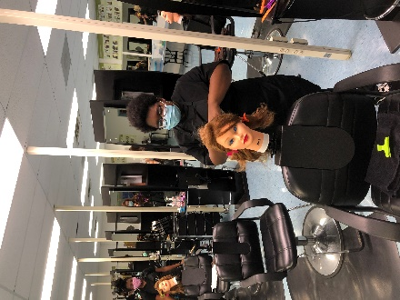
What brought you to ANTC? I enrolled in the Cosmetology program because I thought the class would be interesting.
What is your dream job? The dream job for me would be to develop a business combining Cosmetology and Art to do behind the scenes movies.
What is your favorite class that you have taken so far? Why? My two favorite classes are Cosmetology and Art because you get to use your creativity in both of these classes which I like a lot.
What is the best advice you have been given by your instructor at ANTC? Time is money! So, use it wisely!
What is your favorite memory at ANTC? The favorite memory I have being at ANTC is the first day I arrived, I like all the different things I could learn from just walking around the building.
What was the first feeling you had when you attended ANTC? I was nervous about being in class with the other county but once we met, I made friends and had a lot of fun.
What words of wisdom do you have for other students? The words of wisdom I have for the other students is you may not know or understand it today, but keep trying you will get it; don’t give up!
ANTC ALUMNI HIGHLIGHT!
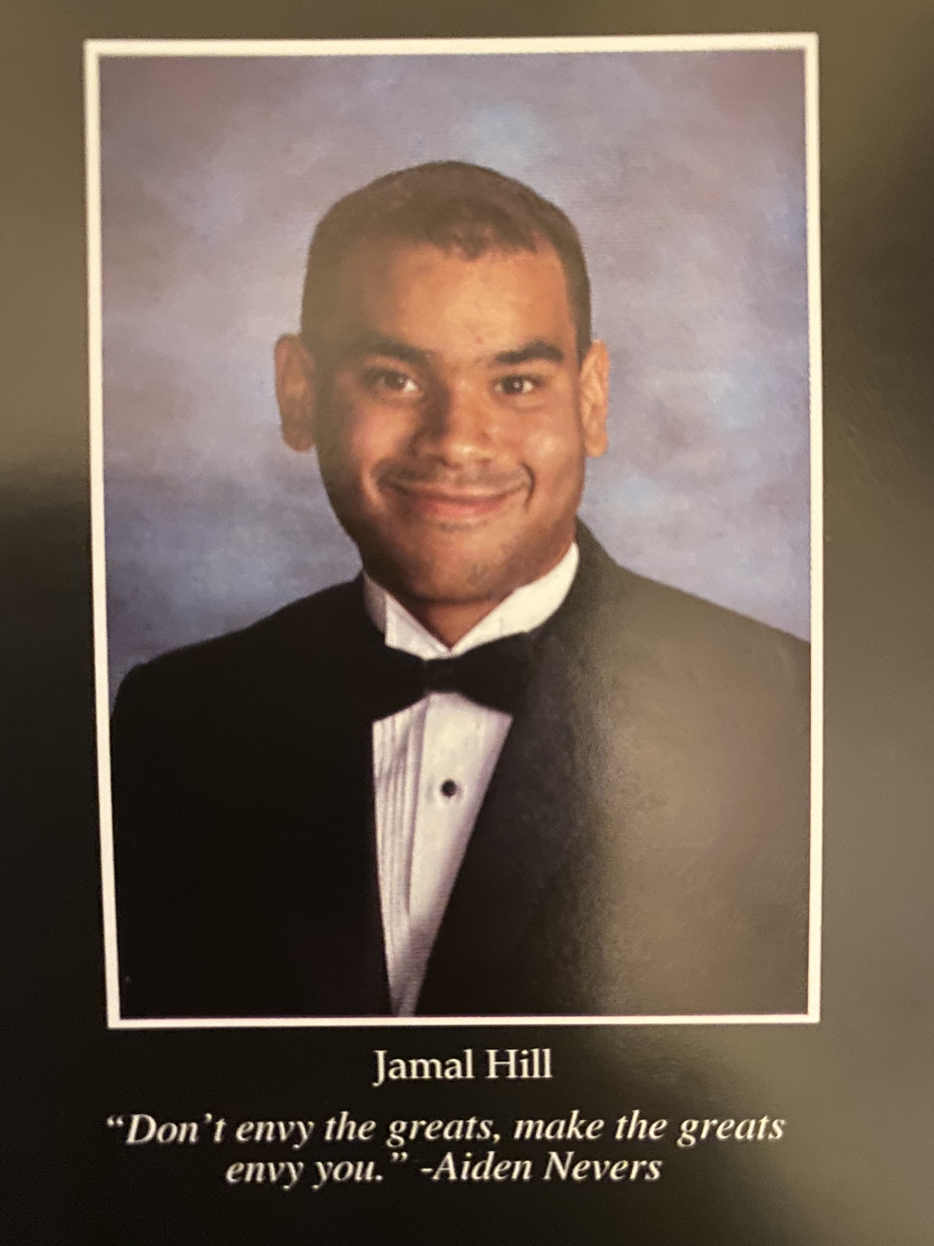
Jamal Hill
High School: Amelia County High School 2020
ANTC Program: Medical Assistant
College: Radford University, Freshman
Career: Medical Laboratory Science-My future is
bright and includes working in the medical laboratory
field but with some rough spots along the way.
DID YOU KNOW?
WHY CTE? WHY NOW?
ANTC has offered CTE courses to varying degrees in the past and currently delivers a CTE program that depends on local and state funding. Given the Virginia Profile of a Graduate requirements and the increasing need of graduates to be college and career ready, there exist opportunities for CTE improvements and community-wide benefits. One such opportunity for improvement is that CTE can provide multiple pathways for all students. Regardless of a student’s post-secondary path, CTE can play a role. CTE can provide students with:

- hands on learning opportunities to determine their interest in a career,
- training in a career pathway for students who have no plans to attend college, and
- opportunities for post-secondary training in a career pathway

Celebration
Congratulations to Mr. Spradlin and our Auto Body Program for achieving ASE Accreditation!!!
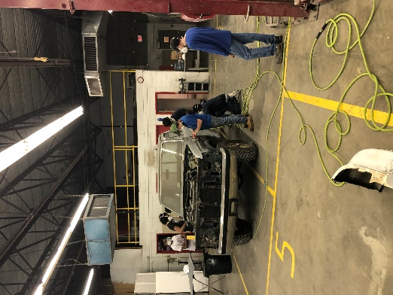

Staff Spotlight: Ms. Susanne Brown
Current Position: Finance Manager, ANTC

Previous Positions: Bookkeeper, Human Resources, Finance Supervisor

Hobbies: Reading, Decorating

Other Interest: Listening to Music

Family: A Son and Daughter, 1 Granddaughter and 4 Grandsons

ANTC serving our Alumni!

State Board Cuts!!!
Program: Cosmetology I & II
Amelia County High School, Cumberland High School, and Nottoway High School

Skills: State Board Cuts and Marcel Curling Iron

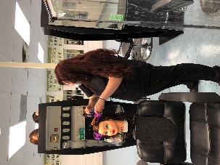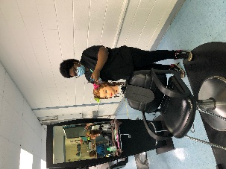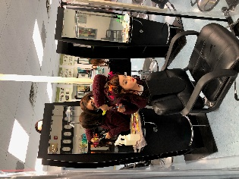
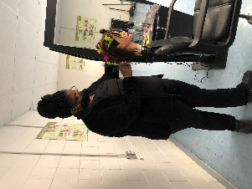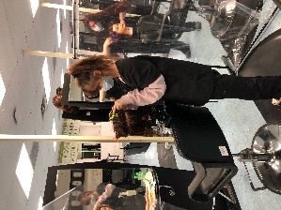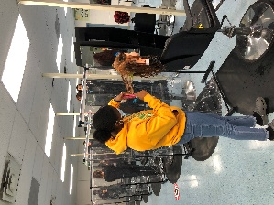

Marcel Curling Iron!!!
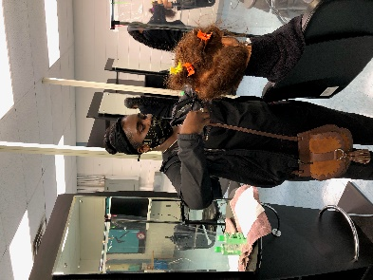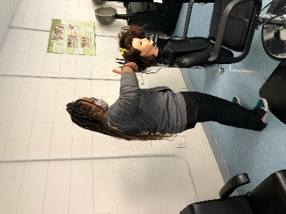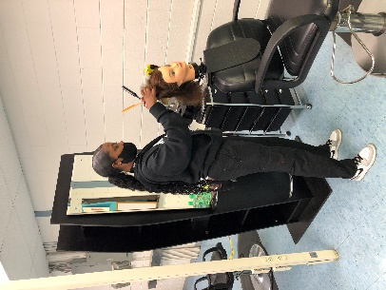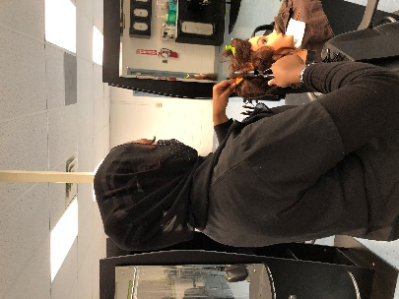

Body Mechanics
Current Program Feature: Medical Assistant I & II
Amelia County High School & Nottoway High School

Skills: Practicing Body Mechanics, and Assisting with a Pediatric Exam
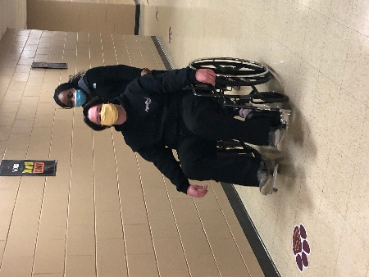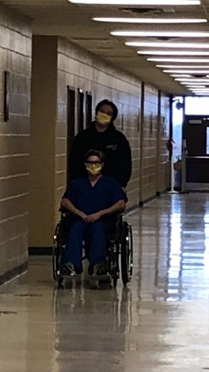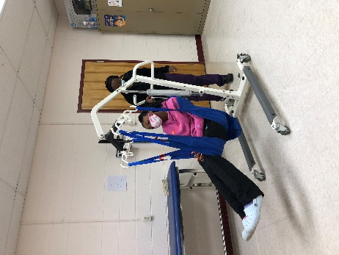

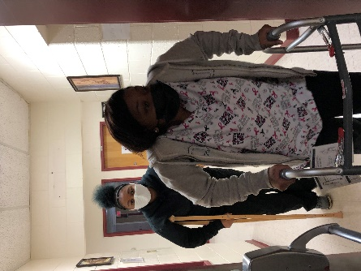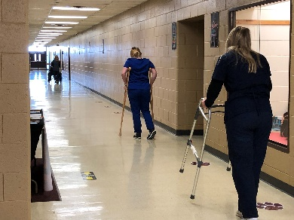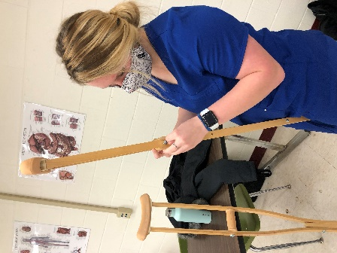
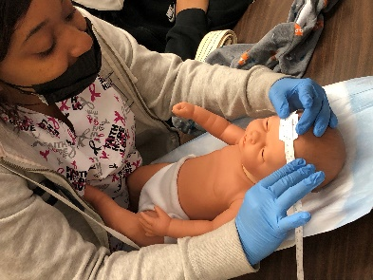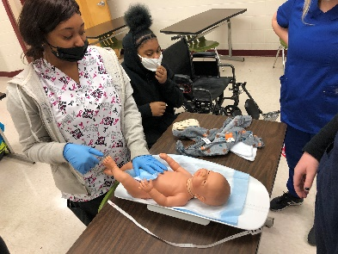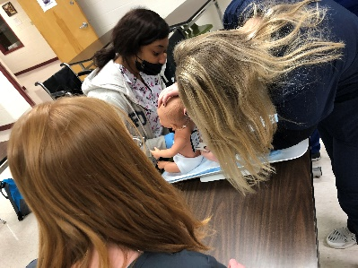
Pediatric Exam
Program: Auto Body I & II
Amelia County High School & Nottoway High School

Skills: Blocking and Shaping Filler

