**Introducing the**

**Testo Anabolic Patch  
Direct Testosterone Enhancement**

The Most Advanced Non-Prescription Testosterone Patch

With A Direct Time-Release Anabolic Response Formula

Anabolic hormone support utilizing direct transdermal delivery

**Boost endogenous testosterone**

Unmatched lean muscle mass and strength boost in *clinical trials*

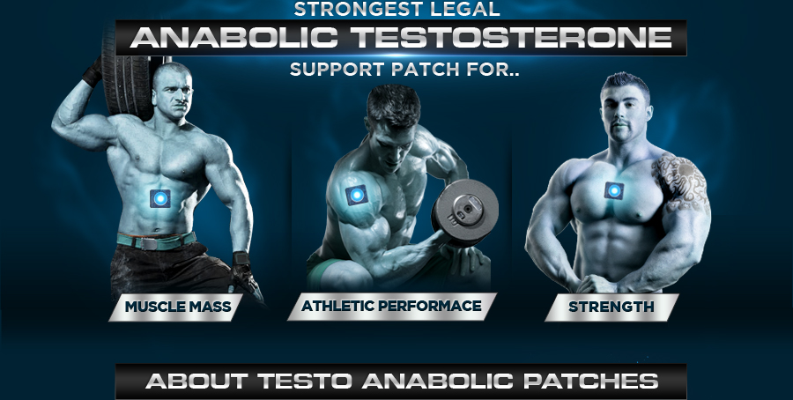

When it comes to anabolic hormone support for the modern athlete, nothing can compare to the Testo Anabolic Patch from Nutracell Labs. Extensively clinically trialled, this patch features a proprietary time-release transdermal formula to dramatically increase your testosterone levels for prolonged periods – which is essential for real muscle growth! Utilizing the latest in technological advancements, this patch is guaranteed to pack on strength, muscle mass and boost performance for even the hardest of hard gainers.

More testosterone -> More lean muscle growth – Don’t let average testosterone levels be your limiting factor, go beyond your genetic potential!

Anabolic testosterone levels have been proven to be elevated significantly for up to 24 hours following the application of a single Testo Anabolic Patch thanks to the time-release technology. With massively elevated testosterone, the most vital muscle building hormone in the human body, you can build and sustain a much higher bulk of muscle mass! The Testo Anabolic Patch can fully unlock your own endogenous anabolic limits much better than any pill or capsule on the market. The era of safer and much more effective steroid-alternatives has begun!

In a randomized, cross-over, double-blind, placebo-controlled clinical study, previously-trained test subjects using the TESTO ANABOLIC PATCH were evaluated over 12-hour period. Subjects significantly increased total testosterone by 376% over the placebo group in only 12 hours.

**Testosterone helps to maintain a feeling of well-being.**



**Testosterone boosts muscle development   
and bone strength.**



**Testosterone maintains sex  
drive, sperm count and fertility.**

* **100% Legal, Non-Prescription Anabolic Testosterone Patch**
* **100% Safe and Suitable for Age 18+**
* **Immediate Transdermal Activation with Fast & Sustained Results**
* **Dramatically raise anabolic hormone levels**
* **Massively boosts muscle size, definition and hardness**
* **Instant and sustained overall energy boost**
* **Enhances training intensity and motivation**
* **Proven to improve fast & slow twitch muscle strength/performance**
* **Increased fitness, stamina and circulatory health**
* **Promotes reduction in body fat levels**
* **Significantly increases libido and sexual performance**

The Testo Anabolic patch contains an ergogenic formulation which boosts endogenous testosterone secretion in synergy with the bodies own natural functions, giving rise to no negative side effects and meaning that no “post cycle” crash occurs after discontinuing use, with no PCT required!

With the new Testo Anabolic patch the multi-function anabolic response formula is delivered directly through the skin (transdermally) into the bloodstream. With this time release delivery method the stomach’s powerful digestive acids are bypassed and the natural testosterone boosters in the formula are delivered into the bloodstream at full strength and more importantly – fully intact!

**Strongest legal, non-prescription   
testosterone enhancement which is essential for unhindered muscle growth.**



**Unmatched size and strength gains without resorting to using uncountable feeble supplements**



**Testo Anabolic patches aid in the release of  
growth hormone as well as testosterone Another vital trigger for muscular development, so   
essentially results in a double dose of growth factors**



**High testosterone eliminates body fat, especially in the stomach region**



**Testosterone improves the mood, motivation levels and drive focus**



**The only side effect is you will experience a massively enhanced sex drive!**

Transdermal delivery is essentially an instantaneous and continuous direct to bloodstream delivery method that massively outperforms traditional pills and capsules.

The minute a Testo Anabolic Patch is applied, your body heat activates the time release functionality of the transdermal patch and the advanced formulation begins to transit through the skin (derma) into the countless small blood capillaries under and throughout the skin. Thanks to the optimized time release functionality, Testo Anabolic Patch deliver their formulated dose directly into the bloodstream over several hours. The time release function is optimised to work with the formula for optimal results.

##### *Doctors have been prescribing testosterone patches for low testosterone individuals for years, and it was only a matter of time until this technology was taken further and developed for the elite athlete market.*

Testo Anabolic patches are safe and effective in helping you reach your goals. Non-patch supplements such as pills and capsules all share the same major drawback in that they enter the body via the stomach which subjects them to powerful digestive acids which destroy and degrade over 90% of the essential ingredients before they even enter your system! Comparatively, the Testo Anabolic patch formula moves through the skin transdermally directly into the capillaries and blood beneath your skin.

As soon as a Testo Anabolic patch is applied the process begins and over the next 12+ hours the time-release anabolic response technology releases a steady dose of the formula nutrients with 100% bioavailability and utilisation. Most importantly of all, you get the benefit of 100% of the active formula instead of the 10% you would get with other oral testosterone booster supplements!

**Bodybuilders have known for decades that elevated anabolic hormone levels directly relate to an increase in athletic performance, strength and every area underpinning physical dominance. Increasing your levels of circulating free testosterone naturally will undoubtedly take your sports or fitness workouts to a whole new competitive level. In fact, fitness experts worldwide know of the importance of testosterone levels and how it can make or break an athlete. Quite simply, for individuals with average levels of testosterone, athletic dominance is not possible without anabolic hormone support. The Testo Anabolic Patch not only changes the playing field, but it rewrites the entire rule book!**

**How long does each Testo Anabolic Patch last**?   
Each patch consists of an anabolic matrix reservoir which delivers a potent dosage over a 12 hour period. All Nutracell Labs Testo Anabolic Patches are meticulously manufactured to the highest standards with absolute precision potencies. In many cases the highest potency concentrations allowed under UK law.

**How is the Testo Anabolic Patch used**?

Remove the patch from the packing sleeve. Peel the backing from the medical adhesive and apply the patch to a clean, dry area of skin. Anywhere on the back, stomach, upper arms orthighs will work well. Patch can be worn for up to 12 hours before it must be disposed of. Due to the extreme potency of this product, general improvements in strength, stamina and athletic performance can be noticed shortly after using the patch. If looking for optimal muscle mass gains the patch should be used to elevate testosterone levels for periods of at least 8-12 weeks during which significant changes in body composition can be noticed.

**Can the Testo Anabolic Patch be used alongside Testo Extreme Anabolic**?

Absolutely! Both products work through different biological pathways, so for those looking for rapid and explosive multi-platform anabolic effects they are the perfect stacking partners.

Clinical trials have demonstrated that stacking these 2 highly potent products undoubtedly provides some of the strongest muscular gains available on the market today.

**Is it necessary to use Post Cycle Therapy (PCT) with Testo Anabolic Patch**?

No. The negative feedback loop of the hypothalamic-pituitary-testicular axis regulates the production of endogeneous testosterone and this is in no way negatively effected through use of Testo Anabolic Patch. Most importantly, this means no post cycle crash and no loss of hard earned gains either!

**Who can take this product**?

This product is suitable for anyone over the age of 18 years, it is designed for males and those looking to amplify anabolic levels and build permenant lean muscle whilst burning off fat.

**Are there any negative side effects**?

The Testo Anabolic Patch contains a perfected matrix of biologically active ingredients that will help maximise natural testosterone levels, along with enhancing the function of growth hormone (GH) & IGF-1 safely and easily. You won't experience any of the disturbing and upsetting side effects that traditional anabolic androgenic steroids can create. No gynocomastia, no acne, no post cycle blues & loss of muscle mass, just a steady anabolic boost that amplifies size, strength and athletic gains.

**Product Ingredients:**

D-Aspartic Acid, Lepidium Meyenii, Rhizoma Curcyliginis, Herbal Epimedii, Radix Morindae, Officinalis, Caulis Polygoni Preparata, Tribulus Terrestris 95% Saponins, Zinc Gluconate, Radix Angelicae, Cortex Phellondendri, Rhizoma Anemarrhenae.

