Welcome to the
Friendship Force Florida Suncoast Club Located in Pinellas County, Florida

Our club is based in the Clearwater/St. Petersburg area of Pinellas County on the west coast of Florida known as the Suncoast. Our area is a major tourist destination known for its favorable climate, world-class museums, cultural offerings, and miles of award-winning white sand beaches, as well as nature parks, lush gardens and year-round activities on water and land. We are fortunate to live in one of the most beautiful parts of Florida and promise you a warm reception and an itinerary suited to your members’ interests.

About the Journey
Typically, our inbound Journeys are 5-7 nights. We customize the itinerary to your group’s interests and tell you of any special cultural events occurring during your visit. In addition to planned outings and activities, an inbound Journey usually includes a welcome party, dinners in our members’ homes, a ‘free’ unplanned day to pursue individual interests, an evening where the Ambassadors take their home hosts to dinner, and a farewell party.

Planned daytime activities that showcase our area usually include the attractions detailed in this brochure. We invite you to choose the activities that your club would find most interesting. We’ve provided brief descriptions, but you can read more about each online. The Journey cost will depend upon the activities you choose.

Best Times to Visit Us
*Best times to visit us | High | Low | Rain- days | Rain inches
January | 70 | 54 | 7 | 3.0
February* | 73 | 57 | 6 | 2.2
March* | 77 | 61 | 7 | 2.8
April* | 82 | 66 | 5 | 2.6
May* | 87 | 72 | 5 | 2.5
October | 84 | 70 | 6 | 2.6
November* | 77 | 63 | 5 | 1.6
December | 72 | 58 | 6 | 2.8
We are delighted to host your club, and we will let you know if there are any conflicts with your preferred Journey date. Although museums and indoor attractions are air-conditioned, we recommend visiting during one of our ‘tourist season’ months to the right to maximize your chances of experiencing our best weather.

Source: St. Petersburg historical averages from U.S. Weather Service and bestplaces.net

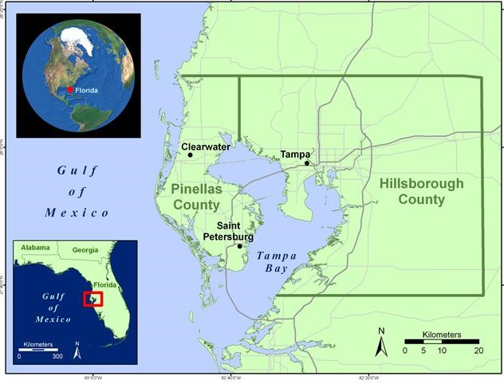
Airports
Most Ambassadors arrive at Tampa International Airport (TPA) located about 20 miles (32.1km) to the west. Another convenient option is the nearby St. Pete/Clearwater Airport (PIE). Our club will help arrange transportation to your home hosts from these two airports.

Nearby Orlando, Theme Parks, Space Center, Cruise Ports, and More
If incoming Ambassadors plan to visit additional Florida attractions before or after their FF Journey, they may choose to begin their trip from other Florida airports. The Orlando International Airport (MCO) is about 105 miles or a 2-hour drive away. Other major Florida airports are more distant. Chartered buses and rental cars are the most convenient way to reach our area from those airports.

Our Website
www.ff-fs.org

POPULAR AREA ATTRACTIONS

St. Petersburg (usually 1 or 2 days) Downtown St. Petersburg is vibrant with waterfront parks, walkways, museums, outdoor restaurants, entertainment venues, shopping and mural walls. It’s also fun to just sit with an ice cream cone and people watch. In addition to the destinations noted below, downtown St. Pete hosts a Saturday Market from October-May (biggest in SE USA), a visitor’s trolley, history museum, dolphin boat rides, Segway and bike rentals, and much more.

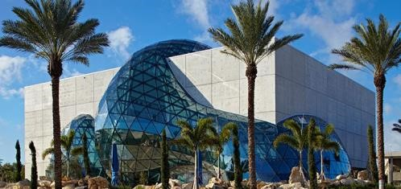
- Dali Museum
This is one of the “must see” museums in our area, even if you are not a fan of surrealist art. People come from around the world to see this very extensive collection of Dali’s work. The museum building on the waterfront is unique, dramatic, and worth of visit on its own. You may tour the museum with headphones, or with one of their well-informed docents. We recommend that you spend two to three hours when visiting this venue.
www.thedali.org

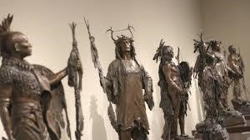
- The James Museum
The James houses an extensive collection of Western art collected by its owners, Tom and Mary James of Raymond James Financial Services. When the James traveled to the western U.S., they were enchanted by the wildlife, the art, and the landscapes. They wanted to preserve images of the frontier they had grown to love so much, as well as help support local artists. Much of their art was initially displayed in their corporate headquarters, but when it outgrew the space, the James family built this museum to house the collection. We offer this as an excellent alternative to the Dali Museum for those who have been to the Dali in the past.
www.thejamesmuseum.org

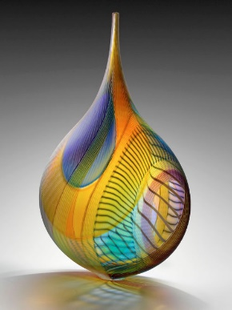
- The Imagine Museum
The Imagine Museum has a collection of over 500 beautifully displayed pieces of contemporary glass pieces that will have you marveling at the artists’ creativity and skill. Corey Hampson, who worked with the benefactor, assembled the collection to tell a story. According to her, “Studio glass in America developed into the worldwide exchange of ideas, techniques, and concepts that it is today.”
https://www.imaginemuseum.com

- Chihuly Collection- Morean Arts Center

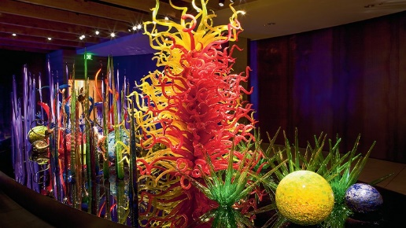
This venue contains works from the world-renowned Chihuly Glass Art Collection, as well as galleries filled with locally made art, and gift shops. There are hourly glass blowing demonstrations and the Morean Center for Clay. Glass artist Dale Chihuly famously said, “I never met a color I didn’t like.” It’s a phrase that sums up the work of this internationally renowned artist whose life has been characterized by bold hues and fantastically colored glass sculptures.
https://www.moreanartscenter.org

- Duncan McClellan Gallery
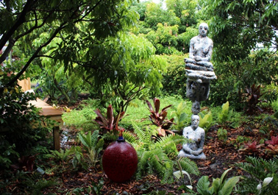
Another popular destination in St. Petersburg is the Duncan McClellan Gallery, which features glass artists from around the world. Here you can see glass blowing demonstrations, purchase stunning glass pieces, and/or enjoy their 5,000 square feet sculpture garden.
https://www.dmglass.com

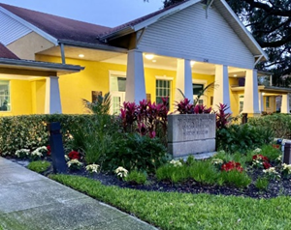
- Dr. Carter Woodson African American Museum
This museum is of historical and cultural importance to the community of St. Petersburg. Named after the African-American historian and civil rights activist, who is best known as the founder of Black History Month, the Museum is located in what was once a bustling entertainment district. During the era of segregation, performers such as Ray Charles, Ella Fitzgerald, Cab Callaway and others came to play. In addition to housing memorabilia from that era, the museum hosts special events and rotating exhibits of historical, cultural and artistic significance. With advance notice we can usually arrange for a special program as well as samples of authentic soul food. Dr. Carter G. Woodson African American Museum | Dr. Carter G. Woodson African American Museum - St. Petersburg, FL (woodsonmuseum.org)

- Museum of American Arts and Crafts Movement
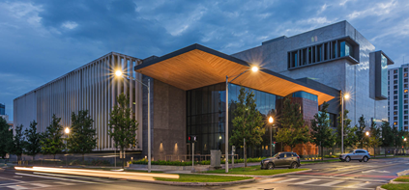
The Museum of the American Arts and Crafts Movement (MAACM) is the only museum in the world dedicated exclusively to the American Arts and Crafts movement. Founded by local philanthropist and collector Rudy Ciccarello, MAACM is St. Petersburg’s newest museum, featuring stunning architecture, incredible works of art, and an ideal location in the downtown waterfront arts district.
https://www.museumaacm.org

- St. Pete Pier
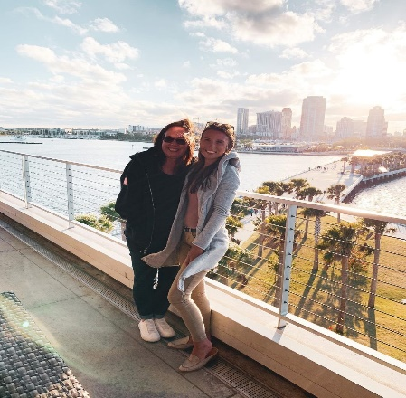
The St. Pete Pier was recently named the country’s #2 new attraction country by USA Today. This 26 acre pier/park, which opened the summer of 2020 on the city’s picturesque Tampa Bay waterfront, contains a beach, lawns, shopping, a playground, a water park, a discovery center, fishing area, restaurants and bars, an amazing sculpture by Janet Echelman, as well as panoramic views of the St. Petersburg skyline.
https://stpetepier.org

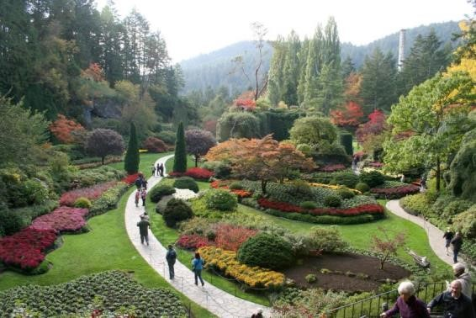
- Sunken Gardens
This lush tropical botanical paradise in the midst of a bustling city is on the National Register of Historical Places. As St. Petersburg’s oldest living museum, it features more than 50,000 plants and flowers, waterfalls, and a flock of flamingos on its 4+ acres. We can arrange guided tours.
www.stpete.org/attractions/sunken_gardens/index.php

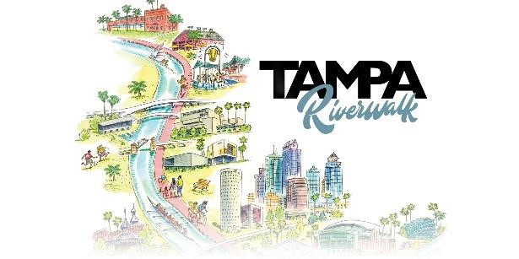
Tampa (usually 1 day)
Other than Busch Gardens, the most popular attractions in Tampa are located on, along, or near the 2.6 mile long pedestrian Tampa Riverwalk, that is dotted with skyscrapers, entertainment, marinas, museums, and parks.
https://www.tampa.gov/riverwalk

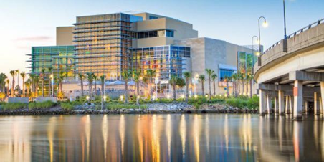
- Tampa Bay History Center
Located right on the Riverwalk, the History Center (a Smithsonian Affiliate Museum) highlights over 12,000 years of Florida’s history and heritage. Through hands-on experiences and immersive theatre, you will learn about the pirates and Buccaneers, Cuban immigrants, early pioneers, native Americans, and African slaves who contributed to Tampa’s rich history. NOTE: Many of our Ambassadors choose to visit the History Center in the morning and early afternoon, and then visit Ybor City in the late afternoon, finishing the day with dinner and flamenco show at the original Columbia Restaurant.
www.tampabayhistorycenter.org

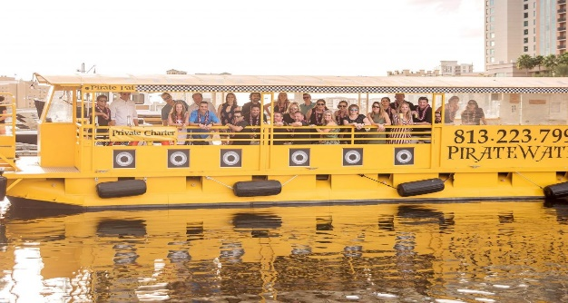
- Hop on, Hop off Water Taxi
Another favorite of our Ambassadors is the Hop On, Hop Off water taxi in Tampa. We can hire the water taxi for a short private river/sightseeing tour, or purchase day tickets to allow our visitors to spend the rest of the day on the water taxi, getting on and off where they please
https://www.piratewatertaxi.com

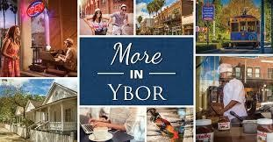
- Ybor City
One of the gems of Tampa is Ybor City, also known as “Cigar City.” It was founded in the 1880s by Vicente Martinez-Ybor and other cigar manufacturers. The abundant work attracted many immigrants primarily from Cuba, Italy, and Spain. They built homes, restaurants, social clubs, and shops, creating a city within a city. At the Ybor City Museum and adjacent cigar worker homes, you can learn about the lively history of Ybor City and its distinctive culture.
Home - Ybor City Chamber of Commerce

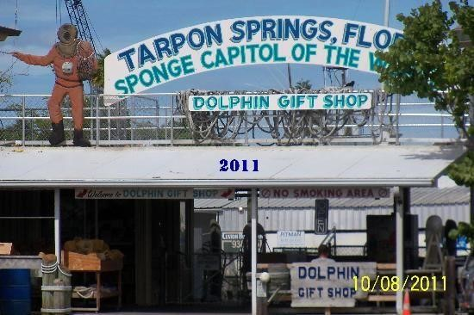
Tarpon Springs (Usually 1 day)

Known as the “Sponge Capital of the World,” Tarpon Springs is a community about 10 miles north of Clearwater. It is situated on the Anclote River where Greek immigrants settled during the early 1900’s to build a thriving sponge industry. Greek heritage and traditions are still very strong here.

Many of our visitors enjoy visiting the Saint Nicholas Greek Orthodox Cathedral, which was modeled in part to resemble the Hagia Sophia in Istanbul, Turkey. A local guide can relate the history of the church and share how the early Greek residents built this church with their earnings.

We can also suggest a restaurant where you can enjoy some famous Greek food, and/or a boat ride to see how sponge divers earned their livings.

In the town’s waterfront shopping area, there are several small private museums where you can learn more about sponge diving, as well as many art galleries and specialty shops housed in buildings dating to the late 1800s.

There are also many beautiful parks in Tarpon Springs. Sunset Beach is a white sand beach on the lovely Gulf of Mexico. Another park, Spring Bayou, is a natural spring where you can often observe manatees in the winter.
Tarpon Springs Florida - Things to Do & Attractions in Tarpon Springs FL (visitflorida.com)

Other Interesting & Fun Experiences We Can Share With You

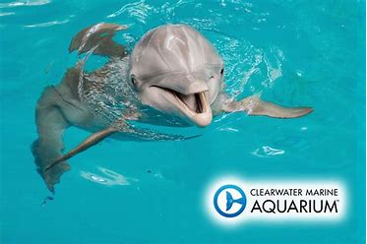
- Clearwater Marine Aquarium
The Clearwater Marine Aquarium, which opened in 1972 as a place to rescue, rehabilitate, and release injured or ill marine animals, is very popular with guest of all ages. The famous dolphin, Winter, was rescued in 2005 and brought to this aquarium, where she was fitted with the first prosthetic tail. If you visit you may see the dolphins, sea turtles, otters, and other aquatic animals being rehabilitated. Special boat tours and behind the scenes tours are also available. Clearwater Beach is nearby, and we usually stop at the beach if we visit the aquarium. Popular restaurants line the beachfront.
https://visit.seewinter.com

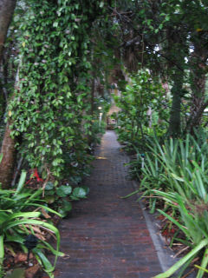
- Jungle Prada Park
For those who enjoy history, a visit the Jungle Prada Park is interesting. The Spanish explorer Panfilo de Narvaez is thought to have landed in this area in 1528. The park contains shell midden mounds created by Native Americans of the Safety Harbor culture between AD 1000 and the mid-16th century. The family who owns this land is dedicated to education and the preservation of this archeological site. It is open for tours.
Welcome to the Sacred Lands Preservation and Education Website!

- Heritage Village
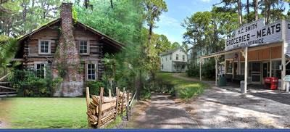
Heritage Village is a 21-acre living history museum located in the heart of Pinellas County. Nestled among natural pine and palmetto are 33 historic buildings that have been moved to these premises to show the buildings of the late 1800s through the early 1900s. The village houses two schools, a railroad depot, a general store, church, and numerous furnished period homes. We can often arrange a docent tour.
www.pinellascounty.org/heritage

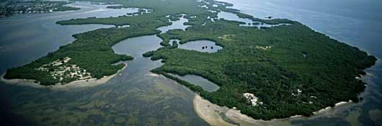
- Weeden Island Culture Center
For visitors interested in Florida and its history, we recommend a visit to Weeden Island Cultural Center in north St. Petersburg, where indigenous peoples lived for thousands of years. Weedon Island Preserve is an expansive 3,190-acre natural area located on Tampa Bay. This coastal system, comprised of aquatic and upland ecosystems, is home to numerous species of native plants and animals, an educational facility and a rich cultural history. A 4.3-mile pedestrian walkway, accessible from the visitor’s center, makes it easy to observe birds, animals and coastal plants.
http://weedonislandpreserve.org

A Few Destinations Especially Suited for ‘Free Day’ Excursions

- Spring Baseball
Spring in FL means baseball fans are everywhere. The NY Yankees, Toronto Blue Jays, and Philadelphia Phillies all make the Tampa area their spring training headquarters from late February to later March. Your favorite team may be in town to play them. Game tickets are available to baseball fans with advanced reservations.
MLB Tickets: Buy tickets for MLB games today | MLB.com

- The Beaches!!
There are too many beautiful beaches to mention, but no trip to our area is complete until you have put your toes in our justifiably famous white ‘sugar’ sand. Clearwater Beach, St. Pete Beach, Pass-A-Grille Beach, Caladesi Island, Honeymoon Island, and Fort De Soto are some of our favorites.

- The Jolley Trolley
This inexpensive trolley runs from Clearwater Beach north to Tarpon Springs. It’s a great choice for a relaxing and leisurely tour of our local artisan beach towns.
https://clearwaterjolleytrolley.com

- Pinellas Trail
For the more active and adventurous Ambassadors, the 43-mile Pinellas rail-trail is popular. Bikers and walkers enjoy the variety of sights along this flat recreational trail that runs the length of the Pinellas peninsula from Tarpon Springs to St. Petersburg.
Pinellas County, Florida - Park & Conservation Resources - Pinellas County Trail Guide

- The Ringling Museum
The Ringling Museum in Sarasota occupies 66 waterfront acres along Sarasota Bay and includes a Museum of Art, gardens, a circus museum, the historic art deco home of John and Mabel Ringling called Ca D’Zan, as well as restaurants and a gift shop. The museum is approximately 55 miles south of Clearwater.
https://www.ringling.org

A Few Special Destinations A Bit Further Away

If your group is interested in native landscapes and wildlife, we highly recommend spending a day at either Myakka River State Park or Homosassa State Park. As both parks are approximately 75 miles away, we may offer car pools or charter a bus or van to these locations.

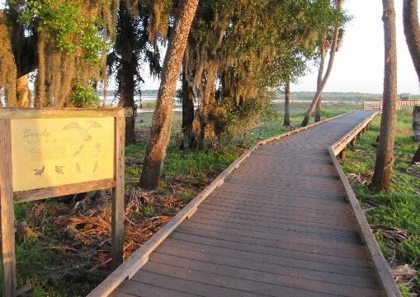
- Myakka River State Park
The scenic Myakka River flows through a vast expanse of unspoiled wetlands, prairies, hammocks, and pinelands. Activities at the park include a narrated boat trip (you’ll see plenty of alligators and wildlife), a bird walk, nature trails, interpretative center, a unique canopy treetop trail (first in North America), gift shop for unique Florida gifts, and a café where we often arrange for box lunches. With advance notice we can often arrange an official welcome and education by a park ranger.
Myakka River State Park | Florida State Parks

- Ellie Schiller Homosassa Springs State Wildlife Park
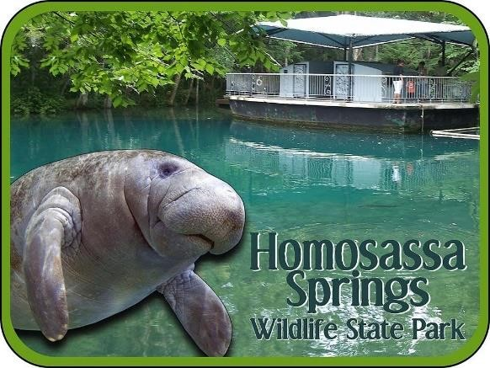
With admission you enjoy a narrated boat tour, daily manatee program, underwater observatory, and wildlife encounter and education programs led by rangers. The park has excellent amenities and features elevated boardwalks from which you can view a variety of captive animals indigenous to Florida such as alligators, black bears, red wolf, key deer, flamingoes, and whooping cranes.
Ellie Schiller Homosassa Springs Wildlife State Park | Florida State Parks

