Millie’s Paws Hydrotherapy Centre & Grooming Studio  The Midlands School of Dog Grooming & Small Animal Hydrotherapy  Brindley Road  Bayton Road Industrial Estate  Coventry  CV7 9EP  T: 07925 917949  E: milliespawshydrotherapy@outlook.com  W: www.milliespawsgroomingstudio.co.uk | 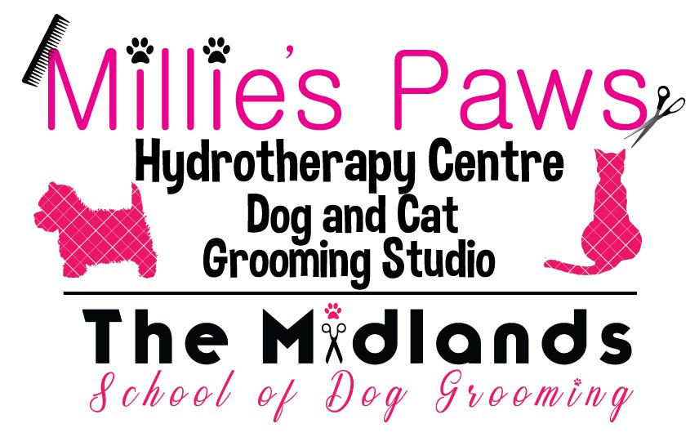
VETERINARY CONSENT & REGISTRATION FORM
Owner to complete section A & B |  |  |  |  | Veterinary practice to complete section C. This section must be completed & signed & returned to Millie’s Paws with the accompanying clinical notes
Section A
Clients name
Clients address (including postcode)
Client contact number |  |  |  |  |  | Client email address
Section B
Patients name |  |  |  |  |  | Breed
Date of birth |  |  |  |  |  | M/F |  |  |  |  |  |  | Neutered/Spayed Y/N
Weight |  |  |  |  |  | Temperament
Description of problem
Section C | TO BE COMPLETED BY YOUR VETERINARY SURGEON & FORWARDED TO MILLIE’S PAWS  ALONG WITH CLINICAL NOTES
Veterinary surgeons name
Practice address
(including postcode)
Practice telephone number |  |  |  |  |  |  |  | Practice email address
Summary of condition
Current medication
Areas of concern
In your opinion is the above-named patient in a suitable condition for hydrotherapy/fitness swims? |  |  |  |  |  |  | Y/N
Veterinary surgeon name
Veterinary surgeon signature |  |  |  |  |  |  |  |  |  |  |  | Date

