Happy
May Day!

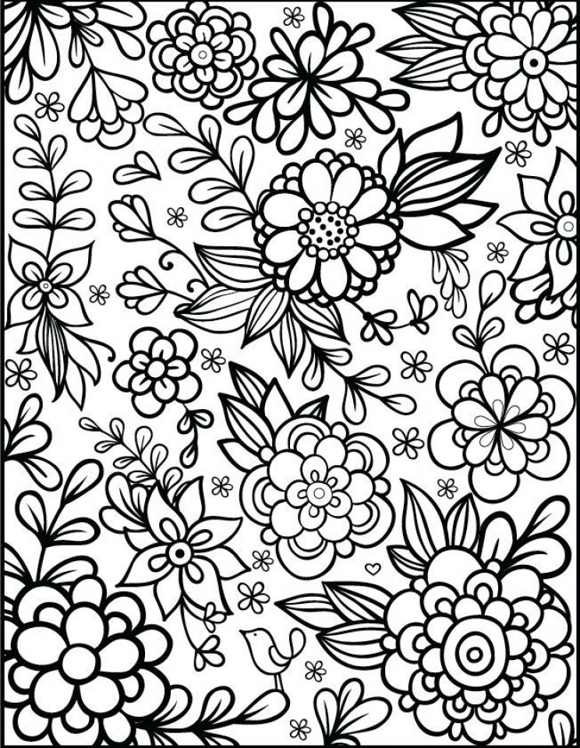

First Lady Eleanor Roosevelt received a May Basket of flowers from young children in 1938

May Day, or the first day of May, is traditionally a celebration of spring and the awakening of nature after the winter months.

May Day is usually associated with flowers, dancing, and maypoles and sometimes the ritual of crowning a “May King” and “May Queen”.

Historically, people would leave a paper basket or cone with spring flowers and sweets on each other’s doorsteps, usually anonymously. The custom was to knock on the door and yell, “May Basket!,” and then run! If the person delivering the basket was discovered, the recipient would give chase and try to steal a kiss!

May Day celebration has been reintroduced to Wilbraham by the Peach Blossom Festival as a safe and socially distanced activity to bring us together this spring. Share your love for your neighbors in Wilbraham by sending a May Basket to someone you know! Print out a paper cone at our website www.peachblossomfestival.org or visit our Face book page.
The Peach Blossom Festival will return in June of 2022.

