Turn n Road
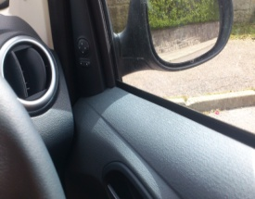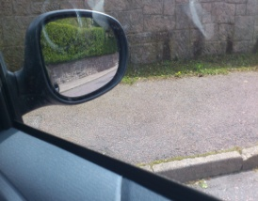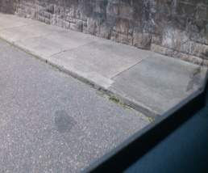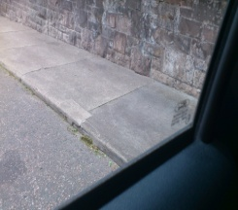
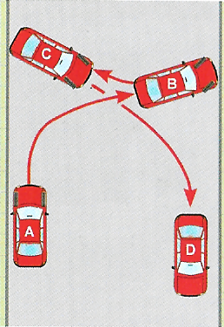
The three key points to this manoeuvre is control, accuracy and observations, In other words your hand, foot and eye co-ordination. You can perform the manoeuvre in 3 or 5 points if required. Before starting the manoeuvre check the camber of the road and how this would affect the control of the car. I would aim to use as much of the road as possible no matter what size of road you are on. To help the control of the car set gas and bring clutch to bite then clutch down a thickness of a pound coin, this will stop you shooting forward.
- Prepare the car in first, then clutch to bite and then down pound coin then make all round observations.
- Release the handbrake and steer briskly to the right, (have your full lock on by the time you are half across the road), Observe as you come across until you reach your first ref point, then steer to right till steering wheel is straight or full lock achieved.
- Secure the car and prepare the car into reverse, clutch to bite then down the pound coin.
- Make all round observations then release the handbrake looking over your left shoulder through the rear window while steering briskly to the left if required.
- Half way across look over your right shoulder for your next reference point, when you are there steering briskly to the right till you meet your next reference point.
- Secure the car and prepare the car into first gear, clutch to bite then clutch down thickness of pound coin.
- Make all round observations then release the handbrake steering briskly to the right observing as you come across, then pull at a safe place

What can go wrong? Pace too fast (clutch too high), shooting forwards before steering Clutch too high), Steering too slowly(concentrating on feet instead of feet and steering), missing reference points, Lack of observation.

What went well? What needs development?

What is the fault?
Why did it happen?
What is the solution?
What is the benefit of the solution?

What is the fault?
Why did it happen?
What is the solution?
What is the benefit of the solution?

What is the fault?
Why did it happen?
What is the solution?
What is the benefit of the solution?

What is the fault?
Why did it happen?
What is the solution?
What is the benefit of the solution?

