Nutrition Plus, Inc.
121 Mays Rd., Winfield, KS. 67156
www.nutritionplusinc.com

Executive Director: Emily Roark (620) 221-2777 roark2@cox.net
Administrative Supervisor: Patti Brenn (620) 218-1811 pattibrenn@cox.net
Topeka Area Coordinator: Susan Morrell (785) 230-7441 smorrell12@gmail.com
Menu Advisor: Jacque Zimmerman (620) 660-0236 jacque.nutritionplus@gmail.com

November is:
National Gluten-Free Diet Awareness Month
National Fun with Fondue Month!
National Pepper Month
National Peanut Butter Lovers Month

Important Dates:
5th – Claim Due (claims received after the 5th may not be processed in time to pay in November and might be paid with December’s payment).
23rd – Checks and Direct Deposits go out.

Family Meal Service

Family style meal service is an option for you, that allows children to serve themselves at mealtime. All required meal components are placed on the table, and the kids are allowed to choose the food items they want, in the amount they want. Adequate amounts of each food must be on the table, with at least the minimum required portions for each participant present. Serving bowls and pitchers should be small enough for participants to lift
and pass around. Multiple bowls may be needed for full portions. The provider may help participants who are unable to serve themselves, but portions served to the participant must be at least the minimum portion size.
To make this successful, follow these simple steps!
- Set the table with all meal components and tableware.
- Wash hands!
November 2021
- Get everyone seated, including yourself, or an adult to supervise.
- Pass the serving bowls and pitchers around the table. (kids not taking a food item are encouraged to try some at a later time).
- Kids who do not take full portions are
encouraged to take more later but are not forced.
- Any components that are served by a provider must be the minimum portion required
- Make sure you are role-modeling good meal time behavior!
Benefits of Family Style Meal Service Are:

- Less waste!
- Kids can choose what foods they want to eat. This builds confidence and improves self-worth!
- Allows kids to self-regulate and understand hunger signals. It’s important to let them know it’s ok to stop eating when they’re no longer hungry. (The days of “happy plates” are over. Now we look for “happy tummies”! This is less shaming for not emptying their plates.)
- Development of motor skills, dexterity, and hand strength
- Development of social skills through meal time conversation
- Role modeling from you and your staff
- Positive eating environment

These are just some of the benefits you and your daycare kids can get from this style of meal service. It is acceptable in the Nutrition Plus food program as well as the CACFP. We have a few of you already doing this and the reviews have been great!
I’m Thankful For… 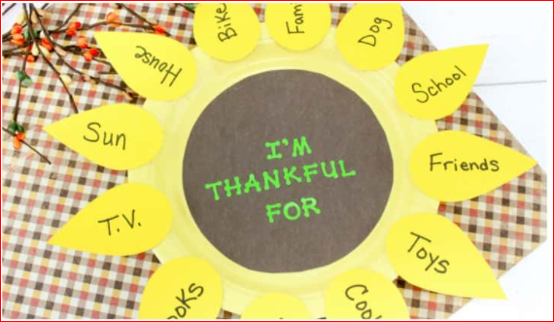

Supplies:
Paper Plates
Construction Paper in yellow & brown
Markers
Yellow Paint is optional to paint the plate
Non-toxic paint is optional to write on brown paper
Glue

Instructions:
1. Color or paint the paper plate yellow.
2. Cut twelve 3-inch tear drop shape petals from the yellow paper. If desired, you can make a template so all the petals are uniform, but this isn’t necessary.
3. With the brown paper, cut out a 5-inch circle and glue it into the inner circle of the paper plate.
4. Write with markers or paint “I’m Thankful for” in the center of the brown circle.
5. Now, help your kiddos write twelve things they are thankful for on each petal. Many preschoolers will need you to help them write out these words, but many older children can do this step on their own.

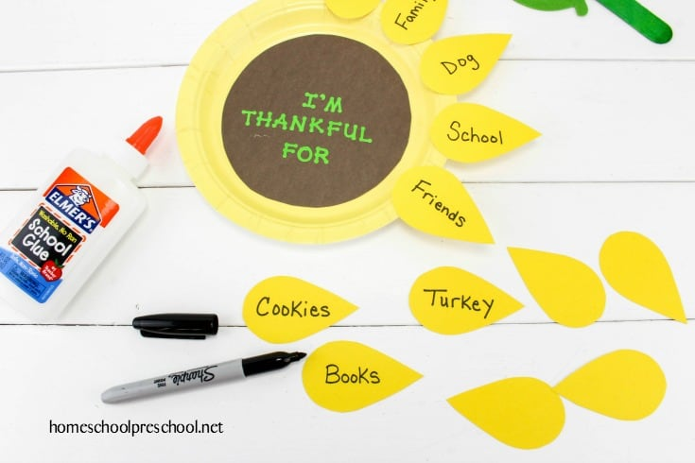

6. Glue the petals around the outside of the plate with the tip end pointing outward. Finished!
Fondue For Kids!
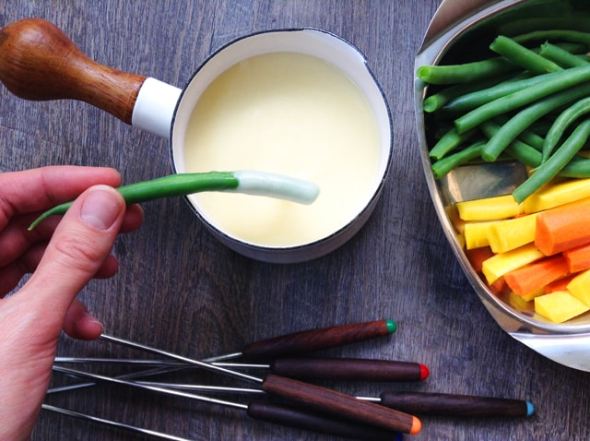

Ingredients:
1 cup chicken broth, low-sodium
1/4 teaspoon lemon juice
2 clove garlic
3 cup Swiss cheese
1 1/2 cup cheddar cheese, shredded
2 tablespoon cornstarch
1/4 tsp, ground white pepper
1/8 teaspoon paprika

Instructions:
In a small, heavy-bottomed pot (cast-iron is best) bring the broth, lemon juice and pressed garlic to a gentle simmer over medium heat.

Meanwhile, place the cheeses into a large Ziploc bag along with the cornstarch, and shake until the cheeses are well-coated (this is a great task for kids!)

When the broth mixture begins to simmer, reduce the heat to low, and add handfuls of cheese, one at a time, whisking the fondue after each handful until the shreds are completely melted.

Once all the cheese is well-incorporated, remove the pot from the stove and stir in the pepper and paprika.

Serve immediately with vegetables, fruits and bread for dipping!

Happy Thanksgiving from Nutrition Plus

