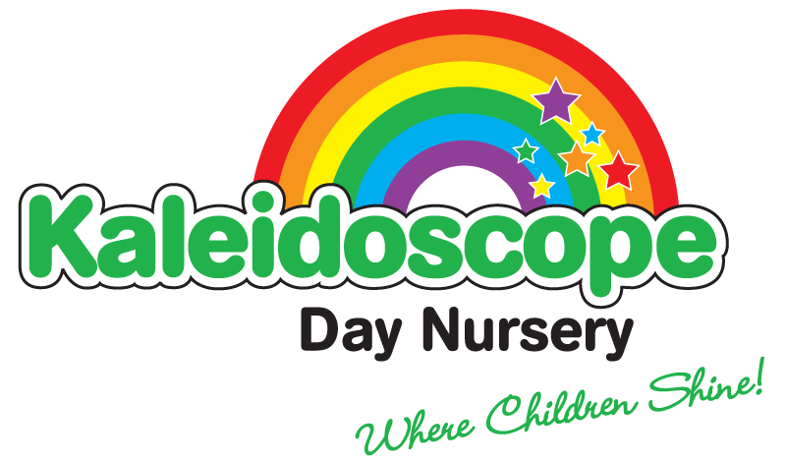

Issue 15

Review Date: September 2022

BEHAVIOUR MANAGEMENT POLICY

Kaleidoscope Nursery operates a basic code of discipline. Children learn self-discipline, group discipline, and the difference between right and wrong and to be polite and use acceptable behaviour. The staff will always explain why certain types of behaviour are unacceptable.
Children at Kaleidoscope Nursery will not be disciplined by smacking, slapping, shaking, shouting, etc.
We aim to make this an area where parents and Nursery will share the same philosophy and work together to help the children become polite and caring individuals, to promote the child’s self esteem and to provide a happy and secure environment for everyone.

Objectives
Through the following provision, we hope to fulfil our aims and promote positive behaviour:

- To provide experiences to encourage the child to have a positive self-image through games, turn taking, stories and valuing the childs contribution at all levels
- To be positive and consistent at all times
- Give positive instructions
- Our SENCO is responsible for behaviour management, and attends regular courses, provides strategies to support staff and parents and keep up to date with relevant changes. If the SENCO is not able to give clear advice then she will work closely with Coventry SEND support services for support and to seek the appropriate advice.
- Each room has ‘Golden Rules’ displayed the children are encouraged to follow these rules at all times
- To encourage social skills – please, thank you, consideration for all and turn taking
- There are certain times when a child has to conform to nursery procedure e.g. story times, tidying up, fire drill and accepting the discipline of noise levels
- By example children are encouraged to work within acceptable busy noise levels to ensure a calm working atmosphere.
- When dealing with a child, always use a positive approach to emphasize that it is the action taken which is unacceptable and not the child, depending upon the age and understanding of the child, the child maybe asked to sit on our ‘thinking/sad chair’ to reflect upon their actions
- Encourage children to vocalize that they do not like being hurt and to express their feelings
- Encourage the child to say sorry, if possible help them to comfort and befriend the victim
- For dangerous situations that require immediate action e.g. throwing bricks, sand etc warn the child giving reasons, and distract them with another activity, if the behaviour persists remove them from the activity under adult supervision for a specified period of time
- Enable parents to feel comfortable in approaching staff about any problem that is worrying their child which may be affecting the child’s behaviour
- Any significant and/or repeated behaviour will be recorded and parents will be required to sign to acknowledge the behaviour
- Where appropriate after consultation with parents, we will access expert advice if necessary from Coventry SEND support services (early years team) and any other relevant agencies
- In extreme cases, exclusion may be considered

All of the above will be done in accordance to the child’s age and level of understanding.

Physical restraint

Physical restraint will not be used on any child unless it is absolutely necessary i.e to safeguard the child, staff or other children. If physical restraint is used, this will be recorded and the parent will be required to sign to acknowledge the behaviour. We will also inform the Local Authority as soon as possible.

Bullying

At Kaleidoscope we aim to:
A) Develop a shared understanding of what bullying is and how to develop ways of both identifying and working to prevent bullying
B) Act promptly and liase with children and parents involved in bullying and to support the victim
C) Promote to parents that bullying is not a normal part of growing up and is a totally unacceptable form of behaviour
D) Promote the positive self-image of each child to try to counteract the negative feelings which bullying can trigger

4-11 Club and After school

Our policy is to be “firm but kind” and to encourage good standards of behaviour. To support this staff encourage discussions with the children to enable them to be aware of situations around them that are both acceptable and unacceptable. The children make their rules, which they would like to see upheld.

- The children and staff do not want any bullying, fighting, spitting, bad language, name calling.
- The children would like to see, children being respectful to other children, adults and staff at all times, looking after toys, sharing, and working together.
- The children must wear appropriate clothing and suitable footwear
- Children must use the resources and equipment appropriately and safely to protect them and others around them.
- Children must listen to staff and follow out instructions as accurately as they can
- The children and staff will not be ridiculed or threatened in any way.
- If at any time a child becomes aggressive/violent towards their peers or staff members, staff will contact the parents who will be expected to collect their child asap. The child will be placed in isolation whilst awaiting collection.

The staff aim to promote good behaviour by being good role models and praising and rewarding good behaviour. Any behaviour considered by staff to be unacceptable or is causing unnecessary distress to other children will be discussed confidentially with parents. Staff are willing to work with parents in order to devise a system of behaviour management to encourage good working relationships with parents. We also have good working relationships with staff at the school regarding behaviour. However any such challenging behaviour, which remains unresolved, may lead to the request of your child to be removed from the club permanently.

Parental co-operation is essential to ensure the club provides a pleasurable time for everyone involved.

