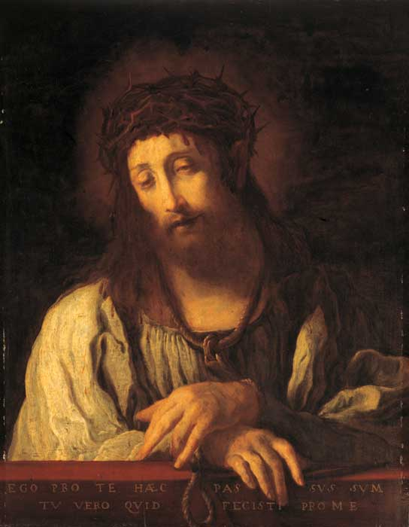
Now What
March 18, 2018
John 12:20-33
Grace and peace to you from God our Father and from the One who gave his life for you, Jesus Christ Our Lord, amen.
The picture you see on the front wall is of a painting by an Italian artist by the name of Domenica Feti (1589 – 1623). He was a very prolific artist of the late 16th and early 17th centuries. In fact, there still exists today several different versions of this particular painting is several museums across Europe. Apparently, it was a good seller for the artist because he made several of them… This specific version is located toady in Munich Germany. I bring this painting to your attention because it has changed the lives of many people and this morning I’m going to tell you about just two of them. This is Feti’s vision of the resurrected Lord Jesus. It’s called “Ecce Homo”, which is Latin for Behold The Man. I’m not sure if you can read the words the artist painted at the bottom of this painting. They’re written in Latin. The English translations reads, “This have I suffered for you; now what will you do for me?”
In 1719 a young nobleman, Count Nicholas Ludwig Zinzendorf was touring Europe and encountered this painting. It was at that time hanging in a museum in Dusseldorf Germany. There were thousands of paintings in that museum, but this one by Domenico Feti struck him forcibly, stopping him in his tracks and changing his life forever. “Ecce Homo” (“Behold the Man”) presents a very human and tender Christ crowned with thorns. But it was those words across the bottom of the canvas that stuck in Zinzendorf’s mind, “This I have suffered for you. Now what will you do for Me?” Zinzendorf stood frozen by the painting in a sort of daze. It seemed to single him out personally. Already a pious Lutheran, Feti’s challenge continued to haunt him long after his experience with this painting. He was a very rich man, living literally in the lap of luxury, having everything money could buy. Yet, because these words haunted his soul, he soon vowed to serve Christ and began a life of extraordinary service to the church and society. Zinzendorf used his extensive land holdings to offer safety to people being persecuted by the Catholic Church. One such group who came under his safety net were the Moravians. These folks were influenced by Zinzendorf’s “religion of the heart” and before his death had already sent our over 225 missionaries all over the world. Today, I look forward to the Daily Texts published by the Moravian Church and I repost them for my FaceBook friends to read and enjoy. Domenica Feti’s “Ecce Homo”, through Count Zinzendorf still affects us today, even if we didn’t realize it.
Another life similarly changed by this very same painting was a woman by the name of Frances Ridley Havergal. She traveled to Dusseldorf to cultivate her knowledge of the arts in 1852. The young woman observed a print of Feti’s painting, “Ecce Homo,” in a pastor’s study and was also moved. Christ appears humble and demeaned while the artist asks each generation of viewers, “This I have done for you. Now what will you do for Me?” Havergal remembered the painting after returning to England, and she began to elaborate on Feti’s simple request. Several stanzas later she had a poem. Havergal eventually became a celebrated writer of hymns with well over 200 credited to her, but her most famous, “Take My Life,” which we’re going to sing in a few minutes, was inspired by that moment in a Dusseldorf study as she pondered the life changing question, This I have suffered for you. Now what will you do for me?...
Getting back to our Gospel text for today, did those Greeks move beyond their curiosity and observation of Jesus to be drawn closer to him by following his way of the cross? Did they, like Nicholas Zinzendorf come to have one, and only one passion, for Jesus only? Were they moved by Jesus’ sacrificial love to proclaim the Good News to others using words of inspiration like Francis Havergal? We’ll never know because the Bible never mentions them again. Yet, by their story, we’re nudged to ask ourselves, what about us? Jesus’ response to the curious Greek seekers, and to all of us, is an invitation to something above and far beyond just being curious observers of Jesus. Being a follower of Jesus involves nothing less than the way of the cross. Life with Jesus is a life of sacrificial love. As he begins talking about his own death, Jesus speaks in metaphor and parable of a single grain of wheat planted in the ground to die there in order to give life to a new plant, which will bear much fruit—Jesus teaches us all his way of the cross and prepares us for ours too. Millions, maybe billions of people down through the centuries have discovered the truth of Jesus’ way of the cross, Zinzendorf and Havergal are just two examples.
How about you? I know you are here mostly because you have been changed by the love of Jesus Christ and this worship we participate in is our way to say thank you. It’s your way to praise the God who not only created you, but who also sustains you through all the stuff life deals out every day. Over the next few weeks we’re going to hear about the suffering Jesus willingly went through for you and me. Next week on Palm-Passion Sunday, we’ll experience the excitement of Jesus triumphant entry into Jerusalem immediately followed by the story of his passion and death. As we move through Holy Week our worship services are designed to help us experience just exactly what it was that Jesus was willing to suffer for us. If the only part of the story you ever hear is how Jesus came to Jerusalem amid shouts of praise and adoration on Palm Sunday, then you return the following week on Easter to see the empty tomb, you skip over the cost of God’s grace for you. You skip over the cross and the crucifixion. You skip over the depth of God’s real love for you. You skip over God’s actual grace.
There’s so much more to the story of Jesus than how He accepts you as you are. While that is true, Jesus does accept all people, sins and all, that’s just the starting point. Jesus loves us too much to let us stay that way—dead in our SIN. He calls and invites us to become more than observers and receivers of his love. He calls us to give up our lives as he has done for us--To give up living for myself only and to give my life to others as a living sacrifice, following His example. Seeing what Jesus gave for me, what can I give for Him?
In our world, far too many people want to know what God can do for me. Some people even come to worship service thinking they are going to receive something, a blessing, a relieved conscience, or an answer to a prayer. If that’s why you come here, that’s okay, don’t stop coming, but let me suggest that maybe Jesus is inviting you into a deeper, more satisfying relationship. Rather than coming to see what you get out of worship, may I suggest coming to worship with the attitude of gratitude, thanking and praising God for the many blessings you have already received, starting with the benefit you have by being his child. How about thanking our God for loving you so much that he was willing to become a human being with all our quirks and weirdness. Imagine Jesus sitting at the right hand of the Father in Heaven and agreeing to give up his place at the throne to come here and have to be humiliated as a mere mortal human being, let alone a human being who was nailed to a cross and murdered for yours and my transgressions. You see Jesus’ sacrifice didn’t start when he was arrested or when he was beaten or spat on. It didn’t begin with nails and a cross, no it began in heaven when he agreed to be born of a virgin and become one of the creatures. In his letter to the Philippians Saint Paul said is so beautifully, “⁵ Let the same mind be in you that was in Christ Jesus, ⁶ who, though he was in the form of God, did not regard equality with God as something to be exploited, ⁷ but emptied himself, taking the form of a slave, being born in human likeness. And being found in human form, ⁸ he humbled himself and became obedient to the point of death-- even death on a cross. (Phil. 2:5-8 NRS) Knowing what Christ has done for me, what can I do for him? What can I not do for him is more the proper question.
May Christ who is lifted up on the cross draw us ever closer to him so that like Nicholas Ludwig Zinzendorf, Frances Ridley Havergal and countless others; our passion is Jesus, Jesus only! May we be so moved by Christ’s love for us, by his passion, and by his death, that we forget about ourselves and live only for Him. May we learn to love what Jesus loves, have compassion like Jesus, and then give like Jesus gave. Amen.

