(The lost books are: Mark, Luke, Kings, Acts, Revelation, James, Ruth, Numbers, Job, Amos, Esther, Judges, Titus, Lamentations, Hebrews & Peter)

Came across this remarkable Bible book quiz while on holiday in Honolulu. Kept me looking so hard. The facts were that some answers were easy, others required some revelation. It causes quite a jam especially since the names of the books were not capitalized. But the truth will become apparent and the numbers add up. It's a real job and a most fascinating quiz. Yes there will be some that are really easy to spot. Others may require judges to help them. I will quickly admit it usually takes a vicar to find one of them and will lead to loud lamentations when it is found. A little lady says she brews a cup of tea so she can concentrate better. See how well you can compete. Relax now, for there really are sixteen names of books of the Bible in this paragraph.

ACROSS: 1, Overwhelmed. 9, Valleys. 10, Strap. 11, Top. 13, Reel. 16, To do. 17, Incite. 18, Load. 20, West. 21, Notice. 22, Wash. 23, Thin. 25, Ash. 28, Noah’s. 29, Ever not. 30, Onesiphorus. DOWN: 2, Value. 3, Reed. 4, Host. 5, Lisp. 6, Ear lobe. 7, Overflowing. 8, Opportunity. 12, Obtain. 14, Lid. 15, A cross. 19, Abstain. 20, Wet. 24, Hindu. 25, Asks. 26, Help. 27, Hero.

Readers contributions to the magazine are always welcome. Hard copy (hand written if easier) to the Rectory address or by email: to : st.marysstockport@gmail.com
Editorial discretion with regard to content and space available will apply.
St Mary’s in the Marketplace
St Mary’s Rectory, 24 Gorsey Mount Street,
Stockport, SK1 4DU.
0161 429 6564 www.stmarysinthemarketplace.com
St Mary’s in the Marketplace
“SECURING THE FUTURE FOR THE NEXT 100 YEARS” 50p

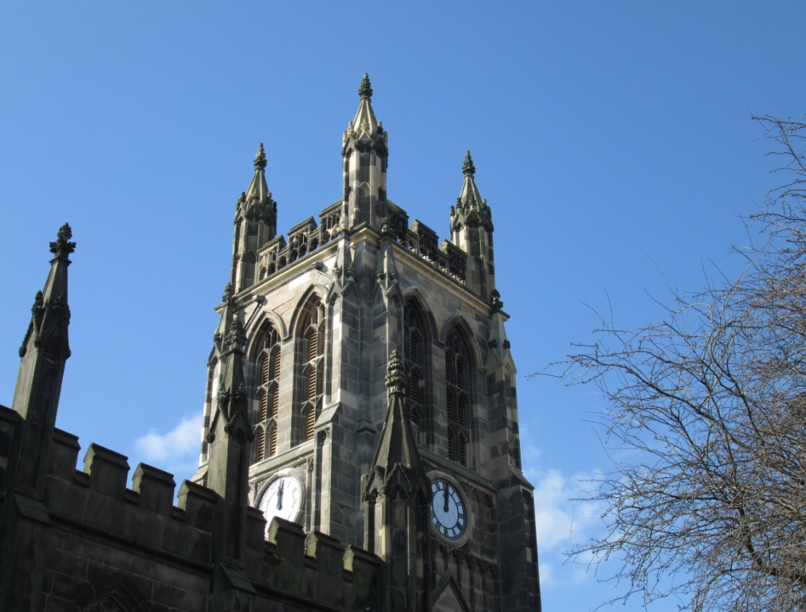

From the Rector’s Desk
Dear Reader .
.
The other day someone said – “goodness me, we are nearly halfway through the year already. It will soon be the longest day”! As I arose, at 5.30am one morning, and caught sight of a stunningly brilliant red and orange sunrise over the Pennines, away to the east. I realised how true that was. The sun had shifted from the house tops of Athens Street, to the tree tops of the north-east, in just a few weeks. ‘Tempus fugit’ – time flies!

In the course of these past months the pace of life and the changes that have come about at St Mary’s have been quite dramatic. The legacy is dust! And as someone said to me recently, “it will take time to settle”. A great deal of hard work has been undertaken, and will continue to be done by a very few, to ensure that St Mary’s looks and feels at its very best for regular services, opening days and special occasions like the wedding of Andrew and Lorna this month.

Recently I passed a hotel, or castle, I don’t rightly recall, and it had a big sign outside the gate saying simply “Wedding Venue”! This struck me as interesting. We have so few weddings, I wonder if people have forgotten, in the few years that such places have been licensed for weddings, that the traditional place for “a wedding venue” is actually a church! How much life has changed in recent years. So should I put up a sign outside St Mary’s saying “Wedding Venue”? What do you think?

Traditionally bells are rung at weddings. I very much hope that the bells of St Mary’s will be heard again very soon, thanks to the hard work and goodwill of our Steeple Keeper, Clive Carlton, who has been waiting patiently for the work on the Tower to finish. Again much dusting, cleaning and oiling and lubricating needs to be done, high up there in the Bell Chamber, before the bells can safely be rung again. The sound of the

Bite back at hunger this Christian Aid Week
12-18 May 2013
Today 870 million people are in desperate
need of food. This is a scandal.
Together, this Christian Aid Week, we can help
some of the world’s poorest families get enough
to eat. For good.

Our efforts may be a drop in the ocean – but we are supporting THE SUPER SOUP LUNCH on Tuesday, 14th May at St Mary’s. We will be serving soup and a roll for just £1.00 per serving – all proceeds to Christian Aid.
Every serving of soup matters – every contribution helps. Come and join us – enjoy a light lunch and stay to the lunch-time service to be taken by Rita Waters (Reader) who will also be making and donating home-made soup to be served over this special lunch-time.

Dates for the Diary

Sunday, 2nd June

The Big Lunch St Mary’s in the Marketplace

Ready or not (and probably not) “The Big Lunch” will be held at St Mary’s this year following the success of our first “Big Lunch” held last year at St Andrews in celebration of the Diamond Jubilee. We may not have all the new furniture and the kitchen may not be fully equipped by then, but we will manage …
Pop the date in your diary – further details to follow shortly.

Sunday, 9th June

Civic Service St Mary’s in the Marketplace

The Mayor and Mayoress Elect, Cllr Chris Murphy and Mrs Dorothy Murphy invite you to attend their Civic Service to be held at 10.30am on the 9th June. We are delighted to have with us for this special service The Rt Revd Dr Peter Forster, Bishop of Chester and students from St Paul’s CE Primary School, Brinnington.

bells, ringing across the Market place, and indeed across Stockport is a wonderful sound, and one that has been sadly absent for 7 years.

The other aspects of St Mary’s outward appearance in recent days, since the completion of work on the Tower, which have been commented on, have been “a clock that is not working and a flag that is not flying”. The clock needs a complete overall. It is a “Town Clock”, which means that the Council is responsible for its maintenance. It is a sizable undertaking and is having to be given due consideration before the work is done. Hopefully the clock will be keeping perfect time, as before, in the near future., As for the flag of St George which has indeed not been flying proudly from St Mary’s since last year, the reason for this is simple – the halyard was delivered incomplete, and I dare not risk putting up a very large flag without everything being “shipshape and Bristol fashion”. We all look forward to seeing the flag flying again from St Mary’s.

In a recent sermon the Bishop of Stockport described vicars in three ways – as “undertakers, caretakers and risk takers”. The first are those who see their task and ministry as seeing their congregation safely off into the next life; the second are those who see themselves as primarily concerned with caring for the church, its buildings and its property; and the third are those who takes risks, for the sake of the Gospel. It made me smile, because I could tick the first two boxes, but was uncertain about being a risk-taking vicar. “Thank you, Bishop for reminding me!”

Now that St Mary’s has been completely re-furbished, and given a new look, ready for the 21st Century, I am sure that it is the right time for there to be a RISK TAKING VICAR/RECTOR. Jesus often said to his disciples “Do not be afraid” – and indeed the prophets of the Old Testament said the same “Do not fear”. Do I hear someone say “Go for it Rog!”? This seems the only – and the right way forward, as we move inexorably towards the longest day!
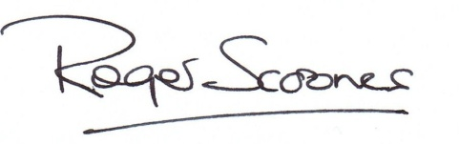
Yours prayerfully

A Standard for loving
(Based on 1 Corinthians 13 – by Rev John Hastings)

A loving person never loses patience with people,
but is always at their service.
A loving person isn’t envious of anyone,
or disrespectful toward anyone.

People who really love never boast,
never consider themselves more important than others
and never do anything for selfish motives.
They don’t take offence
or keep a score of wrongs done to them.

A loving person doesn’t revel in people’s misdeeds,
but only enjoys what is right and true.
A loving person forgives others without limit,
encourages them by placing confidence in them
and never gives up hope in them.

Loving people is something that can never come to an end.
Where everything else falls short
and when everyone else has given up,
the loving person still goes on loving.

Lost Bible Books

(There are sixteen Bible books somewhere in the following paragraph. Can you find them?)
Came across this remarkable Bible book quiz while on holiday in Honolulu. Kept me looking so hard. The facts were that some answers were easy, others required some revelation. It causes quite a jam especially since the names of the books were not capitalized. But the truth will become apparent and the numbers add up. It's a real job and a most fascinating quiz. Yes there will be some that are really easy to spot. Others may require judges to help them. I will quickly admit it usually takes a vicar to find one of them and will lead to loud lamentations when it is found. A little lady says she brews a cup of tea so she can concentrate better. See how well you can compete. Relax now, for there really are sixteen names of books of the Bible in this paragraph.

---------------------------------------------------------------------------------
The Mayoral “seal” of approval
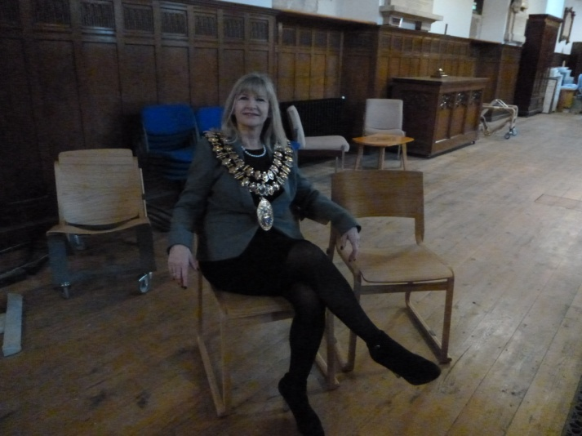

Trying them for size – Cllr Wendy Meikle – Mayor of Stockport – has a look at the Chorus “Theo” chairs, now on order for use at St Mary’s.

Across
1 Overpowered (Deuteronomy 11:4) (11)
9 ‘The — are mantled with corn’ (Psalm 65:13) (7)
10 ‘Each man—a sword to his side’(Exodus32:27)(5)
11 On the death of Jesus the curtain in the temple was torn from— to bottom (Matthew 27:51) (3)
13 Stagger(Isaiah 28:7)(4)
16 ‘Anyone,then,who knows the good he ought——and doesn’t do it, sins’ (James 4:17) (2,2)
17 Stir up or provoke(Acts13:50)(6)
18 Burden(Luke11:46)(4)
20 ‘As far as the east is from the—,so far has he removed our transgressions from us’ (Psalm 103:12) (4)
21 Sign(Luke23:38)(6)
22 ‘After that,Jesus poured water into a basin and began to—his disciples’ feet’ (John 13:5) (4)
23 The nature of the seven ears of corn which swallowed up the good ears in Pharaoh’s dream (Genesis 41:23) (4)
25 Has(anag.)(3)
28 ‘This is the account of Shem,Ham and Japheth,—sons’ (Genesis 10:1) (5)
29 ‘I will...make them drunk,so that they...sleep for—and— awake’ (Jeremiah 51:39) (4,3)
30 Paul said of him,‘he often refreshes me and is not ashamed of my chains’ (2 Timothy 1:16) (11)

Down
2 Worth (Matthew 13:46) (5)
3 ‘A bruised — he will not break’ (Matthew 12:20) (4)
4 ‘Suddenly a great company of the heavenly — appeared with the angel’ (Luke 2:13) (4)
5 Slip (anag.) (4)
6 ‘Take an awl and push it through his — — into the door, and he will become your servant for life’ (Deuteronomy 15:17) (3,4)
7 Bountiful (2 Corinthians 8:2) (11)
8 ‘Therefore, as we have — , let us do good to all people’ (Galatians 6:10) (11)
12 Acquire(2Timothy2:10)(6)
14 Container cover(Numbers19:15)(3)
15 ‘He...became obedient to death,even death on——!’ (Philippians 2:8) (1,5)
19 Refrain(1Peter2:11)(7)
20 ‘She began to—his feet with her tears’(Luke7:38)(3)
24 One who worships Brahma,Vishnu or Shiva(5)
25 ‘Give to everyone who—you’(Luke6:30)(4)
26 ‘I lift up my eyes to the hills;where does my—come from?’ (Psalm 121:1) (4)
27 One of those whom the Lord said would be taken from Jerusalem and Judah as judgment on them (Isaiah 3:2) (4)
May 9: Ascension Day - 40 Days with the Risen Christ
40 days after Easter comes Ascension Day. It may seem crazy to call it Eastertide when Easter is clearly over! - but these are the 40 days during which the Risen Christ appeared again and again to his disciples, following his death and resurrection.
The Gospels give us little of Christ’s teachings and deeds during those forty days. Jesus was seen by numerous disciples: on the road to Emmaus, by the Sea of Galilee, in houses, etc. He strengthened and encouraged his disciples, and at last opened their eyes to all that the Scriptures had promised about the Messiah. Jesus also told them that as the Father had sent him, he was now going to send them - to all corners of the earth, as his witnesses.
If you want to add more detail to Christ’s appearances, the stories can be found in Matthew 28; Mark 16; Luke 24; and John 20.

May 19: Pentecost/Whit Sunday – the birthday of the Church
Pentecost took place on the well established Jewish festival of Firstfruits, which was observed at the beginning of the wheat harvest. It was exactly 50 days after the Passover, the time of Jesus’ crucifixion.
A feast day to celebrate the country’s wheat harvest does not sound exactly world-changing, but that year, it became one of the most important days in world history. For Pentecost was the day that Jesus sent the Holy Spirit - the day the Church was born. Jesus had told his apostles that something big was going to happen, and that they were to wait for it in Jerusalem, instead of returning to Galilee. Jesus had plans for his apostles – but he knew they could not do the work themselves – they would need his help. And so the apostles and disciples waited in Jerusalem, praying together for several days. And then on that fateful morning there was suddenly the sound as of a mighty rushing wind. Tongues of flame flickered on their heads, and they began to praise God in many tongues – to the astonishment of those who heard them. The curse of Babel (Genesis 11: 1- 9) was dramatically reversed that morning.
That morning the Holy Spirit came to indwell the apostles and disciples of Jesus: and the Church was born. The Christians were suddenly full of life and power, utterly different from their former fearful selves. The change in them was permanent. Peter gave the first ever sermon of the Christian church that morning: proclaiming Jesus was the Messiah. His boldness in the face of possible death was in marked contrast to the man who had denied Jesus 50 days before. And 3,000 people responded, were converted, and were baptised. How’s that for fast church growth! Of course Pentecost was not the first time the Holy Spirit had acted in this world. All through the Old Testament there are accounts of how God’s Spirit guided people and strengthened them. But now, because of Christ’s death and resurrection, he could INDWELL them. From now on, every Christian could have the confidence that Jesus was with them constantly, through the indwelling of the Holy Spirit.
May 19: Dunstan - the abbot who restored monastic life in England
In this month of Vocation Sunday, Dunstan (909-988 AD) stands out as an example of what just one person can achieve when they follow the call of God on their life. Dunstan was born near Glastonbury, of a noble family with royal connections and church connections; his uncle was archbishop of Canterbury. But in 935, at the age of 26, he was accused of ‘studying the vain poems of the pagans’ – and expelled from court. He nearly married, but instead made private monastic vows and was ordained a priest by Elphege, bishop of Winchester. Dunstan felt God’s call on his life, and responded. That decision was to shape English history. Not at first, however. For Dunstan began his priestly life by simply returning to Glastonbury and living as a hermit. He painted, embroidered and did metalwork. But when in 939 Edmund became king of Wessex, he recalled Dunstan and made him abbot of Glastonbury. The monastic life of the country was all but dead: the Danish invasions and the hostility of local magnates had seen to that. Dunstan set out to change all this, and went on to restore monastic life in England, under the Rule of St Benedict. Down the years, Dunstan saw kings come and go: Edmund, Edred, Edgar, Edward. Under King Edgar Dunstan was made bishop of Worcester in 957, bishop of London in 959, and archbishop of Canterbury in 960. Thus was born a fruitful collaboration between King and Archbishop which was to reform the Church in England. Monastic orders began to thrive once more. After the Conquest, the days of Dunstan would be looked back on as the ‘golden age’. Dunstan was zealous for the faith. He taught, prayed, fasted, repaired churches, acted as judge, inspired national laws of the land, made sure taxes were paid, and encouraged his monks in their manuscripts and prayers. He remained active right to the end of his life: he preached three times on Ascension Day 988, and died two days later, on 19 May, aged nearly 80.
They wrote of him: he was without doubt “chief of all the saints who rest at Christ Church’ (Canterbury). It has been well said that the 10th century gave shape to English history, and Dunstan gave shape to the 10th century.
A Happy Coincidence
Each year there is a crisis – behind the scenes – as to which school is going to be willing and able to take part in the Annual Civic Service at St Mary’s. It’s a worrying time, because schools are so busy, and extra-curricular activities – especially at weekends are difficult to organise.
This year, however, there has been no hint of crisis. The Mayor-elect Cllr Chris Murphy instantly nominated a school of which he is a governor, St Paul’s CE Primary. The Head Teacher, Mrs Julie Bottomley and her Deputy Head, Jo Harrington, who are familiar with St Mary’s, accepted this invitation without hesitation. The service is now planned and in the process of being prepared, as always to make that a special and happy occasion for the Mayor and Mayoress, and for the school children involved, and of course for the congregation.
By a happy coincidence Rita Waters, Reader at St Mary’s, who will be sharing in the service, leading the prayers, is a past pupil of St Paul’s School, and she was very happy to return to school recently to meet the Head Teacher. This is what she said of St Paul’s “It was lovely to go and see the changes from when I was at school. It was very small in those days, So much progress has been made. It seems a very warm and pleasant place – a very vibrant school. A very happy school, I’m looking forward to them coming to St Mary’s and being part of the service myself”.
A happy coincidence indeed.

Mayor-Making
Each year there is enacted in the splendid Edwardian Town Hall Council Chamber a handing-over ceremony which few see, except for the result of it. A new Mayor of Stockport receives his or her great chain of office, resplendent in gold and enamel decoration, and the Past Mayor steps down from the chair of office to make way for the new Mayor, who then proceeds to chair the Councils affairs for that meeting and the coming year. The result is that you see a Mayor and chain, going around the Borough. Throughout the year, giving dignity to the Office of Mayor and acting as our leading citizen, besides being a focus for the name of Stockport Metropolitan Borough Council. On May 21st, Councillor Chris Murphy will be made Mayor with Dot his wife as his Mayoress. We look forward to welcoming them to St Mary’s for their Civic Service on Sunday, 9th June. And we do not forget to thank Cllr Wendy Meikle for her public service and goodwill in her past-mayoralty year of office! Roger will once again serve the Mayoralty as Mayor’s Chaplain for the coming year
All Change!
Andrew Lythall has been serving Curate at St George’s for the past three years and has now moved across the road to be Vicar of the neighbouring parish of St Albans with St Thomas. This has left a larger than usual gap in the “ministry team” at St Georges, owing to the retirement in December of Rev. Alan Bell, their vicar. Having undertaken regular services of Holy Communion at St Albans during their Interregnum, Roger as Rector will now “change places” and beginning a short spell of conducting services at St George’s during their “Interregnum” in order to help out the two retired clergy still in place. The new Vicar of St George’s, announced last month, . Rev. Canon Elaine Chegwin-Hall, is thought to be arriving in September. It’s “all change” in Stockport Deanery. Meanwhile Roger will continue to take Holy Communion Services at St Luke’s, Brinnington during THEIR Interregnum. He is very grateful to Rita Waters and visiting clergy for their help and support during his absence in these Parishes, and also while he is on holiday.
New Trees
The Mayor of Stockport attended St Mary’s recently to plant, a tree to mark the Queen’s Jubilee.
Our Jubilee tree has to wait for the work to be completed outside and for the right time of year for planting.

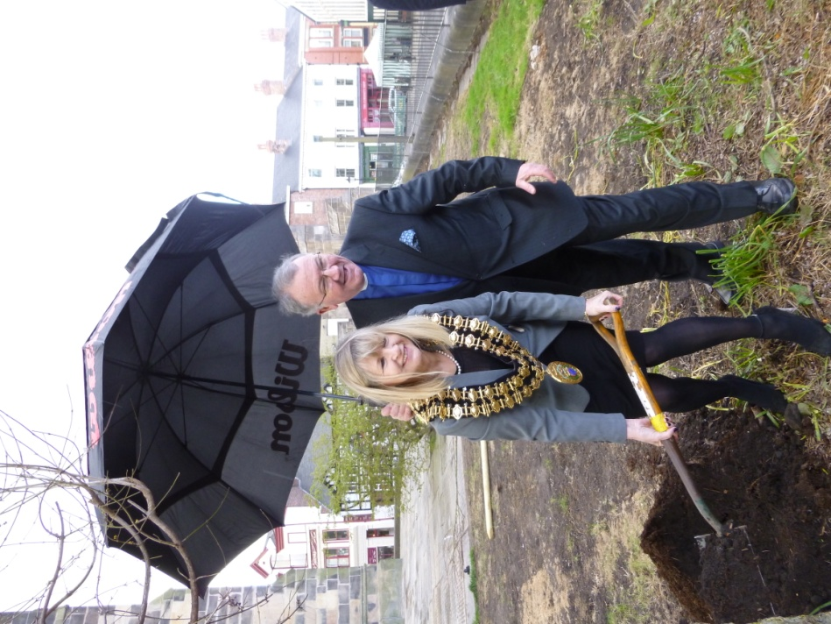

The Council have actually planted EIGHT new trees at various locations and we look forward to further maintenance work taking place in the graveyard later in the year.

