

Spring Newsletter 2022



Tl’etinqox Government

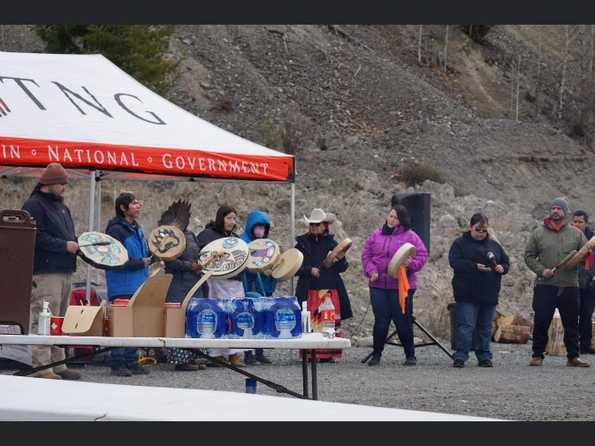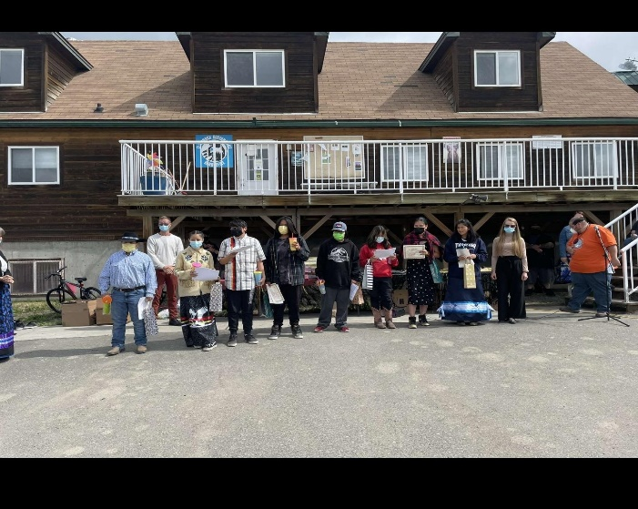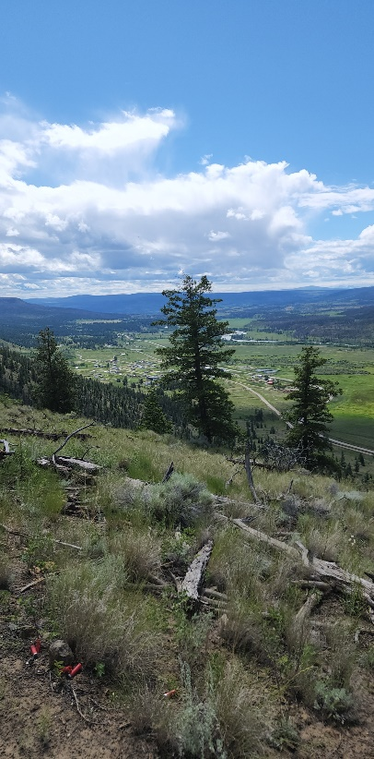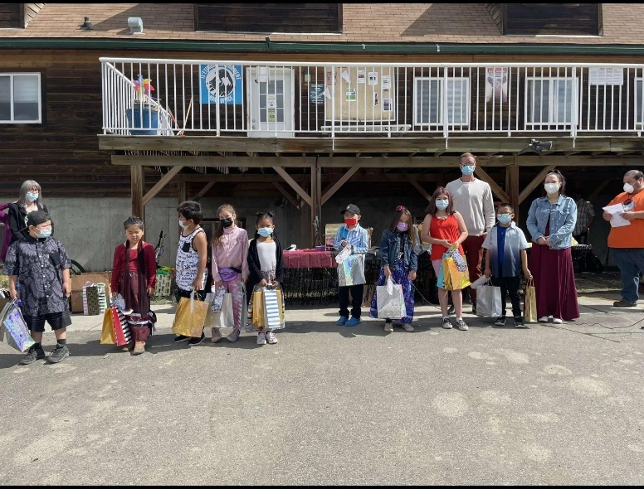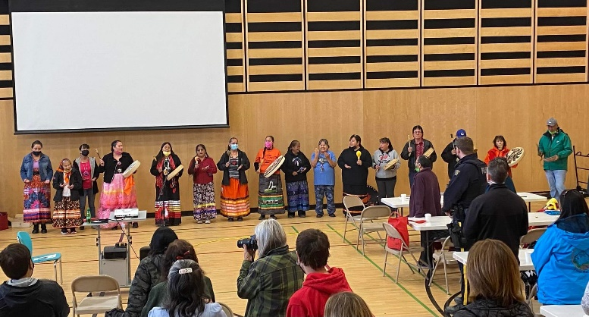

Unfortunately, Chief Joe has been super busy with political activities and was not able to get his update in by the time this newsletter went to print. Chief Joe will give a general update to community during the July 20, 2022 community engagement sessio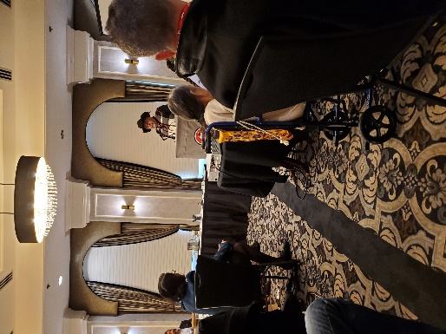n.

*Chief Joe’s Update*

*Executive Director Update*

Hello Everyone,

Thank you for reading my community update. It is really important to me that community understands how much good things your staff are doing for the community, so I hope that seeing the seasonal newsletter gives better insight to all the wonderful things we all do here for you! 😊

Some recent updates:

**Regina Workshop:** In June I went to Regina to attend a workshop with the Cowessess First Nations to learn what they have been doing in regards to their Child and Family Services. I learned that Tl’etinqox is on the right track to taking back jurisdiction over our children in care. It was a really inspiring trip and I want to extend a big Sechenalyagh to TNG for inviting and funding Angela, myself, and our Social Work practicum student Priscilla Gilpin to attend this important invent.

**New funding applications:** I recently applied for the 10-year infrastructure gap grant in the amount of 60 million. It does not mean we will get 60 million from the grant, but I asked for everything I could think of. The grant came to me in an email and had a short deadline (a few days). I worked with Urban Systems (our engineers) and got the grant done in the nick of time. I asked for 60 new homes, 150 renovations, paved roads, a proper water and sewer system at the meadow, among many other things. Please see the spreadsheet attached for more information.

• Recently some funding opened up that could be used for capital purchases such as for vehicles. I have applied for 2 new SUV’s for the Social and Justice department so that our employees can take clients to scheduled child and family meetings, attend court with clients, and be in a marked TGO vehicle for the purposes of business.

**Old Funding Updates:** I still need to work on the custom elections process. It has been on my mind to deal with but it has been so busy since the province lifted the restrictions. I would like to start with some small community engagement sessions and do a few online ones to accommodate out-of-community members and those who wish to be online rather then in person.

• The survey I talked about in my last update is finally complete and we are now approaching the government for funding for the boardwalk to the river! It is really exciting to be venturing towards active tourism and it could lead to us creating bike trails, snow shoe trails, cross country skiing trails and having a “library” where all this equipment can be borrowed by community members to use on those trails.

**Reminder:** *just a friendly reminder, we are still requiring masks to be worn in all our buildings in order to ensure the safety of everyone. Staff are continuing to rapid test every other day in order to protect everyone in our offices*

**Policy Development update:** We went to Kamloops in March for a staff workshop. We wanted to Indigenize our Human Resources manual to align with our values as Tl’etinqox-T’in and gathering together to concentrate on that work for 3 days was essential to the development of that document. Important sections will reflect and will align more with our culture, values, and traditions.

Exciting new ventures: we are currently in the process of developing an APP with the Nautswat Tribal Council that will allow community members to download the app onto their smart phones and instantly be notified of events, postings, emergency alerts, and have easier access to important information all the tips of your fingers!

**Community Engagement session**: Staff are excited to have our first in person meeting with community members on Wednesday July 20th! The purpose of the engagement is to showcase all the updates from departments about what they have been up to, what is new, and answer questions community may have. Unfortunately, we don’t have a finance manager anymore so there won’t be a financial update, however we are offering to take emails of community members and we will provide 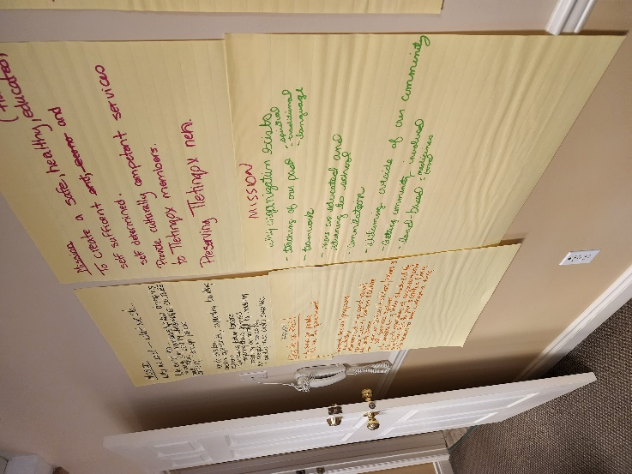an emailed copy of the 2022 audit when it is completed. The purpose of having it in a “world café” style is so that all staff have tables and are able to engage one on one or in small groups to talk about what it is that they do. It gives staff the chance to really dive into details about what it is that they do, instead of graze over the topic in a formal presentation. We want to see how this format works, if its successful then we will continue to host meetings in this manner, but if it doesn’t work then we will try something else.

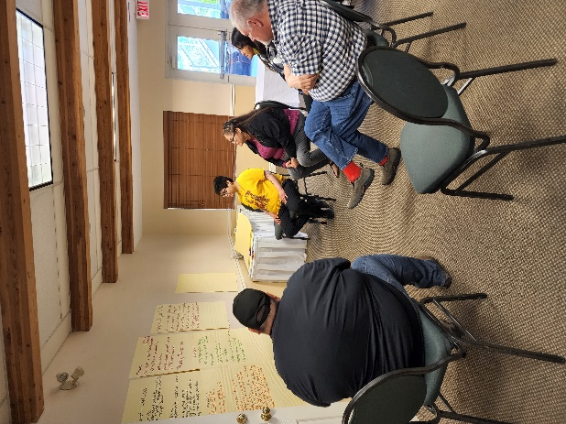Overall, administration is quite the busy position and its very rare that I have nothing to do. I oversee all projects in community and oversee all employees under TGO. I did not think my position would be as hectic as it is, so if you call and I am not available please leave a message for me to call you back because it is hard for people to catch me at a good time. I usually have to return calls after 4:30pm most days.

I hope that you and your family enjoy the summer holidays and take in all the culture camps we have planned throughout the season. It is definitely nice to see community again!

Sechenalyagh,

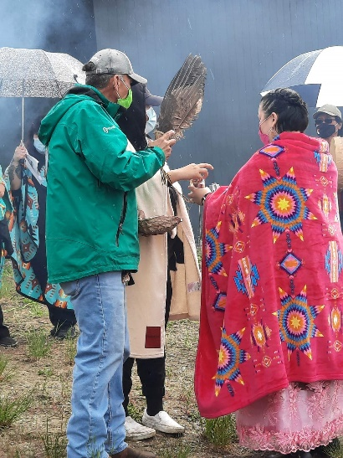Ashton Harry

The above are some pictures from our staff workshop in March 2022

*Tl’etinqox Administration*

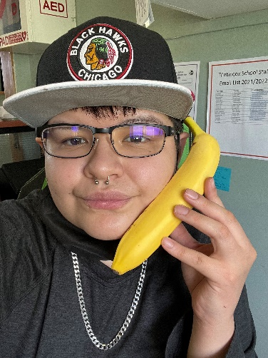

My name Is Denelle Noskiye and I grew up in Tl’etinqox. I have been the receptionist since August 2021. This new year we have upgraded our phones in the offices! On top of my receptionist duties, I am the Executive Director’s Assistant and have completed training regarding this new position.

Unfortunately, our office remains closed to the public. I look forward to the day we are open to the public again! Sechenalyagh

*Nen Coordinator*

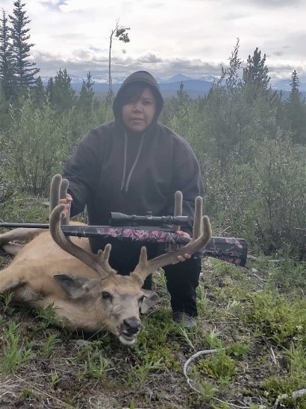?Eghughtelug! Hunilhtah? Sid Se?anest’ah. Sid Seghuzi Allison Charleyboy selh sedah. Se?aba Alvin Frank sedah. Se?inkwel Annette Frank sedah. Se?intsu Emily Frank belh Marie Dick (Malizini) Ja Xili. Se?intsi Mack Frank (Mack Andy) belh Eddie Dick Ja Xili. As of March 2022, I am the new Nen Coordinator for Tl’etinqox. Since I have started, it’s been busy and exciting at the same time. Started off with the Nen Retreat, meeting the other Nen Coordinators, did some GIS Training (learning how to prepare online/offline mapping). Attended a lot of meetings so far, (Forestry, Nen, Beringia, Invasive Plants, etc.), also assisted with ceremonies to heal the land/waters. Gathering old stories. I helped with the Archaeologists over at Tsiyi (Bull Canyon), found some artifacts, it’s incredible to hold something that our ?esggidam (Ancestors) have held 100 years ago. As I always say, I have learned a lot in my life, but I still have a lot to learn (Jigwedes’ax). I am excited to reconnect with our Elders soon, I would love to hear about our history and the stories you are willing to share. I am also on the Tsilhqot’in Women’s Council, representing Tl’etinqox, for well over a year now. Enjoying that role as well, it’s a good learning experience. I am open to any ideas so, don’t hesitate to call me at the Tl’etinqox Government Office. Can’t wait to see you all in the months to follow. Until then, take care and don’t forget to keep hydrated.

Question of the Month…Do you have a Traditional Name? If so, what was it?

Looking forward to hearing from you all.

Sechanalyagh Gulin.

Allison Charleyboy

*Housing Update*

Gwetaʔaghunt’i (Good Day),

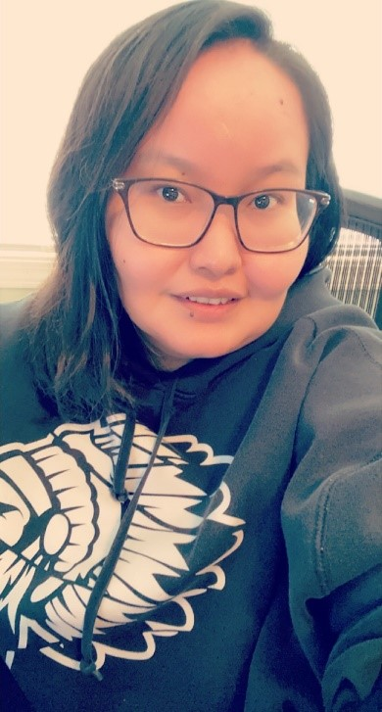Hope you are all enjoying your summer so far, with all the rain we been having. So far working as a Housing Clerk I’ve completed 23 different course that have to do with housing, some were short courses. An upcoming course I will be taking will be in September. We will be doing assessments on houses with BC Housing & other housing managers from surrounding communities. So, by September we will be picking 6-7 houses to assess, notices will be handed out ahead of time to which places are picked. So, every year we can start doing our own assessments on houses in the community. Also, for the maintenance fee agreements & Rental Agreements I haven’t seen much come in. So far, I’ve seen 13 for maintenance fees that need to be paid monthly. For rent there is 26 places, all subdivision area has to pay rent. Rental agreements have to be resigned every year. The houses in the community are 146 houses & so far with maintenance fee & Rental agreements signed are 39 houses. If maintenance and/or Rental agreements aren’t signed maintenance can’t be done on the house. If you are on social assistance papers can be signed with your Income assistance Worker or with me at the Tl’etinqox Government office. Rental Agreements for the subdivision can be signed with me. Septic tank cleaning will be done in August. Only those who are up-to-date on maintenance fees/rental agreements and paper work will be done.

*Operations & Maintenance*

You can contact me at the office

(250)394-4212 ext. 242 or by email housingclerk@tletinqox.ca

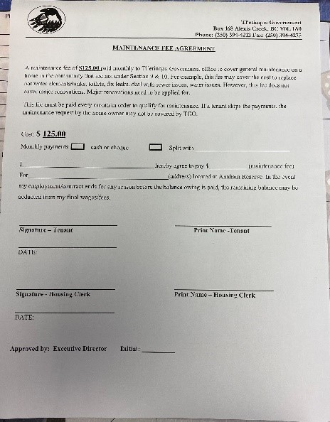Sechenalyagh

For some of the roads, we are working with AKC contracting on fixing certain roads where there were some bad washouts/muddy sections in the spring/putting in ditch lines and making them more snow plow accessible in the winter.

For upcoming summer months it’s very important please remember to use the community water wisely, when misused everyone else is affected.

If anyone happens to see any source of water coming from the ground, please report to the office ASAP.

Hope all is well and looking forward to summer months. “Hopefully not too hot”

Stay safe everyone!

Tyron

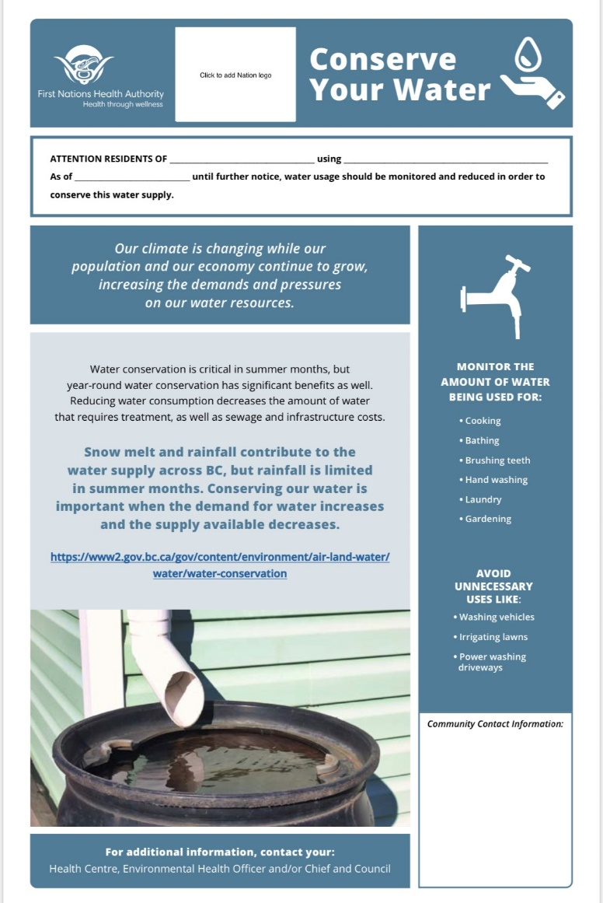

*Fleet Update - Eleanor*

I am in charge of all Tl’etinqox Government Fleet: Tl’etinqox School, Tl’etinqox Health, Tl’etinqox Band and Dechen Ventures.

Every Spring and Fall of each year are the busiest times so from January-March/July-September all the school buses & van, Health buses, band dump truck, water truck, Dechen Logging trucks all have to have (MVI) Motor Vehicle Inspections every six months as per Motor Vehicle Act & ICBC in order for fleet to be insured and work with (CVSE) Commercial Vehicle Safety and Enforcement. I have to make appointments at the shops for all the Fleet and find qualified drivers which sometimes can be challenging, I at times have to hitch hike to either pick up or drop off fleet.

In between, if any of the fleet have mechanical issues or break downs, I first call the shops to see what is available then call tow trucks to let them know location & type of vehicle so they bring the appropriate rig to haul to the shop, I sometimes head out with the tow trucks to make sure they find the vehicle which can turn out to be an all-day event. Any accidents or incidents I deal with the body shops and ICBC depending on the damages and take pictures & reports from drivers. On top, I help with Dechen First Aid Trucks-order medical supplies and often have to make emergency runs for parts or medical supplies. My general duties are to schedule maintenance and repairs on all fleet.

**SAFETY TIPS:**

How to protect yourself during a Road Trip: by Johnnie Gall

➢Don’t advertise your travels to widely; especially, on social media and if you are travelling alone. Please let your family or friends know when you arrive at your destination.

➢Wear sunscreen.

➢Keep bumper stickers to a minimum-makes you a target for thieves.

➢Be aware of your surroundings; especially, at night when getting out of the vehicle.

➢Have a secret storage place.

➢Pepper spray.

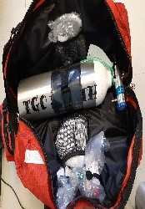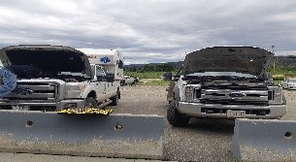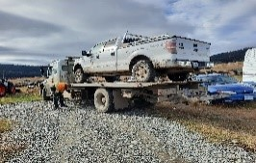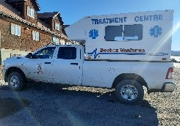➢Don’t just “hide” your key in the gas cap or hitch-be creative.

*Social Services Update*

Happy Spring/Summer all!

First of all, we are really excited to have Priscilla Gilpin join our team as a practicum student who is expected to transition to the social worker role here at TGO! She will be helping in the next few months helping develop and implement programs, create policies and be assisting me with supporting families.

The first policy we are drafting is a cultural humility policy for the social services/justice departments for community partners, outside agencies and peoples who aren’t from the local area. The reason for creating this policy is to reduce differences, increase similarities and to educate and incorporate cultural awareness/inclusion for the meaningful work we assist families with.

Over the winter months we completed the “Indigenous Governing Body” piece for children and families which falls under the new federal act respecting First Nation, Inuit, and Metis children and families. This requires MCFD to give us the opportunity to increase preventative support to families prior to intrusive/court involvement. We were the 6th out of 10 active IGB agreements province wide which is a huge accomplishment.

The TGO social services department is also collaborating with Denisiqi to host a Nation-based family care home training and community members are encouraged to sign up by contacting Jacquelyn at Jacquelyn@denisiqi.org or 250-392-6500.

*Social Services Continued*

I look forward to the upcoming community engagement meeting on July 20th 2022 and providing more information on how our department can assist on and off-reserve community members!

Respectfully,

Angela Giovanelli

Happy Spring Tl’etinqox!

Ok so we could do without the cold weather and the wind and begin to get a little more sunshine.

I have been busy helping community members with Provincial Court, Indigenous Court, Probation appointments and Restorative Justice.

There has been lots of planning going on for a very busy summer for all of us. Keep on the lookout for 2 new programs happening this summer – Making Matriarchs and Become a Warrior – invitations and posters will be sent out shortly to give everyone in the community the opportunity to join in.

We in Social Development have been very lucky to have Practicum Student Priscilla Gilpin join us for the next few months. Priscilla has hit the ground running and is such a welcome addition to the programs. Priscilla has begun teaching beading classes for the Monday night Women’s Groups.

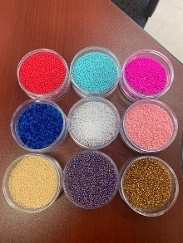

So far, we have completed Pop Sockets for our phones. Priscilla has load’s more projects set out for us during the next few months – wristlets, earrings, key chains!

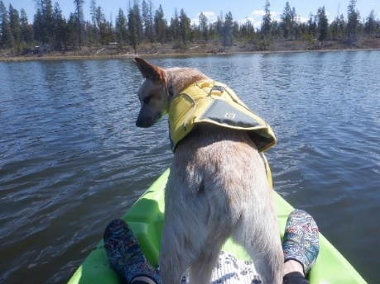 If there is a craft that you would like us to share with you, please give us a call at 250-394-4302 and tell us about it! We want to hold sessions that are of interest to you!

It is time to get back out onto the land and enjoy the wildlife, lakes, mountains and trees. I have already been out on the lakes with my trusty sidekick Ruby and our new ride!

I got my new kayak at Canadian Tire where there was a wide variety of kayaks for both children and adults. There are kayaks specific to fishing or just touring around on the water. Please remember to also get yourself a lifejacket if you think this is an activity for you! Safety first every time!

If you have any questions or suggestions feel free to give me a call at 250-394-4302.

Get ready for an exciting summer!

Sechenalyagh,

Kelly Feldinger

Justice Coordinator

*Equine Program*

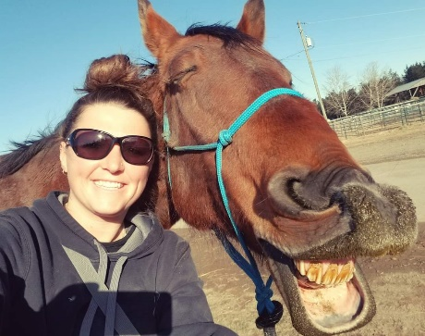

My name is Paula Splichal and I am thrilled to be a part of the equine program in your community. I'm originally from Vancouver, but my love for horses and the open country brought me to Teepee Heart Ranch over 8 years ago. Since then, it was my dream to live out here and continue to somehow incorporate horses into my career. Over the years I've traveled all over the lower mainland colt starting, which eventually took me to the Chilcotin and then Alberta, and now back in BC. My path brought me here, and I truly believe this is where I am supposed to be. For all the children in the community who haven't been around horses, I hope to see you down at our grounds. And for all the children who are already in our program I hope to play a part in reaching your goals with these magical animals. Looking forward to riding with you ❤️

*Indian Registry Update*

I’ve been working at home a bit more as for the COVID Testing & protocols. My son, Chili Frost had covid so had to stay home for ten days. I went camping at Till Lake with my ?Aba on May long weekend and as the weather wasn’t as great cold windy even a bit of snow, I caught a cold I did not have covid but as per protocol had to stay home. A few times my daughter was sick so had to stay home. My apologies if it was frustrating to get a hold of me.

I’m generally in the band office Monday & Tuesdays until 2:30pm only and then can be reached in town via cell 250-302-1252.

I’m so grateful summer is here, I’m not sure yet when I will take time off as I really enjoy camping out west with my family. I will let our receptionist know so she can let you know when you call. There are always forms I gave her up front for the days I am not here.

Hope you all have a great & safe summer!!

Trudi Frost

Indian Registry Administrator

*Health Updates*

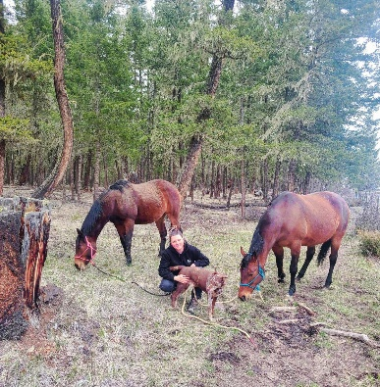

My name is Dr. Mitch Verde and I am the Health Director in Tl’etinqox. Recently, I have joined the Human Resources Team on an interim basis. Before you phone me and ask about your sore back, I am not a physician, but I do have a Doctorate in Psychology. I have been the Health Director for close to three years now and I have been honored to serve this community. Due to the high rate of vaccinations for Covid-19, and the use of rapid testing, we are steadily moving towards normalizing our community services. You have probably noticed an increase in the programs and services that we offer. Keep a look out for our upcoming healing and culture camps. In addition to our regular health programs, we are once again operating our Riverside Garden and have expanded it to include a berry section and the beginning of our orchard. We have also started a three-year program focusing on harm reduction, and due to climate change making summers hotter, we will be loaning air conditioners to homes where Elders live. While we work towards normalizing our services, our goal is to improve them over what we have offered before. Our nursing program is constantly improving, and we recently hired new Youth Workers and an additional Community Wellness Worker. I encourage members of the community to take advantage of upcoming educational programs that will allow you to eventually join the Tl’etinqox Health Team in supporting the health and wellness of our community.

Hi I’ve been here for a couple of years. I help with what is needed and Answer phone calls and direct callers to the right person. Provide assistance to patients and visitors when they arrive at the THS. Schedule appointments based on Dentist availability, Physio, Footcare, Vaccine clinic’s, Healer, Immunization, Mammogram, Medication picks up. Call patients to remind them of upcoming appointments and the team I work with is the health. I also anything is needed for the Dentist (Dr.Constabel). I’m the Dental Assistant for the Dentist Dr.Constabel she is in the community for three days or more if it’s needed. I also work with the Nurse’s Gabriella Realff RN, Fay Breck RN and Flora Stump HCA, Tina Stump HCA, Cybill Pigeon Receptionist, Tyler Judd Physio, Foot Care, Covid-19 Vaccine clinic’s, Workout gym, Cameron Energy Healer, Immunization, Mammogram, Garden work, Cook for Staff or community.

*Health Continued*

Audrey Poucette (Stump, Billyboy)

Hello my name is Deanne Case and I was just recently hired as a community support wellness worker. I was raised here in Tl’etinqox and I am the youngest child of the late Stephen and Elsie Hink. I have two older brothers and an older sister who resides over in the Stone community. I am married and a mother of six children. I have worked for Tl’etinqox School for one school year and I moved on and accepted a job with Dawson Road Maintenance. I worked for Dawson Road Maintenance for 15 years. I decided to leave my job to seek employment here at home. My plan was to come back and work for my community. This is something new to me to be working in an office as my previous job was labour work and outdoor work. I am looking forward to the new experience and helping and assisting community members.

Deanne Case

Community Wellness Worker

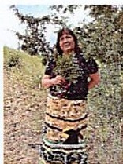Hi everyone! Time for the newsletter again. I'm working at Tl’etinqox Health Clinic. Tina Stump and I, we are the health care aides working under two Registered Nurses (RNs), Fay Breck and Gabriella Realff. They give us a list of eider's names and/or diabetic clients. We take vital signs and blood sugar levels and report them back to the RNs. If we are concerned about anyone, we report this back to the RNs too. I pick up clients for appointments at the health clinic if they do not have a ride. Please call the clinic if you need a ride. So far, I'm enjoying working with the nurses and love visiting the elders, checking on them, and doing their vitals.

Gwetaghunt?I

Flora Stump, Home Care Aide

Awwwh…at last it’s Spring!

The Healthy Coping Groups filled up fast were hosted evenings and lunch hour for 12 weeks with mostly home-made meals, door prizes and tips on various topics such as Sleep Hygiene; Goal Setting; Nutrition etc.

We attempted to reach out with some services around food to help people stretch their dollar farther. Although people signed up for the Good Food Box, the commitment to pre-pay needed encouragement. Also, we tried ‘Reaching-out’ to households with a home cooked meal once a month, which did get a good response. A contest to name the Women’s book club was held, and named ‘Great Minds-Read Alike’. There was some response, but not enough to host the club. It was agreed to target for six in the group in order to stimulate conversation. It was thought the club might like to start on a grief and loss journey reading and journaling the book by Bev Sellers, titled ‘They Called Me Number One.’

*Old Hospital Data Collector*

It was decided to offer the choice of starting these services in the Fall, depending on the responses from community members. Meanwhile, I continue to grow the counselling practice with community members. For those who are on their healing journeys Cecil, Angie and I are hosting a Medicine Collecting day to collect Sage and Indian Tea, with lunch for those engaged with Mental Health Supports. Other departments have asked for connecting in this way, and we are planning to organize with the kids/teachers at the school. Of course, if anyone else would like to be supported, please let us know. Remember too anyone can ask for the medicine stored at the Sage Health Centre.

I have been asked to join as guest speaker for Mental Health at the Men’s Cultural and the Workshop for Victims of Violence.

My #1 Sleep Hygiene Tip! Spend time in Mother Nature. Use the Sun. Natural light is absorbed through your pupils and skin, into the blood stream and to the brain. Dirty light such as computers, cell phones and night lights are absorbed too in the same ways, creating signals to stay awake. Stay away or diminish use from artificial lights after 3pm, including night when zzzzz.

Warmly,

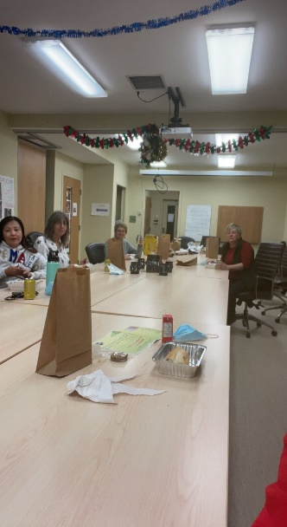Trish, Family Wellness Counsellor

Karen Jim/Interviewer for the Anaham Hospital Fire - My role as the interviewer for the old Anaham Hospital has me busy since being hired by TGO at the beginning of April to conduct interviews on the tragic Anaham Old Hospital fire of May 22, 1958 which took the lives of 12 of our children from the Tsilhqot’in Nation. I work with Kristen Kozak and David McAtackney (Research & Engagement Strategist) and Kristin Kozar (Engagement Lead) of the Indian Residential School History & Dialogue Centre (IRSHDC) from UBC, Vancouver.

My job is interview elders while they share their story or knowledge of the Anaham hospital fire with the assistance of David and Kristen. On the day of the interview, I go over the consent form with you to ensure that you know where your information will be stored (at TNG and IRSHDC), you choose if you want to be voice or video recorded or both. Your recordings will be filed in a secure space at TNG with a backup copy stored at the IRSHDC. Your testimony will not be used in any way without your permission.

On the day of your interview, who you have in the room with you is your choice, but will include:

Karen Jim, who may ask questions to clarify your truth (story) or to help you recall details.

David - who manages the recording devices.

Kristen – the Engagement Lead

Sharing difficult and traumatic experiences may be emotionally triggering and re-traumatizing, so if you wish to have support, I arrange for support people to be present before and after your interview. The support people will leave before your interview unless you wish them to stay. An example of support available is:

Cultural and health support - Health care (clinician counsellor) and cultural supports already based in your community will be used as support. Cultural support may include the use of tobacco, smudging before/after, prayers before and after your interview, the use of tear bags, etc. 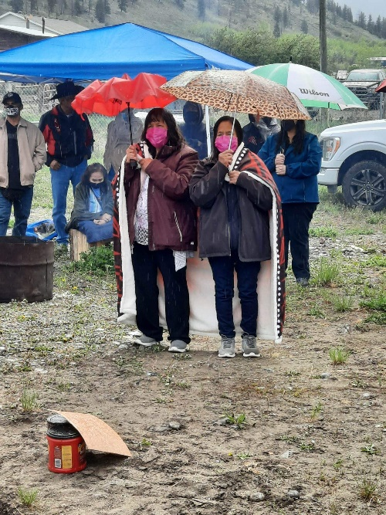*These supports will be available throughout the interview process only upon your request.

Family member or Friend - chosen by you (if you wish support to be present)

On May 23, 2022 we had an event/ceremony in recognition of the anniversary of this event. It was a great turnout and healing for the surviving family members to the children who perished in this fatal fire. I set up a table with 12 candles with individual cards that displayed names of the 12 children with their parents’ name and siblings. I ask that you please contact me if I am missing anybody on that list or if it needs correcting.

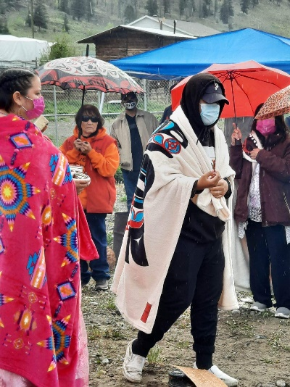We held our first set of interviews with several people from three communities from June 20-24. Thank you to all who shared their truth/knowledge of this fire. We will have more interviews in July and August. If you wish to provide an interview or have any questions, please contact me at 250-394-4658. If anyone has photos of the Anaham Hospital, please let me know if I can borrow it, I can scan it and ensure you get it back.

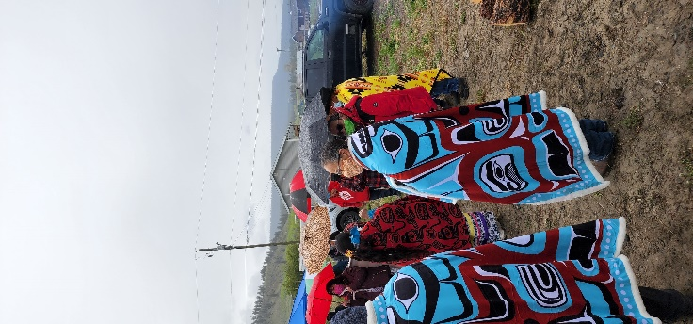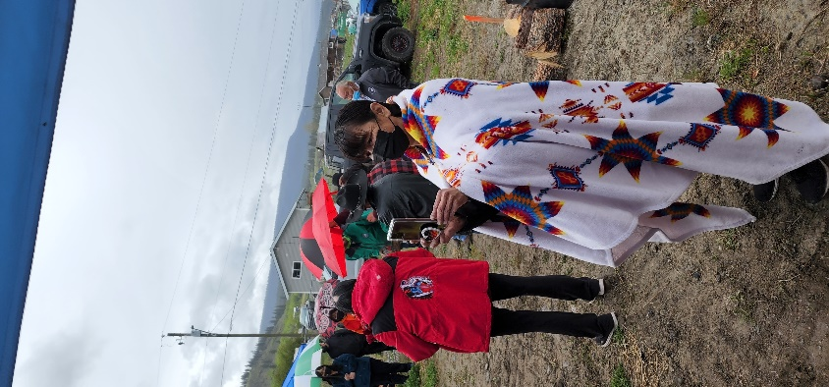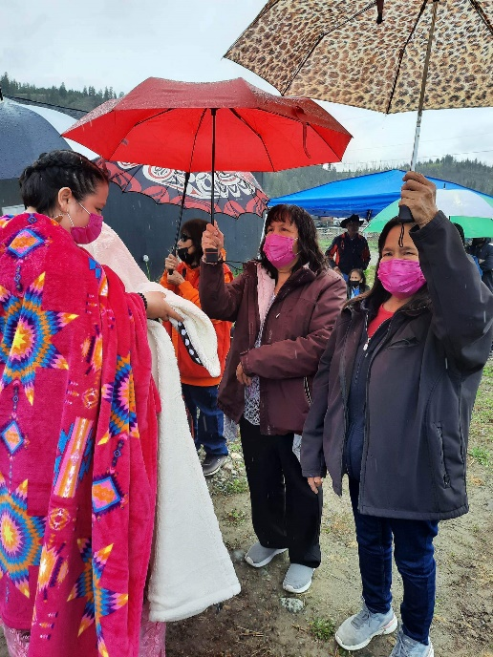This hospital fire from May 22, 1958 was a very tragic and traumatic incident which affected all of our Tsilhqot’in Nations. It is definitely healing to share your story – I received a lot of positive feedback of how sharing their truth has lessened the emotional load that our people have been carrying over the years. It is very rewarding to hear this and I encourage you to share your story. Enjoy your summer as it seems to have finally arrived and I look forward to seeing you. 😊