Cystic fibrosis is one of the most common life-shortening, childhood-onset inherited diseases. In the United States, 1 in 3,900 children are born with CF.
Cystic fibrosis (also known as CF, mucoviscoidosis, or mucoviscidosis) is a hereditary disease affecting the exocrine (mucus) glands of the lungs, liver, pancreas, and intestines, causing progressive disability due to multisystem failure.
- Thick mucus production results in frequent lung infections.
- Diminished secretion of pancreatic enzymes is the main cause of poor growth, fatty diarrhea, and deficiency in fat-soluble vitamins.
- Cystic fibrosis can cause infertility in both men and women; in men there is a congenital absence of the vas deferens, while in women pregnancy is made difficult due to thickened cervical mucus or disrupted ovulation due to malnutrition.
- Often, symptoms of CF appear in infancy and childhood. Meconium ileus is a typical finding in newborn babies with CF.
CF is caused by a mutation in a gene called the cystic fibrosis trans membrane conductance regulator (CFTR). The product of this gene is a chloride ion channel important in creating sweat, digestive juices, and mucus.

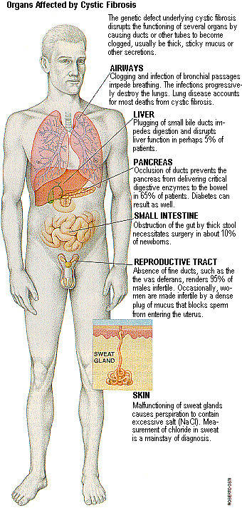

Natural Supplemental Supports:
- Turmeric
- Lecithin - very helpful to the lungs
- Alfalfa - helps to thin mucous
- Protein
- Vitalizer (includes protiotics)
- EZ-Gest - to support digestive enzymes that are needed each meal
- Vita D3

