***Cust Equestrian Group***

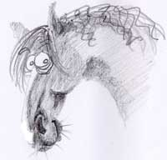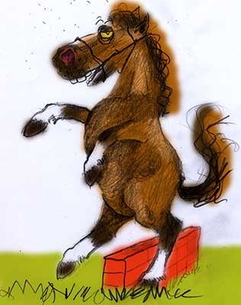

Our Aim

“To provide a fun and safe riding facility for all ages/abilities and for all equestrian disciplines”

*RULES*

1. Signing of membership form and acceptance of membership deems adherance to the attached H&S Policy and all of the following Rules.
2. Membership Categories: Single $50 pa – Family $70 pa - Junior $25 pa – Non-Riding Associate Member $20 pa.
3. Any casual users must adhere to our H&S Plan and CEG Rules and be accompanied by a current Member.
4. Main Entrance to Arena is off O’Farrells Road, with entry also into jumps paddock towards Mill Road.
5. Car parking/Riding is to be kept within the area designated on the attached map.
6. We strongly recommend all riders to wear hard helmets when riding. Members ride at their own risk.
7. Riders under the age of 14 must be accompanied by an Adult.
8. If you wish to bring a stallion to the arena, you must be over the age of 18 yrs, have clear stallion identification and must have full control at all times.
9. The Arena is free to be used by members with no booking required. You are welcome to meet your Instructor onsite but please be mindful of other users and do not use the whole arena. Clause 10 would then apply.
10. Instructors receiving payment for undertaking lessons to Members must have prior approval from the C.E.G. Committee and must provide a Site Specific Health and Safety Plan.
11. All litter is to be removed from grounds.
12. Horse manure is to be placed in designated area – see attached map.
13. Any complaints relating to another member, must be made to the Committee in writing. The Committee will then undertake investigation and ensure they gather information from both parties involved. This will be done in conjunction with the Complaints Policy
14. Not withstanding clause 13, the Committee reserves the right to refuse or revoke a membership application and any activity or behaviour deemed by the committee to be a risk to any person or animal or a detriment to the CEG. may result in the cancellation of membership.
15. Members are to have regard for other users of the arena and also regard to other riders abilities.
16. For the protection of our arena surface. No Galloping of horses in the main arena area.
17. No show type jumping on the surface of the arena. Cavaletti and trotting poles are permitted but must be put away in designated area after use.
18. Our AGM is held every February in which the committee is elected – you are all welcome to attend and have your say.
19. The Committee reserves the right to hold special meetings during the year if so required.
20. All fees are due on the 1st January each year.
21. The club takes no responsibility for any items lost, stolen or damaged whilst on the premises.
22. All personal information obtained from the membership form will only be used for purposes of the Cust Equestrian Group unless prior approval from the member is gained.

