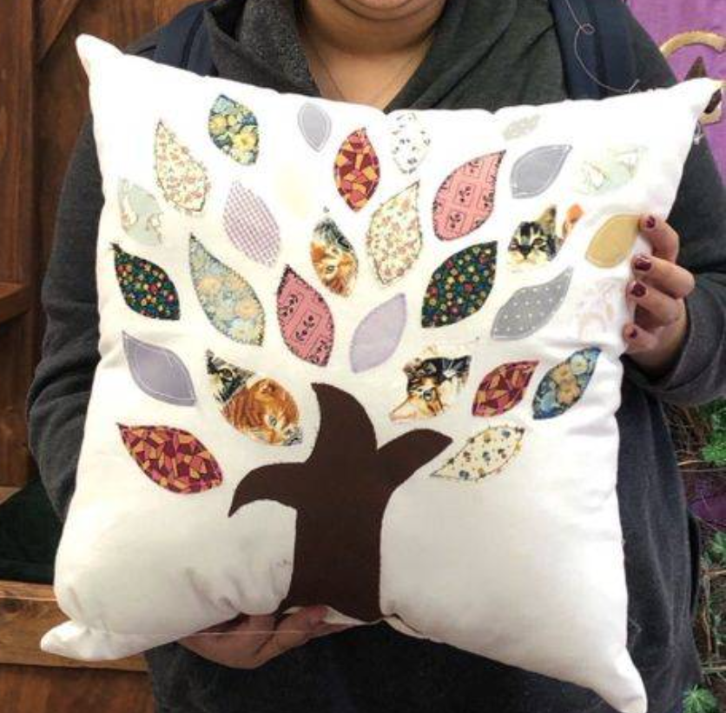
Tree of Life Pillow Supplies

½ yard cotton for pillow
¼ yard cotton for tree trunk
Thread
1 bag of Polyfil stuffing or Pillow insert
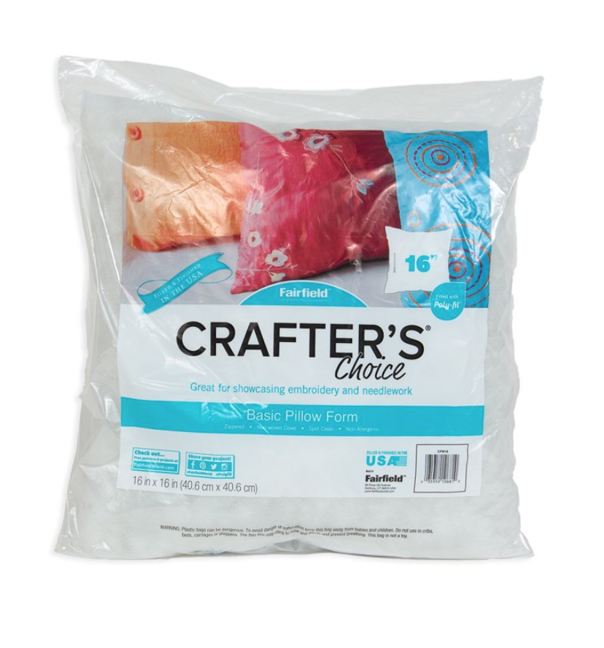

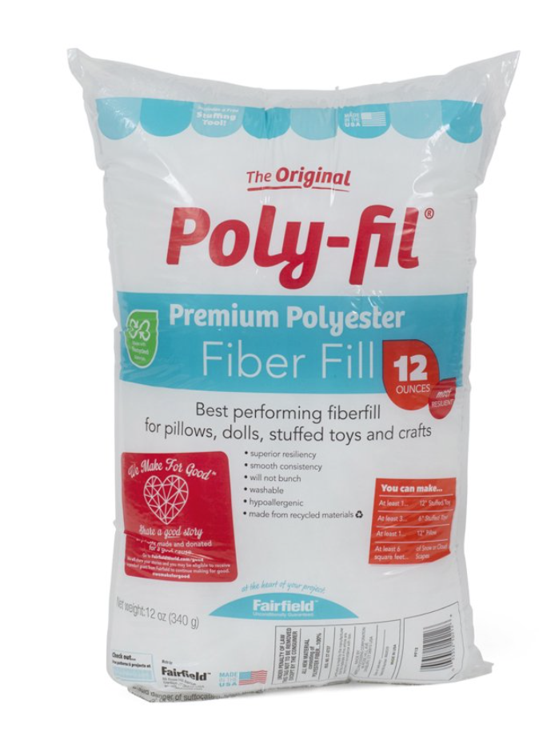

Fabric scraps for leaves – supplied by instructor
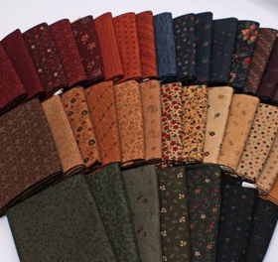
Heat and bond lite – supplied by instructor
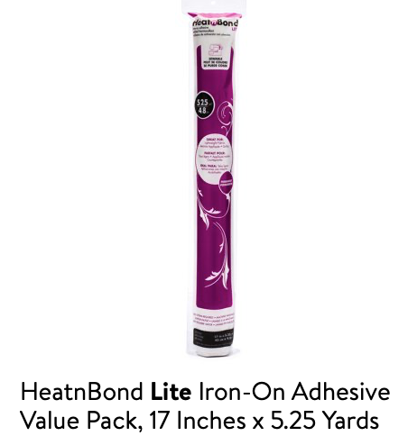

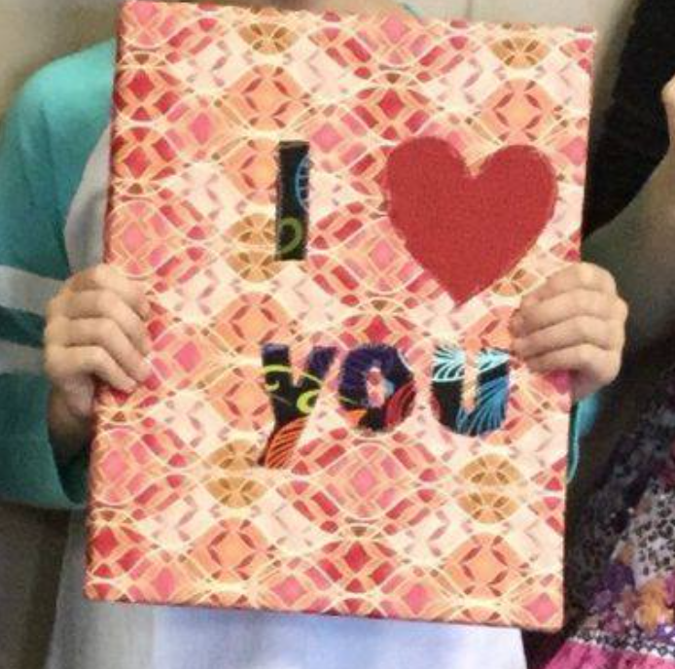
I love you canvas

¾ yd cotton fabric for background
¼ yd or fat quarter cotton for heart
¼ yd cotton print for letters
Thread
16x20 staple back canvas

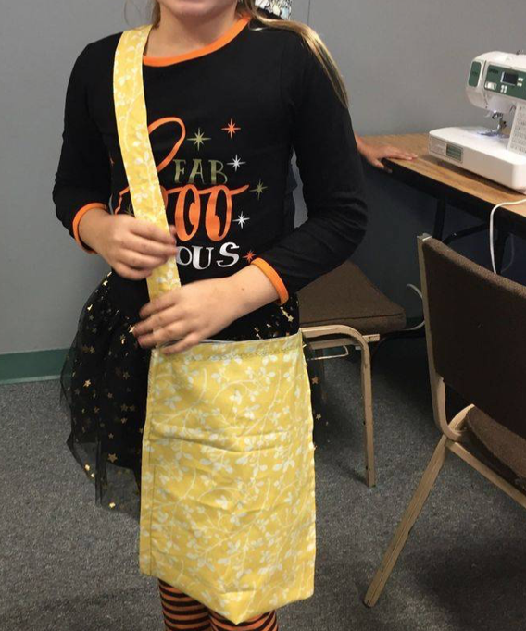

Easy Kids Bag

½ yard denim
½ cotton print
Thread

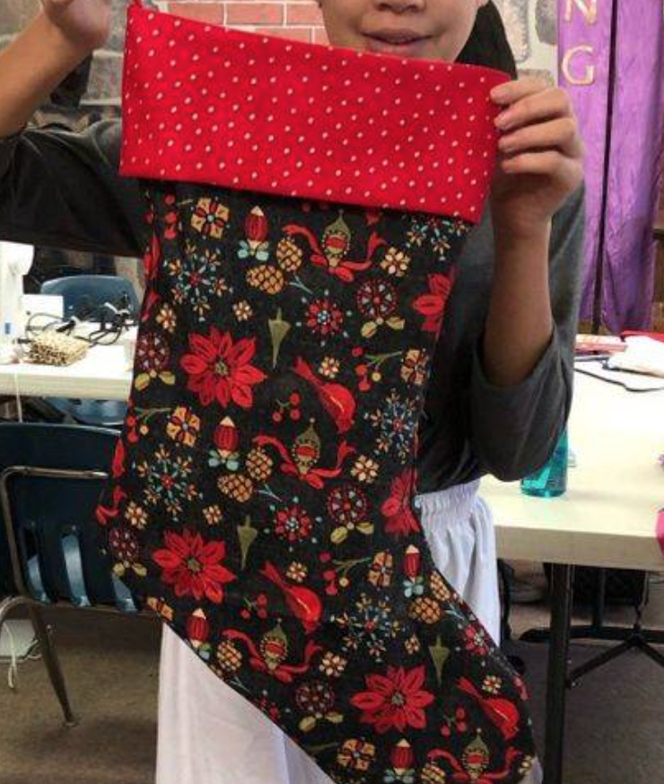
Family Christmas Stocking
¾ yd cotton Christmas print
¾ yd cotton for lining
1/3 yd cotton for boot top and loop

Quilt Batting provided by instructor

