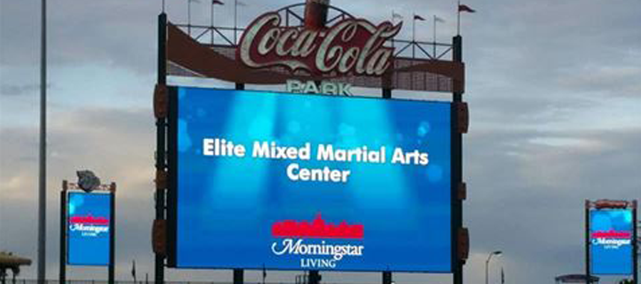

Karate Night at the Iron Pigs - Friday, June 11, 2021
Elite Demo Team to Perform

- An Elite family event, please come & support your Demo Team
- Tickets $11.00 each with a free $2.00 refreshment.
- Please purchase (with payment)your tickets before 6/1/2021.
- All tickets are digital and we will send your tickets to your smart phone.
- Sign-up form for Iron Pigs is located on the table outside the dojo door. Please see Cindy to register…
- We are trying to sell 175 tickets, please bring your friends and family. We are sitting together as a group. This will be great fun for a family outing since the lock-down from COVID.
- Karate Night at the Iron Pigs brings with it a karate bobble head & post game fireworks.

Please stop in to see Cindy if you have any questions!

