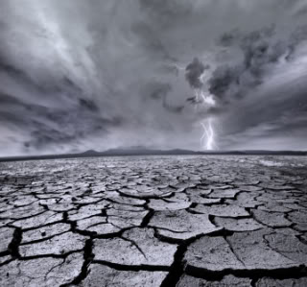

January 15, 2013
Ezekiel 22:30 say’s “ So I sought for a man among them who would make a wall, and stand in the gap before Me on behalf of the land, that I should not destroy it; but I found no one.”
The wall spoken of here is not made of stones, but of faithful people united in their efforts to resist evil. This was a wall of faith. This wall was in disrepair because there was no one who could lead the people back to God. The feeble attempts to repair the gap- through religious rituals or messages based on opinion rather than God’s will- were as worthless as whitewash, only covering the real problems.
What the people really needed was a total spiritual reconstruction! See, when we give the appearance of loving God without living his way, we are covering up sins that could eventually damage us beyond repair. Don’t use religion as a whitewash. I encourage you to repair your life by applying the principles of God’s Words. Then you can join with others to stand in the gap and make a real difference for God in this world.
Increasing In Him
Pastor Ron Suttles Sr.

