
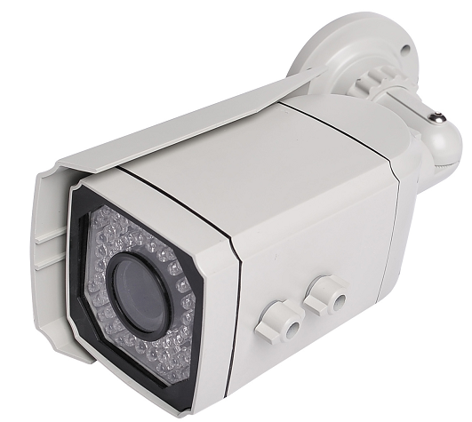Model: DK-SW1WCP
700TVL Vandalproof Face Detection surveillance camera dome
Intelligent image adjustment
1. High contrast scene detection, automatically WDR
2. Illumination Scene Detection automatically adjusts 3D/2D Noise Reduction
(HDNR) and Digital Slow Shutter
3. Face Detection brightness automatically adjusts the dynamic exposure compensation
4. Face tracking detection, automatically adjust the image to enlarge
5. Night Infrared Detection automatically adjusts the exposure intensity
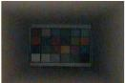 To 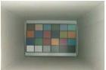 (HDNR)
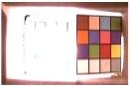 To 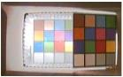 (WDR)
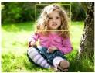 To  (Face zoom)
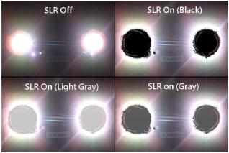 (Light inhibition)

High Fogging Ability
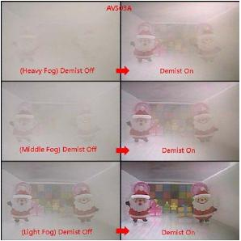
Video processing features
. High-definition images
. Optical octave WDR
. 3D/2D (HDNR)
. Digital Shutter
. Light Inhibition
. Face metering compensation
. Digital processing through the fog
. Face zoom
. Auto Backlight Compensation
. Intelligent IR exposure
. Color rolling Inhibition
. 256 times digital zoom
. Privacy Shield
. Face Detection
. Motion Detection
. Dynamic / static elimination of dead pixels (4096)
. Translucent multi-level menu
. RS485 remote-control
. Multilayer Auto (auto exposure, auto-gain, auto white balance
Automatic iris control, auto focus detection)
. Image settings (brightness, contrast, saturation, sharpness, hue)

Model | DK-SW12CP
Image Sensor | AVS03A
TV Line | 700TVL
Intelligent function | OSD, 3D/2D DNR, WDR
Resolution | 1020H×596V(PAL); 1020H×508V(NTSC)
TV System | NTSC/PAL
Min. Illumination | IR off: 0.001 lux IR on: 0.0lux
S/N Ratio | >50dB (AGC OFF)
Sync System | Internal line synchronization
Gamma Correction | 0.3~1.0 adjustable (usually set as 0.45)
Video Output | 1.0Vp-p,75Ω, Negative
Scanning system | PAL: 525 Lines, 50Field/S; NTSC: 525 Lines, 60Field/S
Shutter Speed | PAL: 1/50~1/10,000s; NTSC: 1/60~1/10,000s adjustable
White Balance | Auto,F/A,U30,CWF,D50,D65,D75 adjustable
Backlight Com. | Auto BLC
Lens | 2.8-12mm
IR Leds/Distance | 66pcs IR LED / IR Range 30~40m
Power Supply | DC12V / 3A (±10%)
Operation Temp. | -10ºC~+50ºCRH95%Max
Storage Temp. | -20ºC~+60ºCRH95%Max

