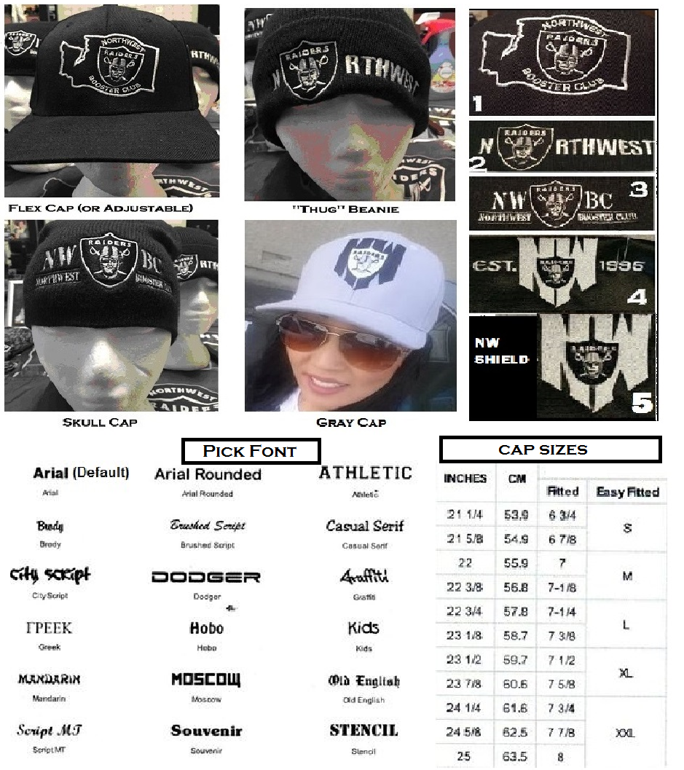
Pick Your Cap: Pick Your Logo:
Color: Black_____ Grey_____ 1.)Washington State Logo ____
Flex Cap S/M ____ L/XL____ 2.)NORTHWEST Logo _____
Thug Beanie _______ 3.)NWRBC Logo _______
Skull Beanie ________ 4.)1995 Logo ________
Adjustable Cap ______ 5.)NW Shield Logo ______
Back Name Embroidery + $10: ________________________

Right Side +$5____________________ Left Side +$5_________________________

CAP $25 + SHIPPING $5 + BACK _____ + RIGHT _____ + LEFT _____ = GRAND TOTAL: $_________

