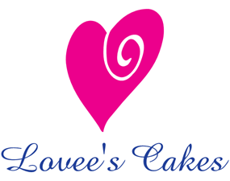

Serving | Round Tier Cake | Price
Up to 30 people | 6” & 8” (2 tiers) | $195
Up to 45 people | 6” & 10” (2 tiers) | $275
Up to 75 people | 6”, 8” & 10” (3 tiers) | $350
Up to 100 people | 6’, 8” & 12” (3 tiers) | $400
Up to 125 people | 6”, 10” & 14” (3 tiers) | $450
Up to 150 people | 6”, 10” & 16 (3 tiers) | $475
Up to 175 people | 6”, 10”, 12” & 16” (4 tiers) | $550
Up to 200 people | 6”, 10”, 14” & 16” (4 tiers) | $625
Up to 250 people | 6”, 10”, 14”& 18” (4 tiers) | $675
Lovee’s Special includes white fondant, plain ribbon of your choice of color upon availability. Choose three basic flavors | 6”, 8” & 10”  $25 cake tasting fee does not apply | $300

Standard Cake flavors  - Wedding Cake  - Chocolate  - Red velvet  - Lemon  - Poppy seed  - Almond  - Vanilla Bean  - marble | Specialty Cake Flavors & fillings  ($10 per tier)  - Champagne  - Coconut  - Carrot  - Black Forest  - Banana nut  - Mint choc chip  - German choc

