Junctions Turning Right

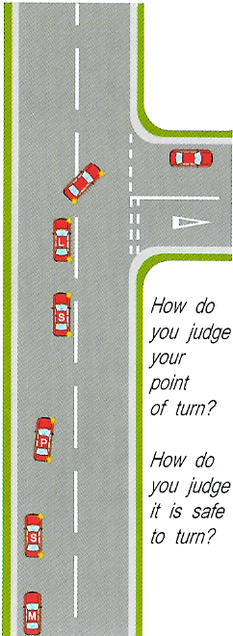
When turning right into a junction use the MSPSL routine
1 . Check interior and right mirror to check the speed and position of the following vehicle. Act on what you see.
2 . Give a right signal.
3 . Position the car left of the centre line
4 . Cover brake and clutch and slow the car down to a jogging pace (20mph and below)
5 . Select 2nd gear bringing the clutch up by the time you are three car lengths from the POT.
6 . Look and assess if it is safe to turn right giving priority to approaching traffic. Ask yourself would I walk across the road? If yes act on your decision.
7 . Look into the new road (to the end of the new road)and steer in when the bonnet reaches the middle line of the junction (using the pull and push method).
8 . Just before you steer in check your right exterior mirror for anyone overtaking (life saver mirror)
9 . Once into the new road check interior and right mirrors to keep you up to date with what is behind.
What can go wrong?
Pace too fast, Looking n wrong place at the wrong time, missing POT and swan necking in or cutting the corner.
POT = Point of turn.

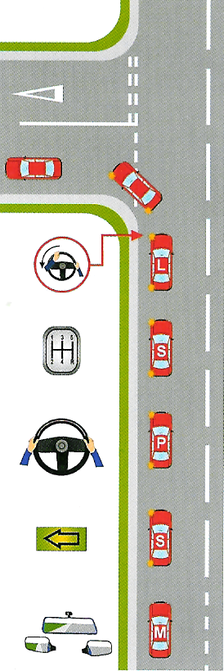
Turning left
When turning left into a side road use the MSPSL routine
- Check interior and left mirrors to assess the speed and position of the following vehicles. Act on what you see.
- Give a left signal
- Position the car in your driving line
- Cover the brake and clutch and slow the car down to a jogging pace (20 mph and below)
- Select 2nd gear bringing the clutch up to regain control by the time you are 3 car lengths from the POT
- Look and assess if it is safe to turn left and also take into account any road signs stating a different speed zone.
- Look into the new road (to the end of the new road) and steer in when the bonnet reaches the start of the bend (using the pull and push method)
- Just before you steer in check your left exterior mirror for cyclist coming up on your inside (life saver mirror)
- Once into the new road check the interior and right mirrors to keep up to date with what is behind.
- If the bend is a right angle bend position the car in your driving line or left of the centre line and your POT is when the corner of the front window.

What can go wrong?
Pace too fast, Using wrong gear, Looking in wrong place at the wrong time, missing the POT and swan necking or hitting the kerb.

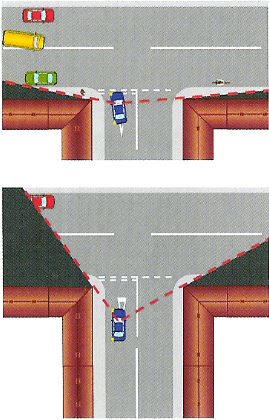
T junctions
When approaching T junctions use the MSPSL routine. Ask yourself some questions, Is the junctions Open or closed? Or is it a Giveway or a Stop Junction. The approch to each of these will be slightly different.
- Give-way junctions - you can decide if it is safe to go or not and go if it’s safe.

- At a Stop junction - you to stop no mater if it is safe to go or not. These are generally positioned because the junction is very closed.

- A closed junction - is where your view is restricted by buildings e.c.t and a decision cannot be made untill you are at the line or over the junction line. Ask your self can I see clearly both ways?

- A open junction - is where you can make your decision if it is safe to got further back.
To approach a open junction to turn right
- Check interior mirror and right mirror
- Give a right signal (delay the signal if there is a side road before the T junction)
- Position left of the centre line
- Cover brake and clutch and slow the car down to a jogging pace (20 mph and below)
- Select 2nd gear bringing the clutch up to regain the control of the car about 3 car lengths from the junction
- Look left and right to make your decision if it is safe. If it is keep going, if not Slow the car to a walking pace clutch down select 1st gear (keep brake covered) and bring clutch to bite.
- Ask yourself some questions when would I walk across the road. If you are coming out in the flow of traffic ask would I also be able to walk back, because you want to be able to come out but also be able to build up your speed to the speed of the road.
- When you do come out keep looking to the right to the end of the new road.
- When you have straightened the steering wheel check interior mirror and right mirror for the speed and position of the following vehicles (you must not cause the following traffic to slow down or change direction for you).
- When assessing if it is safe to go don’t just assess the first approaching car you must also assess the cars behind, are they telling you what they intend to do?

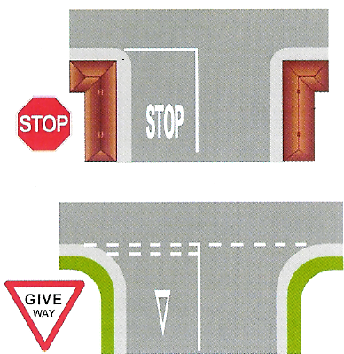
T Junctions
Turning left at a closed junction

- Use your interior and left mirrors to assess the speed and position of the following vehicles. Act on what you see.
- Give a left signal
- Look out for pedestrains and speed signs to tell you the speed of the new road.
- Cover the brake and clutch and slow the car down to a walking pace, cluch down at the start of the bend select 1st gear bring the clutch to bite keeping the brake covered, steer round the contour of the bend looking left and right.
- Once your zone of vision opens up, decide if it is safe to go or stop behind the line. Your door mirror will be under the 2nd line.
- Ask yourself a question, would you walk across the road and back if you are coming out into the flow of traffic. If the pause becomes a way put,( more that one car to giveway to ) put the handbrake on.
- When you decide to go, off brake set gas look to the left to the end of the new road. If you have used the handbrake set the gas and bring clutch to bite just as the last car is approaching then release the handbrake when you decide to go. Don’t sit there with clutch to bitetoo long. Get yourself ready just before you intend to go.
- Once out of the junction check interior and right mirror for the speed and position of any following vehicle. (you must not cause anyone to slow down or change direction for you).

If the junction is a right angle junction, position the car in your driving line or left of the centre line, steer when door mirror meets the bend of the kerb. Steering a full lock out. Thios will keep you on your side of the road and prevents you hitting the kerb as you come in or out of the right angle junction

