Tic Removal

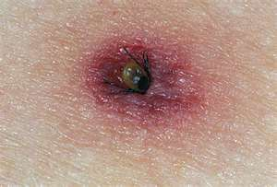
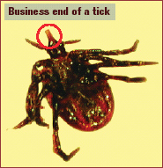

A School Nurse shared the information below … it really works!! ….
“I had a pediatrician tell me what she believes it is the best way to remove a tick. This is great, because it works in those places where it's sometimes difficult to get to with tweezers: between toes, in the middle of a head full of dark hair, etc.”

- Apply Shaklee Basic-H2 to a wet cotton ball.

- Cover the tick with the Basic H2-soaked cotton ball and let it stay on the repulsive insect for a few seconds (15-20)

- The tick will come out on its own and be stuck to the cotton ball when you lift it away.

“This technique has worked every time I've used it (and that was frequently), and it's much less traumatic for the patient and easier for me.
Unless someone is allergic to soap, I can't see that this would be damaging in any way. I even had my doctor's wife call me for advice because she had one stuck to her back and she couldn't reach it with tweezers. She used this method and immediately called
me back to say, ‘It worked!’”

