Nutrition Plus, Inc.

121 Mays Rd., Winfield, KS. 67156
www.nutritionplusinc.com

Executive Director: Emily Roark (620) 221-2777 roark2@cox.net
Administrative Supervisor: Patti Brenn (620) 218-1811 pattibrenn@cox.net
Topeka Area Coordinator: Susan Morrell
(785) 230-7441 smorrell12@gmail.com
Menu Advisor: Jacque Zimmerman (620) 660-0236 jacque.nutritionplus@gmail.com

April is:

National Month of Hope
National Child Abuse Awareness Month
National Lawn & Garden Month
National Fresh Celery Month
National Soft Pretzel Month
National Stress Awareness Month

Training Updates:

I want to thank everyone of you that attended the Topeka, Wichita & Winfield “Mealtimes with Toddlers” trainings in March. It was so nice to see your faces and it was good fun! We have had providers update us with their successes since the trainings!
We will do “Food Safety” in August.

Important Dates:

April 5th – Claims Due
April 29th – Checks/Direct Deposits go out

A smarter mealtime is one in which children are likely to choose healthy foods and eat them! We know that children’s’ eating habits are learned at an early age. Habits don’t just appear. They’re learned from watching others. Studies show, parents and caregivers influence children’s’ food preferences. You can help get them to try new, healthy foods by blending mindful nutrition messages throughout the day and gently nudging children to make healthy choices. Some ways to do this in a daycare setting are:
- Music – Dancing and singing songs about healthy eating, or food in general, makes the subject of nutrition more fun for the kiddos.
April 2022
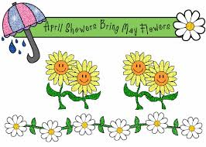

- Introduce new fruits and vegetables by sitting in a circle and passing whole, fresh items around, Let the children touch and smell them, while pointing out the sensory qualities of the foods. “This is a mango, it’s sweet like a strawberry”. “This is a kiwi fruit. It’s brown and fuzzy on the outside and the green inside is soft and sweet!” Or try a vegetable they’re unfamiliar with like, “this is a jicama root. It looks like a potato but tastes sort of like an apple!”
- Gardening with children is a great way to include the children in the whole process of farm to table. Let them assist you in your gardening process by helping ready the area (remove small rocks or clumps of harder soil, by using child-friendly garden tools or by hand. They let them plant some seeds and use little watering cans to water them. Help them check on and observe the rate in which the plants are progressing. Come harvest time, assist them in picking the foods. They can take pride in the foods they’ve grown!
- Family style meal service is a style of dining that allows children to choose what and how much to put on their plate. You should notice less reluctance to try foods if they choose to put the food item on their plate. This freedom can give the children confidence and also results in far less food waste for you!
- Share resources with families. If you do nutrition training in your daycare, share pictures, videos and handouts with the parents. Children are often excited to talk (sometimes nonstop) what they did with their day. If it involves foods, eating and nutrition, they can show their parents the coloring pages they did, crafts they made, and sing them the songs they learned.
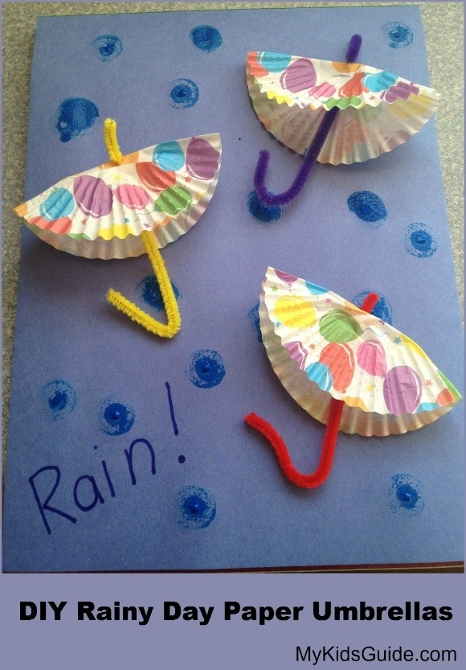

Supplies:
Construction paper of any color (for raindrops)
Blue construction paper
Scissors
Cupcake liners
Glue
Tape
Pipe cleaners in any color
Markers
Blue Bingo Blotters or paint & paint brush

Instructions:
1. Start by having your child paint or decorate the cupcake liners with markers. You can also use ones as seen here that are already decorated.

2. On the blue construction paper, add your rain drops by either gluing construction paper scraps or use your blotter, markers or paint. (This gives you options based on your supplies)

4. Fold the cupcake liners in half.

5. Bend and add the pipe cleaners to the inside of the umbrella with tape.

6. Secure your umbrellas to the blue background by gluing the back of the cupcake liner to the paper and let dry!

8. This is a great time to discuss changing weather. “Do you like the rain?” Allow them to answer and ask their own questions too. Don’t forget, spring often brings in thunderstorms. Discussing these can help lessen the fear and anxiety if they have a chance to voice their feelings.
Chicken or Turkey Noodles
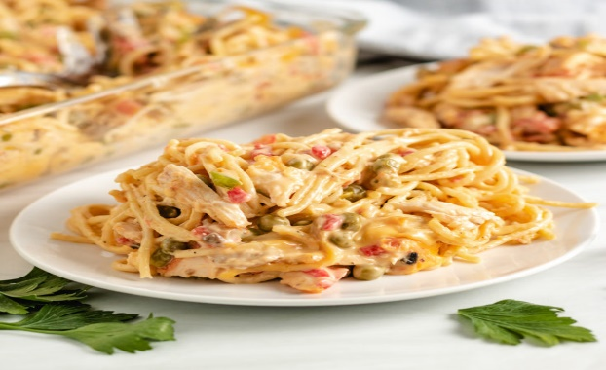

Ingredients:
2 cups Low-sodium chicken broth
1 qt or 7 oz Whole grain spaghetti noodles,
broken in half
1 ½ cups or 6 oz Fresh onions, diced
4 cups or 6 oz Fresh carrots, shredded
1 Tbsp Margarine, trans fat-free
2 Tbsp Whole-wheat flour
¾ cup or 6 oz Nonfat milk
¼ tsp Salt
¼ tsp Black pepper
¼ tsp Dried marjoram
⅛ cup Dried parsley
3 ½ cups or 2 oz Fresh spinach, chopped
1 ½ cups or 7 oz Cooked diced chicken, thawed

Instructions:
1. Heat chicken broth to a rolling boil in a medium saucepan.
2. Slowly add pasta. Stir constantly until broth boils again. Cook about 6 minutes or until al
dente. Stir occasionally.
DO NOT DRAIN BROTH OR OVERCOOK.
3. Add onions and carrots to pasta. Remove from heat. Set aside for step 7.
4. In a medium saucepan, melt margarine uncovered over medium heat. 5 Add flour. Stir well for 1 minute. 6 Add milk. Stir mixture frequently until
smooth and free of lumps. Bring mixture to a boil. Remove from heat.
7. Add milk mixture, salt, pepper, marjoram, parsley, and chicken to pasta mixture. Heat uncovered over medium heat for 3 minutes. Stir until thickened.
8. Add spinach. Stir well over medium heat.
9. Heat to 165° F or higher for at least 15 seconds. 10 Transfer to a baking dish (9”x13”x2
12 Serve size 1 cup. (1 cup provides ¼ cup vegetable, 1 oz equivalent meat, and 1 oz equivalent grains)

You are all doing great! Sunshine is coming soon!

