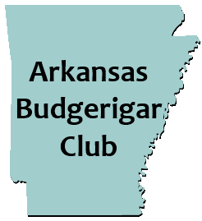
HOSTING THEIR
DEBUT SHOW!

September 28, 2019 BAA Panel Judge: Bob Wilson

All Divisions: Rare, Junior, Novice, Intermediate, Champion
Entry Fee- $3/bird ($30 max fee)

LOCATION
Tyndall Park Gene Moss building
913 E. Sevier St.
Benton, AR 72015

Schedule of Events:
Friday- September 27,2019
12:00pm- Show Hall opens for show setup/bird check in.
6:00 pm-Dinner (a la carte) at local restaurant.
Saturday- September 28,2019
7:00 am- Show Hall opens
9:00 am- Bird check in and entries complete. Staging of birds.
10:00am- Judging begins
12:00pm- Lunch:provided by club.
Sides, desserts, drinks, etc. would be appreciated.
1:00 pm- Bird Auction
2:00 pm- Raffle Item winners are selected

*Donated auction birds and raffle items would be appreciated.*

For local hotel inquiries or any other information contact:
Bill McLean Jr.
501-922-5656
billmclean@att.net

