Nutrition Plus, Inc.
121 Mays Rd., Winfield, KS. 67156
Emily Roark Patti Brenn Susan Morrell
(620) 221-2777 (620) 218-1811 (785) 230-7441
roark2@cox.net pattibrenn@cox.net smorrell12@gmail.com
www.nutritionplusinc.com
March is:
1st – National Peanut Butter Lover’s Day
3rd – Soup It Forward Day
7th – National Cereal Day
9th – National Meatball Day
17th – National Corned Beef and Cabbage Day
18th – National Sloppy Joe Day
20th – National Ravioli Day
23rd – National Chip & Dip Day
26th – National Spinach Day
31st – National Tator Day

Important dates:

March 26th – Checks/Direct Deposits go out

Welcome new providers!

The closure of Noah’s Ark CACFP in Chanute, brings a few new home daycare providers to our Nutrition Plus group. They are mainly based in the Topeka and Wichita areas. We are happy to have them join us and are working hard to make sure they feel at home with Nutrition Plus, after losing their previous food program sponsor. I am ordering new program binders and Crediting Food Handbooks for anyone who doesn’t have one. The “snow-pocalypse” is obviously prolonging the shipping and printing, but we’ll distribute them asap.

The addition of these new members makes this a perfect time to go over a few reminders and helpful
hints to make sure we are all being compliant with the state and federal regulations of the food program. Hopefully this quick refresher helps!
March 2021
*We are visiting. Be expecting us. Stay up-to-date on daily paperwork or computer work. We are doing unannounced as well as announced visits. If you are closed or serving outside your established mealtimes, just text Susan if in the Topeka area at (785) 230-7441 or Patti if in the Wichita area at (620) 218-1811. Although we do have a Facebook page, we do not check it frequently for daily closure messages. It is more for providers and us to share interesting ideas or to pose questions to the group.
*Watch your capacity. We are having problems with overages lately and there isn’t much we can do to help you if you are watching and documenting too many kiddos. The regulations are strict for enforcing these violations. This is unpleasant for everyone if it happens.
*Milk is 1%, ½% or skim for everyone over 2 years and whole (vitamin d) for age 1 up to 2nd birthday.
*On infant menus, all three components are required at all three meals/snacks once they are developmentally ready. This means if infant cereal and a fruit/veggie is offered at breakfast and lunch, it MUST be offered at snack for it to be creditable. “A meal or snack is reimbursable as long as all of the required food components are offered”.
*Save 2 months of labels for all whole grains, cereals and yogurts claimed on your menus. Do not throw them away.
*myfoodprogram.com is still an option for those who want a free online claiming option. It not only has the food program tracking for daily use, but also offers business management tools like expense tracking! I pay for this for you if you want to use it.
*When recording your menus, keep it simple. Only record the component in the box it belongs in. Meat/alt. = meat/alt. vegetable = vegetable. Extra description just clutters up menus and often makes it difficult to read. It’s also unnecessary!

Supplies:
Paper plate
Paint (rainbow colors) good markers work for smaller kiddos
Black and yellow paper
Scissors
Glue
String

Getting started:
Start by having the kids paint (or color) rainbow stripes on the front of a paper plate. Let dry. Flip over and do back side too. Let dry. Blow dryers help speed this up!
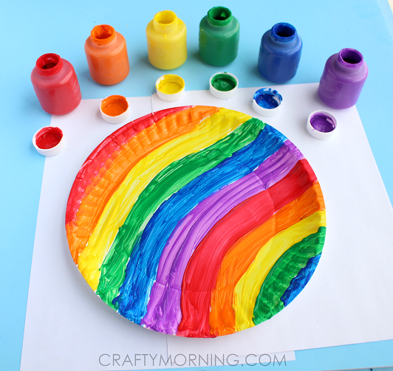
Grab a scissor and start at the outside of the plate to cut in a spiral to the center. Cut out a black pot of gold and glue it to the end of the plate.

Glue on some yellow circles to make the gold! Poke a hole in the middle of the plate and add a string to hang it up!
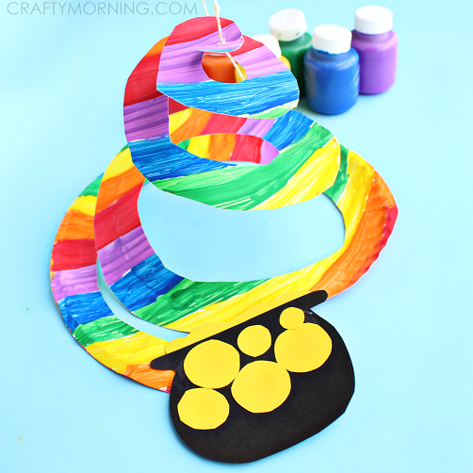
Spinach Egg Bake

2¼ cups spinach, frozen, chopped, thawed, and
drained
6 eggs, large
1 tablespoon feta cheese, crumbled
1 teaspoon onions, dehydrated, chopped
⅛ teaspoon black pepper, ground
⅛ teaspoon salt, table
Nonstick cooking spray

*Preheat oven to 350 °F.
*Thaw spinach in the microwave using package direction or by placing under cool running water. Drain excess water from spinach
*Whisk eggs in a small mixing bowl. Add feta cheese, dehydrated onions, salt, and black pepper. Mix well
*Lightly coat medium baking dish (about 8" x 8") with nonstick cooking spray.
*Spread spinach evenly on the bottom of the baking dish.
*Top spinach with egg mixture. Keep the vegetables spread evenly by slightly stirring the mixture with a spatula or spoon. Place baking dish into the oven.
*Bake for 15 minutes at 350 °F to an internal temperature of 160 °F or higher for at least 15 seconds.
*Broil on high for 2 minutes or until the eggs are set and the top is a light to golden brown color. Remove immediately to prevent burning.
*Cut into 6 even pieces; each piece should
be about 2" x 3¾". Serve immediately. Serves 6.

Thanks for all you do for your families!
Emily, Patti & Susan

