Impetigo

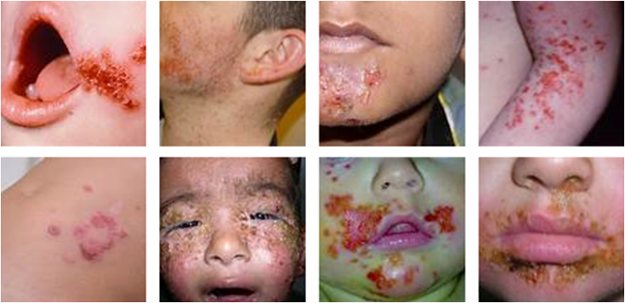
... a highly contagious bacterial skin infection most common among pre-school children

- Impetigo (contagiosa) This common form of impetigo, also called nonbullous impetigo, most often begins as a red sore near the nose or mouth which soon breaks, leaking pus or fluid, and forms a honey-colored scab, followed by a red mark which heals without leaving a scar. Sores are not painful, but may be itchy. Lymph nodes in the affected area may be swollen, but fever is rare. Touching or scratching the sores may easily spread the infection to other parts of the body.

- Bullous impetigo - mainly seen in children younger than 2 years, involves painless, fluid-filled blisters, mostly on the arms, legs and trunk, surrounded by red and itchy (but not sore) skin. The blisters may be large or small. After they break, they form yellow scabs.

Natural Home Remedies for Impetigo
- Applying crushed or slices of raw garlic on the affected area is one of the simplest and equally effective natural home remedies for Impetigo home treatment. In addition to this, consumption or oral cold-processed garlic tablets (Shaklee Garlic) is highly recommended.

- Take Shaklee DR … a natural Echinacea complex orally until the impetigo is gone.

- Double your usual intake of probiotics until the impetigo is gone.

- Break the leaf of an aloe plant and smear on the area.Aloe vera gel also helps to cure Impetigo naturally when used regularly four to five times a day.

- Using apple cider vinegar for cleaning the affected area helps to remove Impetigo scabs. For, this one eighth cup of apple cider vinegar in cup of water. Dip a cotton pad in the solution and use to clean the area. (Do not dip the cotton swab back in the solution … or you can contaminate the solution!)

- Turnip is regarded as the one of the best Impetigo home remedies. For this, slices of turnip should be soaked natural vinegar for about six hours. Then, eat these turnip slices on a regular basis as an effective natural remedy for Impetigo disease.

- Optimize your Vitamin D3 intake to 10,000 I.U. daily.

- Double or triple Shaklee NutriFeron until the impetigo is gone.

