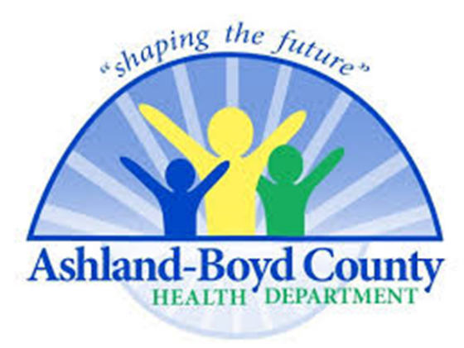

Release for Return to a Sport Activity
9/8/20

The Ashland-Boyd Co. Health Department will not be issuing a release for return to a sport or activity for a positive Covid-19 case. In accordance with KMA guidelines, the release will need to be obtained from the positive case’s primary care physician or other health care provider. The ABCHD does not have a physician or other provider that meets the guidelines by the KMA.

