Beyond RESVERATROL!

Reach for

Shaklee’s Premium Antioxidant Tonic
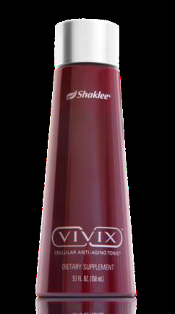

VIVIX
 Protects & repairs cellular DNA
 Revolutionary anti-aging effects
 Promotes mitochondrial biogenesis
(increases size & number of energy
generators in EVERY CELL)

Also Supports:
 Heart Health &
Cardiovascular Function
 Brain Health
 Enhanced Immunity
 Joint Health

Have you heard that RESVERATROL, an ingredient in red wine,
could be the secret to a longer, healthier life?

It is true! … over 2000 research publications including multiple studies conducted by Harvard University, National Cancer Institute, and the National Institute on Aging, clearly prove that nature provides solutions.

1 teaspoon of Shaklee VIVIX delivers the equivalent amount of RESVERATROL found in 100 glasses of red wine
½ teaspoon ……………………………………………………………………………………………… 50 glasses of red wine
¼ teaspoon ................................................................................................................................. 25 glasses of red wine
(For optimal benefit, one teaspoon of VIVIX is recommended daily)

VIVIX is a highly concentrated and potent liquid formula, exclusive to Shaklee and manufactured by a patented process (also exclusive to Shaklee), which ensures absolute potency and freshness.
- Each teaspoon contains 1390 mg of Muscadine grape extract and trans-resveratrol
- VIVIX ingredients are 10X more powerful in slowing aging than resveratrol alone
- VIVIX is GUARANTEED to be standardized to a minimum of 98% purity (typical resveratrol products are 50% or less pure)
- VIVIX does not contain “emodin” (typical resveratrol products contain emodin which causes diaharrea, and prevents an individual from taking optimal amounts)

To FIGHT CELLULAR AGING & MORE … ORDER YOUR VIVIX TODAY! … contact Martha Willmore
905-871-4281 … hoop@inter-pc.com … www.imwillmore.myshaklee.com

