ACROSS
1 Mosaic; 4 Scales; 7 Cana; 8 Claudius; 9 Sadducee; 13 SLM; 16 Self-confident;
17 Sad; 19 Radiuses; 24 Shepherd; 25 Bind; 26 Astern; 27 Arthur

DOWN
1 Mock; 2 Sandalled; 3 CICCU; 4 Share ; 5 Aide ; 6 Equal ; 10 Decor ; 11 Caned ;
12 Elihu; 13 Sherebiah; 14 Moth; 15 Uses ; 18 Ashes; 20 ASEAN; 21 India; 22 Apse ;
23 Eder

Service times at St Mary’s
Sunday: 10:30am Holy Communion
or Morning Prayer
Normally the first and third Sunday is Holy Communion with Morning on the second and fourth. Baptisms by arrangement with the Rector.
Tuesday: 10.00am Holy Communion
12.15pm Lunch-time Service

St Mary’s and the Nave Café is open – Tuesday, Thursday, Friday & Saturday from 9.00am – 3.00pm

Readers contributions to the magazine are always welcome. Hard copy (hand written if easier) to the Rectory address or by email: to : st.marysstockport@gmail.com
Editorial discretion with regard to content and space available will apply.
St Mary’s in the Marketplace
St Mary’s Rectory, 24 Gorsey Mount Street,
Stockport, SK1 4DU.
0161 429 6564
www.stmarysinthemarketplace.com.

St Mary’s in the Marketplace
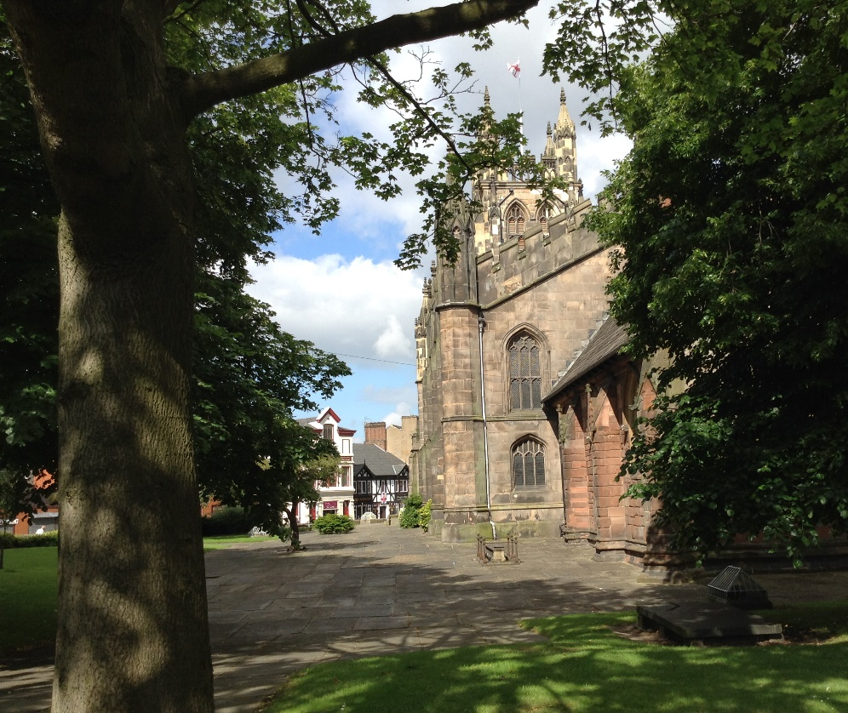
Parish Magazine
August 2014

50p
From the Rector’s “ i-Pad”
Dear Reader
August is a month generally associated with holidays ,and for that reason alone one might expect churches to have a quieter time in August ! Indeed, in some parts of the world, in Canada for instance, I have known of churches closing for the holiday season, since so many members are away on vacation. Not so here in Stockport, nor indeed throughout much of the UK . Many churches hold holiday clubs for children in the summer holidays and many seaside churches open their doors wide to holiday makers, with invitations to coffee and tea and special summer holiday services. If you are on holiday in Stockport, you are most welcome to join us. If you are away on holiday, please take this magazine (which you can also read online, by the way) and pass it on to someone else; and please take greetings to a church in the place where you are on holiday, whether it be at home or abroad.
The month of August begins here in Stockport with a solemn observance of the Centenary Anniversary of the outbreak of the First World War. The Mayor of Stockport took the initiative to hold this service, and asked for it to take place in St. Mary's ,the Civic Church ; and he is to be warmly commended for that. This commemoration is only the beginning of a long period of remembering the terrible events of those days. Our own fine Memorials to the Fallen of the Great War in wood and glass and stone will doubtless be studied ,admired and given due respect in the coming days, telling, as they do, the sad story of lives lost, families shattered and communities bereft of the young men of a whole generation. We have reason to be very grateful to the Stockport Heritage Trust members who have not only produced a booklet recording the details of all the War Memorials in the church, but are also preparing a major event at Mary's in September, as part of the National Heritage Days, which will undoubtedly bring to mind the reality and horror of the Great War and its impact on the lives of the people of Stockport in those days.

CIVIC SERVICE
Commemorating World War 1
following a procession from Stockport Town Hall to St Mary’s
In the presence of
The Worshipful the Mayor & Mayoress of Stockport
Cllr Kevin Hogg & Kathleen Hogg
Preacher: The Venerable Ian Bishop
Sunday, 3rd August 2014 3pm
Everyone welcome
Help would be appreciated by sides persons and members of the congregation to assist visitors to their seats (some of which will be reserved), take the collection from all areas of the church, the serving of refreshments after the service and clearing up afterwards. Advance notification of your availability would be helpful.
--------------------------------------------------------------------------------------------------------------------------
St Mary’s in the Marketplace &
Stockport Heritage Trust
invite you to join us between 10.00pm – 11.00pm
at St Mary’s on Monday, 4th August 2014
in commemoration of the anniversary of World War 1
[the bell will toll from 10.45pm – 11.00pm]
Refreshments available
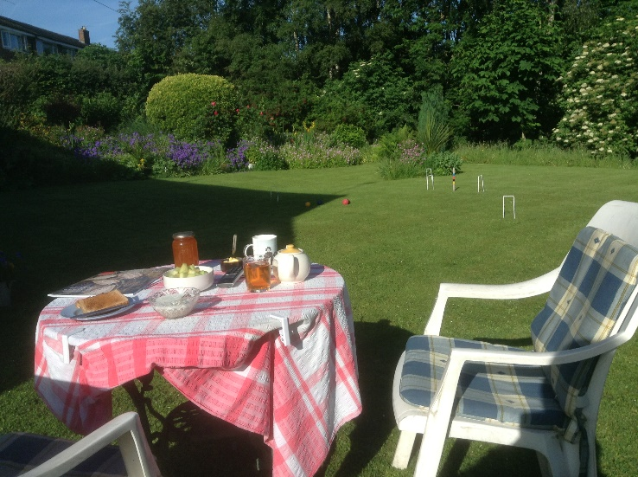
There will be a chair waiting for YOU
Join us on the lawn of St Mary’s Rectory for Roger’s annual “Cream Tea” and “BBQ” on the 17th August.
St Mary’s Rectory
24 Gorsey Mount Street,
Stockport, SK1 4DU
Parking at St Andrews Community Church Hall
Afternoon cream tea 3.00 pm onwards

Outdoor Service in the Rectory Garden 5.00pm
BBQ from 6.00pm
JJ
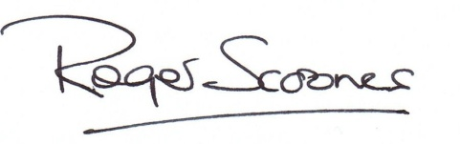
Ticket entry
Cream Tea £6.00
BBQ £7.00
Special Offer: .
Get tickets for both (save £1.00) £12.00.

Looking back, but not quite so far, into the social history of St. Mary's it was sad to record the death of a much loved film and television, Dora Bryan, who made her name in the film A Taste of Honey, staring Rita Tushingham. Like that other well known film Yanks, featuring the youthful Richard Gear, that scenes in that film were shot partly in the churchyard around St. Mary's
Bringing the life of St. Mary's right up to date, it will be a great pleasure and a privilege to christen three children from the parish during the course of this month of August, and like the Commonwealth Games we say WELCOME DO COME IN. Baptism is only the beginning of a long journey through life. We do not know what the future holds for these little one's the world is in many ways a darker and more dangerous place now than it was one hundred years ago. It is certainly a more complex world, and life itself is as fragile as it ever was. The wonderful thing we have to offer the parents and godparents, and the children they bring for baptism is FAITH and HOPE and LOVE, the Gospel of Jesus Christ. This is our reason for being the church in the Marketplace. We have a unique role to play in society , and our community is watching the Church to see if it will live up to its calling to be a place where ALL ARE WELCOME.
I hope that you will find something of interest I in this magazine, and more especially , that you will always find a welcome at St. Mary's this summer.
Yours very sincerely .
Dereen Dethick .
It was with great sadness that we leant of the death of Dereen following a short illness. Doreen has been a faithful member of the Heritage Centre for many years and has enjoyed her time spent in St. Mary's . A full appreciation of Dereen will appear in next month's magazine .

It seems quite awhile now since our plant sale, but for many of us we have the pleasure of being able to see our purchases growing in the garden or placed in pots on the patio. So, although our plant sale is over for 2014 we will be doing it all again in 2015 when someone will be asking: will you buy my plants…..
The Sale of Plants
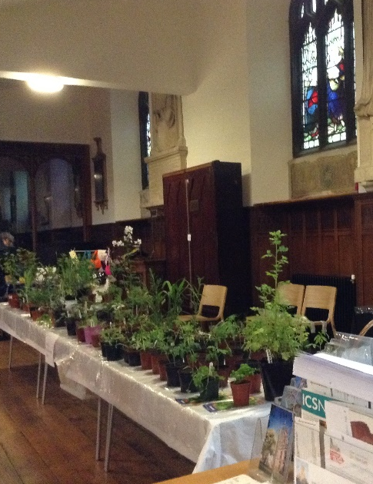
Will you buy my plants,
plants of all sizes?
There be big ones,
Small ones too
That rocky plant in white,
Pink too. Plants will be tall,
Colours all different.
The ladies will sell them
For people who come
Through the big door
And side door
This sale is to raise monies, Poem by Anne Knight
for church to be completed. [Thank you Anne for your contribution to the magazine]

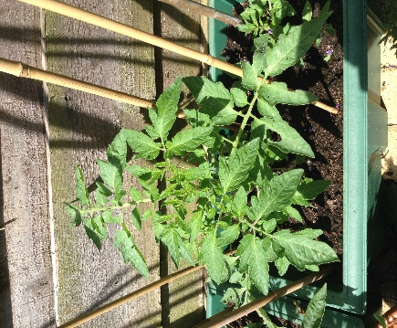
Take one tomato grown by Frank Hamnett, sold to Rita Waters at Harvest time last year. Take seeds from the tomato and grow on to make new plants – sell to me at the St Mary’s Plant Sale! The circle of tomato life you may say!
A little way to go yet before flowers and tomatoes– but you never know – there may be another generation to follow… and all I want is a cheese and tomato sandwich (best bought from the Nave Café I think).
Not good news…
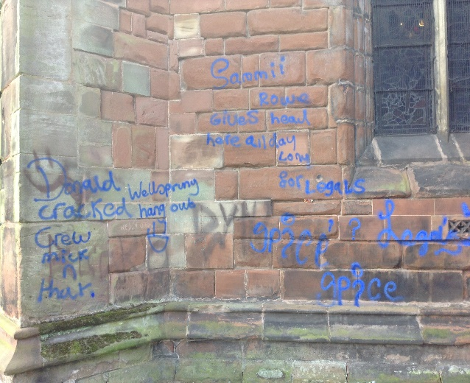
St Mary’s has regrettably been targeted by vandalism in the form of spray can graffiti. The reason for such mindless action is of course unknown, as is the identification of the person(s) involved, although the Police are making enquiries. We will get it removed as best we can with specialist restoration experts – but there is no guarantee of 100% success and no guarantee the culprits won’t return. Increased patrols and checks have been arranged with Greater Manchester Police for which we are most appreciative.

No news yet…
We are still waiting for news as to the outcome of our submission to the Heritage Lottery Fund for the next stage of funding for the conservation and restoration of the Vestries. All we can do for now is “wait” … we were warned that it could take awhile, and hope that we can get the project moving as soon as possible before the weather turns … and do the best we can to raise the short-fall of cash to complete the job in the given time frame.
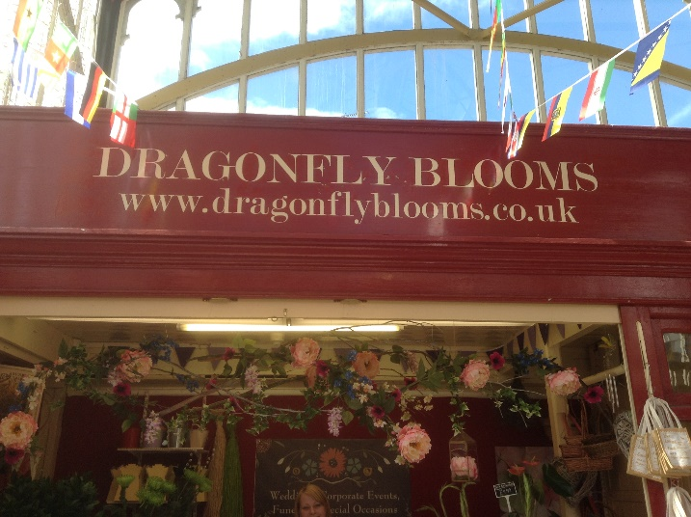
An accident waiting to happen…
The Parochial Church Council has decided to write to Stockport Council expressing concern at the crossing point outside St Mary’s.
Although at the time of making this decision (and sending the letter) not all traffic restrictions in the area had been implemented, it was still felt appropriate to have our concerns noted. A Council representative has updated our PCC Secretary as to the position and we now wait to see what difference the new restrictions will make to the stress and strain to drivers and pedestrians alike trying to negotiate that corner. Is it – an accident waiting to happen? We will continue to monitor the situation. If you have any comments you wish to make – let us know.

Baptisms at St Mary’s
What is a collection of Baptisms called? Well whatever it is we are happy to invite the family and friends of several children being baptised during our morning services on the 3rd, 10th & 17th August and again on the 21st September.
=============================================================

Congratulations to Zoe Simpson and a happy first birthday to Dragonfly Blooms who opened a year ago as part of the National Market Traders Federation’s First Pitch Scheme, which gives would be stall holders a helping hand to start. Of the 100 who applied Zoe was shortlisted for the outstanding trader award and finished second at a ceremony in York. The first time a Stockport Market Trader has been shortlisted in the three years the award has been running. Zoe has now applied for Independent Retailer of the Year as part of the 2014 Stockport Business Awards. We wish her the best of luck for the competition and the future of her business.
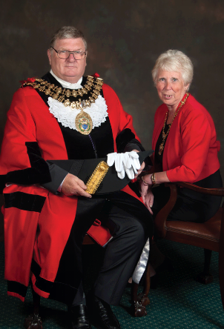
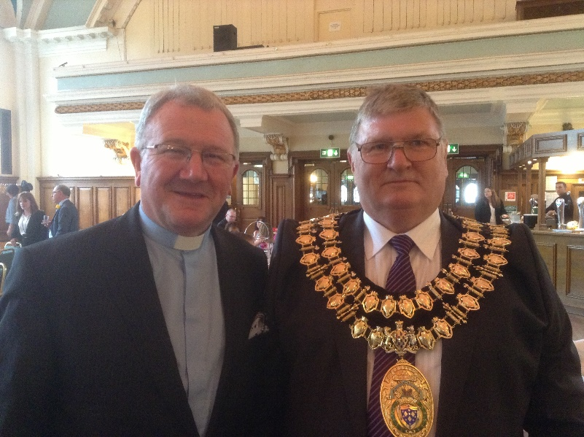
We take our role as the Civic Church very seriously and take a great interest in the lives of the Mayor and Mayoress, supporting them as best we can during their term of office. We are delighted to have hosted the Civic Service in June, to be hosting the special commemorative service on the 3rd August, and to be able to welcome the first citizen(s) of the Borough to St Mary’s throughout the Mayoral year. If you have not already read the biography of the Mayor and Mayoress, Cllr Kevin Hogg and Kathleen Hogg, here it is for you – produced by permission from the Mayor’s Office of Stockport Council.
I was born in 1947 in Wythenshawe, Manchester and have a large family. As a practical rather than an academic person, I left school at 14 to train as a motorcycle mechanic. I subsequently trained as a bricklayer progressing to Site Agent and Clerk of Works.
I have lived in Hazel Grove for the last 27 years. I was married twice before meeting Kathleen. We met in 1986 and married at the United Reformed Church, Hazel Grove in 1989 where she is now an Elder. In May 2014 we celebrated our 25th Wedding Anniversary. Kathleen was born in 1950 and raised in Stockport, and apart from six years living elsewhere, has always lived in Hazel Grove. Kathleen trained at Mirrlees as a Computer Operator, but in 1981 changed profession to train as a nurse. Kath has specialised in the area of Psychiatry for 33 years and still works part time.
In my spare time I love caravanning, and try to spend a few weeks in France every year. I have also spent several years living in Holland and speak Dutch fluently. I can also speak German reasonably well and a small amount of Italian. I am continuing my passion for languages by trying to learn Mandarin.
We are both proud to have this honour.
The Mayor's Charity will be raising funds for Stockport Royal British Legion and the Alex Hulme Foundation.
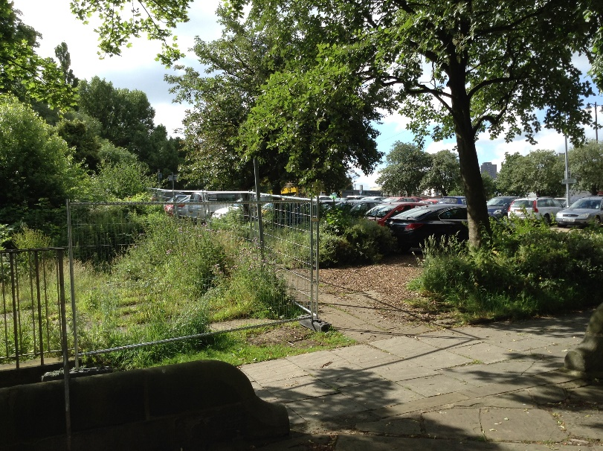
Behind the undergrowth
The “hidden” grave yard just beyond the car park has once again been temporarily fenced off for Health and Safety purposes. Now very overgrown with many of the grave stones uneven, some with signs of soil substances below, it has been necessary to restrict access until the future maintenance plans for the site can be determined.
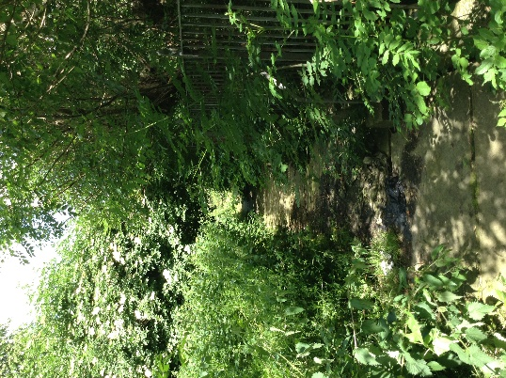
Stockport Council and presently working alongside us to determine areas of responsibility (and are seeking clarification from the Diocese of Chester on certain issues) before making long-term recommendations and decisions. We aim at the present time to restrict access to avoid injury and the dumping of rubbish etc. The graves lost (for now) but not forgotten.
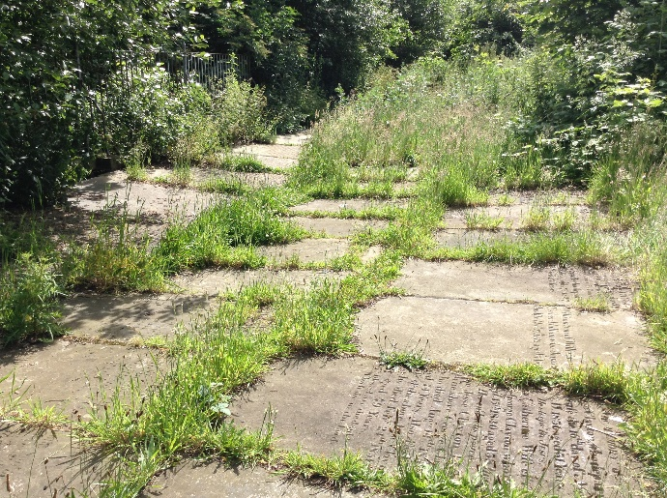

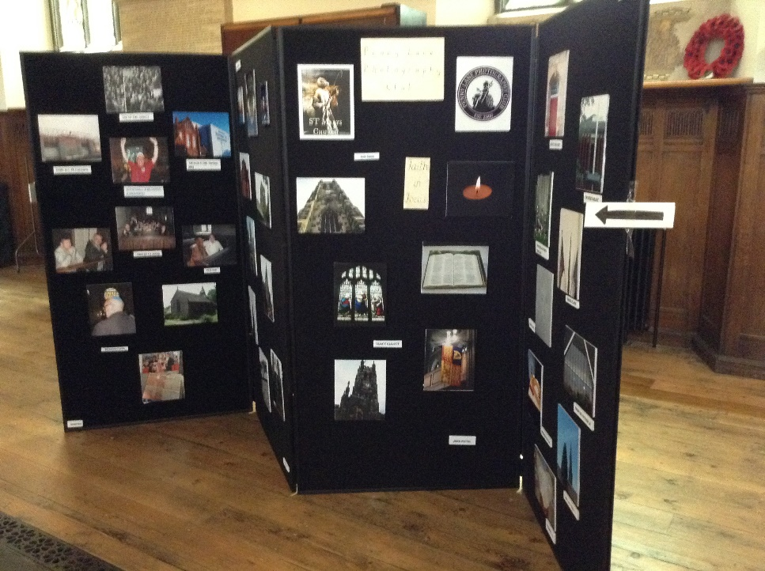

Penny Lane Photographic Club
Congratulations to the members of the Penny Lane Photographic Club and a big “thank you” for bringing the exhibition to St Mary’s. The theme “Focus on Faith” was expressed in many interesting ways – from a simple candle to a page of print – from a stain glass window to “people” photos. Very well done everyone.

St Mary’s “knit and natter”
Take up for the Thursday morning “knit and natter” doesn’t seem to have been all that good over the summer, which is probably quite understandable. However as summer turns to Autumn it’s time to think of getting together again and making items to sell at our Christmas Fayre 2014.

Sessions will start again in September.

St Andrews gets a “make-over” There is northing like a bit of “TLC” and that is what members of the Stockport Evangelical Church have organised for St Andrews. Members of their congregation frequently clean and tidy (as best they can) in support of our efforts, but have taken things a whole stage further. The cross outside the main entrance has been re-painted and the front step repaired. Having found our tins of “brick red” paint (purchased last year but with no opportunity to apply it) the top of the boundary wall between St Andrews and Hall Street is has finally been painted. Following our agreement to purchase the paint etc. required for further work(s) to be undertaken, much of the external paintwork is now looking clean and bright. Weeds have been removed from between the flagstones – some of which have also been pressure cleaned. It’s all starting to look really good. Thank You to the gardening and painting “team” – true friends of St Andrews.
Thanks too to Stockport Children’s Services who have funded and provided the resources to replace the two internal doors to the storage areas. These have been in need of replacement for years, with broken locks and handles on damaged doors.
HOWEVER…. There is still much to be done and a few years now since we moved in over a couple of days and cleaned and decorated internally. We need to sort out communal space, some internal re-decorating is required and of course a “deep clean”. We have rather a lot of chairs – all need checking for safety and given an annual wash-down. The tables (most of which need replacement) also need checking for metal fatigue, with damaged items removed and disposed of.
Anyone, available to help?
With St Andrews in use every Saturday and Sunday, weekend working isn’t going to be a serious option. We are therefore looking for some help on a Monday/Wednesday when St Mary’s is closed and on dates where we have no daytime books at St Andrews. As some of our groups don’t meet during the school holidays, this looks like a good time to start. If you are able to offer some support with any of these maintenance issues, please let us know, so we get a team together.
Stockport Old Town Fringe Festival
Friday 29th August to Sunday 31st August.
Our aim is to be involved in this special weekend with activities running at St Mary’s – live music broadcast via our speakers into the steet outside.
St Mary’s will remain open for events and visits after the morning service on Sunday. Helpers required to welcome visitors Friday, Saturday and Sunday as well as to assit the Nave Café as required. Come and join us for something a little different!

We have not touched on Growth Action Planning for awhile but exciting times ahead…
The primary aim of Growth Action Planning is to help each church in the Diocese to focus on what God longs for it to be like in 5 years time. The church will then decide on its priorities in the coming year. The aim of this is to ensure that each church uses its energy and talents wisely. It follows from this that the most important thing in GAP is to discern God’s calling for our own church and this means that prayer is central to all that we do in GAP. Working on our new plan, in preparation for reporting first to the Parochial Church Council, are Adam Pinder, Catriona Smith and Rita Waters.
Also in the pipeline – “God Loves Offerton” has the approval of the Parochial Church Council to use St Mary’s for monthly evening worship on a Saturday primarily for young people – a bold step but an important one that churches work together to encourage young people to meet with others from other churches and none. The PCC have agreed that the logistics would need to be worked out first and a meeting will be arranged shortly with the Rev Gareth Robinson. The intension is to run the first trial sessions on the 4th October and 1st November.
Our visitors are important and we welcome a lot of people to St Mary’s
Our “front of house” – first impression - has to be “spot on”.
This is one such example “The Visitor”
It was a lovely sunny day, and we had just finished our service, when a stranger walked through the glass doors. “Can I help you?”
“What a lovely church. I’m from Germany” he said, then apologised for his English accent. The gentleman asked many questions about the building. I told him about the crest pointing it out high up and also about the Altar window with the deep blue glass which came from France many years ago. He asked about the building – what is it called? I said “This is St Mary’s”, (forgetting to add “in the Marketplace”).
“Which faith is it – Catholic?” “No, Church of England”. I told him it had not been long modernised with chairs now, but before, we had pews. He paused a minute – “Pews? In Germany we have chairs, but very few people come, in other words the churches are empty” I told him we have a smallish congregation on Sundays. He also mentioned that he was over here for one year on contract. He said he had visited Chester Cathedral.
The gentleman left, thanking me as he passed through the glass doors. He was asking about the graves, so I went to his aid once again. He noticed a child’s grave and asked, “Do they die young?” Remembering my great great-grandfather, I said “Yes, they did in those days”, and told him about my ancestors. We lost a lot of children in our family in that period. It seemed it was a normal thing in my family tree....
Saying goodbye, I went back to church, finished my coffee and left to take the free bus home. Chris Knight
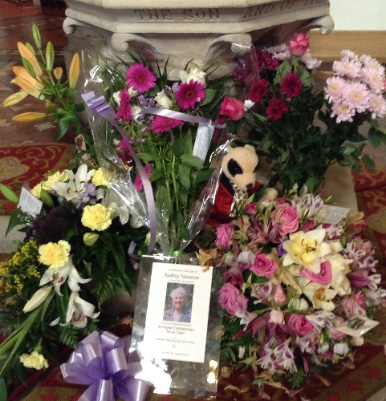
Floral Tributes laid beside the font during the service of thanksgiving for the life of Audrey Nasarow.
The funeral, conducted by Roger, took place on the 26th June at Stockport Crematorium. A quiet but beautiful service well attended by family and friends. St Mary’s tribute to Audrey, a special lunch-time service on Tuesday, 1st July. A collection was taken in the memory of a much loved Audrey (raising £195 for the mission and ministry of St Mary’s – our Phase 6 Appeal). Also distributed at the Thanksgiving Service a short poem provided by the family:

In Loving Memory of Audrey Nasarow 3rd April 1932 – 9th June 2014
When I come to the end of the road,
and the sun has set for me,
I want no rites in the gloom-filled room,
Why cry for a soul set free?
Miss me a little, but not too long,
and not with your head bowed low.
Remember the love that we once shared,
Miss me, but let me go.
For this is a journey we all must take
and each must go alone.
It’s all a part of the Master’s plan.
a step on the road to home.
When you are lonely and sick of heart,
go to the friends we know
and bury your sorrows in doing good deeds.
Miss me, but let me go.
Don’t Forget:
Heritage Open Days at St Mary’s
Thursday 11th – Sunday 14th September
with the Stockport Great War Experience
Stockport Heritage Trust
featuring the St Mary’s “Tuesday” Choir & Nave Café specials

Harvest Festival Weekend
Last Night of the Proms Concert at St Mary’s
Saturday, 27th September
Our harvest festival for 2014 will take place on
Sunday, 28th September
The service of Holy Communion will take place at 10:30am with our traditional collection of items for the Wellspring. [Details of their requirements to be supplied nearer the time]. We will be running a Nave Café “Harvest” Lunch after the morning service.
A date for the diary
Advance notice that the Vikings are coming to St Mary’s
Friday 24th – Sunday 26th OCTOBER 2014
featuring
Serpentyne create a wild fusion of world rhythms, mediaeval and renaissance songs and contemporary beats. Since 2010 they have been taking this compelling mix to audiences throughout Europe.

CROSSWORD
Across
1 Of Moses (6)
4 ‘You have been weighed on the — and found wanting’
(Daniel 5:27) (6)
7 Where Jesus performed the first of his miraculous signs (John 2:11) (4)
8 Roman emperor who ordered all the Jews to leave Rome (Acts 18:2) (8)
9 Member of a conservative Jewish party in the Sanhedrin which believed there was no resurrection
(Acts 23:8) (8)
13 South London Mission (1,1,1)
16 Sure of one’s own ability (2 Corinthians 11:17) (4-9)
17 ‘At this the man’s face fell. He went away — , because he had great wealth’ (Mark 10:22) (3)
19 Airs used (anag.) (8)
24 ‘The Lord is my — , I shall not be in want’ (Psalm 23:1) (8)
25 ‘He has sent me to — up the broken-hearted’ (Isaiah 61:1) (4)
26 At or towards the rear of a ship (6)
27 Cross-carrying evangelist and world traveller, — Blessitt (6)
Down
1 Ridicule (Luke 18:32) (4)
2 Encased in strapped-on light shoes (Song of Songs 7:1) (9)
3 Cambridge Inter-Collegiate Christian Union (1,1,1,1,1)
4 ‘Father, give me my — of your estate’ (Luke 15:12) (5)
5 Assistant (4)
6 On a par (John 5:18) (5)
10 Credo (anag.) (5)
11 Beaten with a rod (5)
12 The fourth of Job’s ‘comforters’, who deferred making his contribution because of his junior status
(Job 32:6) (5)
13 Chosen as a temple attendant, he was described by Ezra as ‘a capable man’ (Ezra 8:18) (9)
14 ‘Do not store up for yourselves treasures on earth, where — and rust destroy’ (Matthew 6:19) (4)
15 Employs (4)
18 Associated with penitence for sins, along with sackcloth (Matthew 11:21) (5)
20 Association of South-East Asian Nations (1,1,1,1,1)
21 Sub-continent to which Baptist missionary pioneer William Carey devoted his life (5)
22 Recess at east end of a church (4)
23 One of the nine sons of Beriah (1 Chronicles 8:15) (4)
============================================================
Survey: The Secretary Bird has already paid the annual subscription to the web-site who supplies the monthly crossword BUT wonders if there is anyone out there who actually does it! Would be interesting to know.

