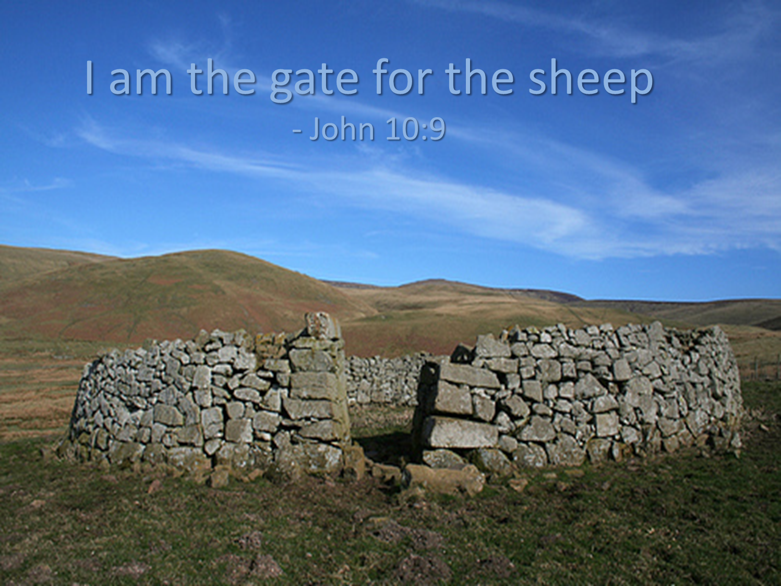

Jesus Is Our Gate and Shepherd
May 7, 2017
John 10:1-10

Grace and peace to you from God Our Father and from the Gate of the sheep, the Great I AM who leads us to abundant life, amen.
A couple of weeks ago I was sitting here in my study working on something important when I got a call from my neighbor. By the way I can’t stress the importance of having and cultivating a really great relationship with your neighbors… I think it’s in the Bible somewhere… So, I’m sitting here working and my neighbor calls and asks me if our alpacas are supposed to be wondering about in the back yard. Now many of you know we installed a very expensive fence last year to keep the alpaca herd from free ranging, so I jumped into my truck and got home as quickly as I could. Alpacas are a lot like sheep. They know my voice, but even more than my voice they know the sight and sound of the bucket that contains their Alpaca Chews. Alpaca Chews are the dietary supplement we feed them because the grasses that grow here don’t contain the same minerals and nutrients they need and that are provided naturally in their native Peru. So, the first thing I did when I got home was fill up the bright pink bucket with Alpaca Chews and started calling out their names. They all immediately looked up from their feasting on the green, green grass of my back yard and most of them ran to me and to the pink bucket that contained their delicious treats. I was able to get 7 of the ten back inside the fence, leading them like the pied piper. The remaining 3, I had to chase around and capture one at a time and drag them back to the safety of the pasture.
I tell you this story as an illustration that what John says is true. The sheep know and recognize their shepherd. Jesus is our Shepherd. Jesus is also the gate of the pasture. We are all the sheep of Jesus’ flock. I wondered what Jesus was talking about when he said he was the gate. I mean we have three gates leading into and out from our pasture. On the day of the great escape somehow the chain that holds the gate closed was either not secured or an extremely intelligent alpaca figured out how to remove it from the latch that secures the gate to the fencepost. In any case I struggled with what Jesus meant by saying he is our gate. I get the metaphorical meaning, but how does it apply.
In my research this week I discovered that shepherds back in Jesus’ day would try to find a natural sheepfold for the flock at night. Something like a box canyon where they would be naturally protected. Failing to find such a natural enclosure, the shepherd would build an enclosure from rocks and sticks. Every night the shepherd would then lay himself down at the opening and literally become the gate. Any sheep attempting escape or any wild animal or thief would have to pass through the shepherd. I have steel gates and chains, but as I’m only too aware, even these can fail. Jesus, on the other hand, doesn’t rely on manmade gates and chains, but on his body and blood to guard and protect us.
Because of the life, death, and resurrection of Jesus he has become the gate to our relationship with God Our Father. There are several theories of how God made this possible. They are called theories of atonement. Atonement is a big seminary word, but simply means how we are made one with God. How does God solve the problem of our sinful nature? God makes a way for us. Our adult Sunday School studied the various theories of how Jesus’ death and resurrection accomplished our salvation, but after spending several weeks we agreed none of our human theories truly explained the mystery of how God did everything necessary for you and for me to become saints in God’s eyes. We also agreed that the process or means God used was really not what was important. In the final analysis, what we all thought was amazing was that God would do it at all. I mean God became human, to become the shepherd and the gate for a race of sinners who turned our backs on the one who created us and who loved us despite our treason. Jesus laid his life down for the likes of me… and you… The how and why aren’t all that important, what strikes me is how much God, through Jesus Christ has done for me and all I can do is say thank you and fall to my knees and worship Him who loved me that much.
In our Gospel today Jesus says he came so his sheep would have an abundant life. I’ve thought quite a bit about what constitutes and abundant life. I know more than a few people who think being a Christian means we need to give up a lot of stuff and life a life of poverty. On the other end of the spectrum you have people like Joel Olsteen who subscribe to the prosperity Gospel, which says once you set your heart on Jesus everything will always be green pastures and rainbows. I’m pretty sure what Jesus meant by an abundant life wasn’t solely about how much stuff we have. An abundant life can be experienced in the midst of plenty and in scarcity. Jesus was talking about the type of life we live once we’re free from worrying about how angry God is with us and what is going to happen to us when we die. It’s the freedom of the Christian, as Luther put it, to be free from bondage to sin, death, and the devil in order to be dedicated to serving God and neighbor. Freedom from all that binds us allows love, joy, peace, patience, kindness, generosity, faithfulness, gentleness, and self-control to flourish. I think we can all agree a life filled with these characteristics would most certainly be an abundant life. Please notice none of these can be bought, nor do they depend on how much money or how much stuff you collect.
One final thought… Even though we know Jesus is our gate and our shepherd we still put our trust elsewhere. We trust our money to provide security in our old age. We trust our children to be our legacy. We need the affirmation of other people to make us feel happy and fulfilled. It reminds me of the story about a tourist visiting the Holy Land of Israel. As they were riding on the tour bus through the country they saw many Bedouin camps with their flocks and shepherds leading the flocks in and out and up and down the hillsides. As they approached Jerusalem though the observant tourist noticed a difference. The shepherds of the flocks in and around the city of Jerusalem were no longer leading the flocks, but was behind the herd driving them. He was yelling at them, chasing them, and even using a whip and a stick to beat them into going the direction he wanted them to go. This very observant tourist asked the guide why the shepherd wasn’t out in front leading the sheep like the Bible says a good shepherd should do. Why was he driving them with a whip and beating them with a stick? The guide explained the man was not a shepherd, but a butcher leading the herd to slaughter…
May we discern the voice of Jesus calling us from our sin filled lives to pasture with him where we receive forgiveness and an abundant life. May we be always thankful God loved us enough to lay down His only Son to be our gate to lead us not to slaughter, but to eternal life. Thanks be to God for freeing us from our bondage and giving us this abundant life, amen.

