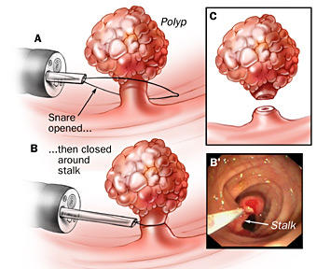
Bowel Polyps
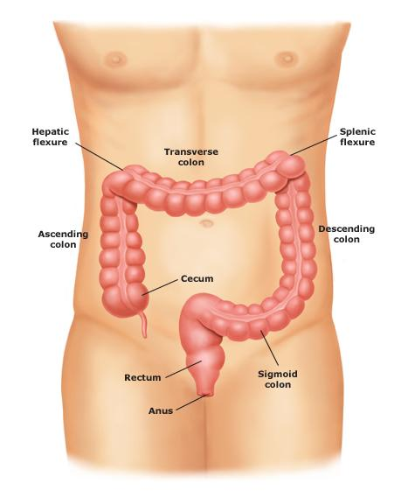
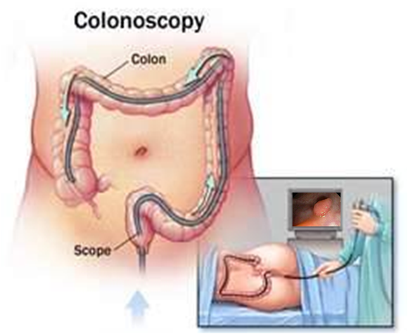

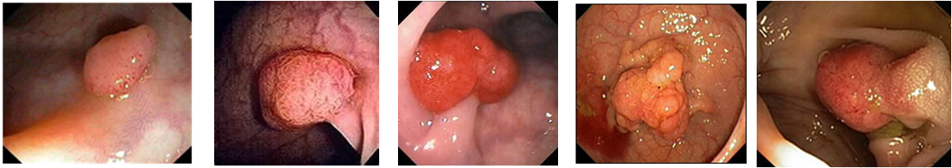

It is a general consensus that most every colon cancer begins as a non-cancerous polyp

COLONOSCOPY: A colonoscopy is an examination of the large intestine using a tiny video camera attached to a flexible instrument. This instrument is inserted via the rectum and guided through the length of the colon. A typical colon is 6 feet in length and looks like a hollow pipe with a ribbed inner lining. The beauty of this procedure is that if a suspicious area is detected by the performing physician a biopsy can be done to make an immediate diagnosis. Also, during this exam colon polyps can be painlessly removed.

POLYP: A colon polyp is an abnormal tissue growth which arises on the inner surface of the colon. Polyps typically arise because of genetic mutations in the DNA of the cells that line the inside of the colon. Polyps occur in the two basic forms of pedunculated (mushroom shape) and sessile (flat).

How to prevent Polyps:
- Take pre- and pro-biotics daily (Shaklee Optiflora)
- Insure that you provide optimal water & fibre in your diet daily
- Avoid processed food (white flour and white flour products, instant rice, etc.)
- Gentle Herbal Bowel Conditioners used daily nourish & feed the bowel lining (Shaklee Herb-Lax)
- Periodic Colon Cleansing is recommended (Celery Flush)
- Optimize magnesium intake (Shaklee VitalMag)

