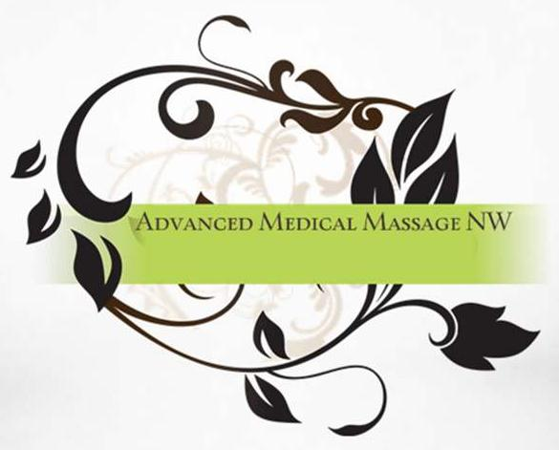

Advanced Medical Massage NW
450 Port Orchard Blvd Suite 390
Port Orchard, WA 98366
360-440-8060

Acknowledgement of Privacy Practices
My signature below confirms that I have been informed of Advanced Medical Massage NWs’ Notice of Privacy Practices. I understand and agree to its terms.
I acknowledge that this office reserves the right to change the terms of the Notice of Privacy Practices and revisions will be posted on the effective date. I may also contact this office at the address above to obtain a current copy.
I have read and understand this acknowledgement.
Printed Name: _____________________________________________________
Signature: ______________________________Date: _____________________

