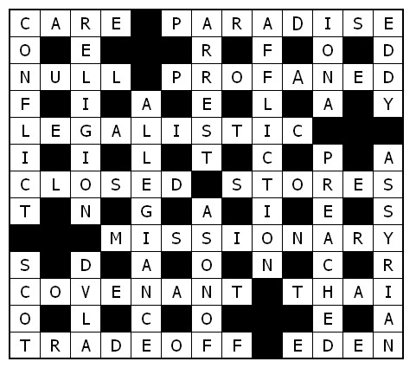

**Service times at St Mary’s**

**Sunday: 10:30am Holy Communion**

**or Morning Prayer**

Normally the first and third Sunday is Holy Communion with Morning on the second and fourth.  Baptisms by  arrangement with the Rector.

**Tuesday: 10.00am Holy Communion**

**12.15pm Lunch-time Service**

St Mary’s and the Nave Café is open – Tuesday, Thursday, Friday & Saturday from 9.00am – 3.00pm

Readers contributions to the magazine are always welcome. Hard copy (hand written if easier) to the Rectory address or by email: to : [**st.marysstockport@gmail.com**](mailto:st.marysstockport@gmail.com)

Editorial discretion with regard to content and space available will apply.

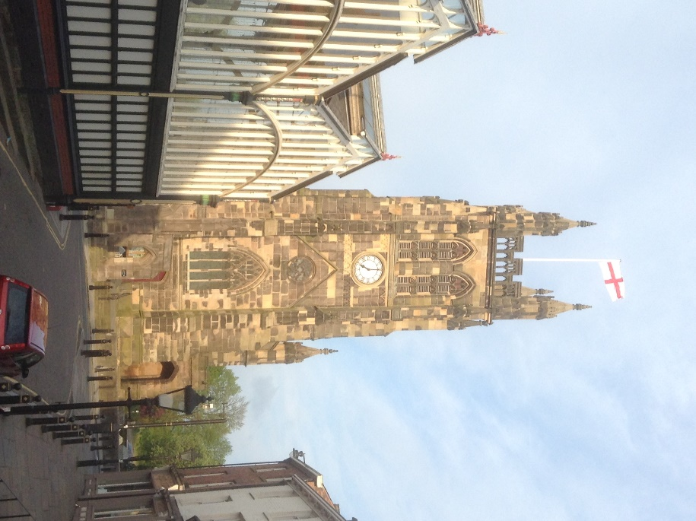**St Mary’s in the Marketplace**  
St Mary’s Rectory, 24 Gorsey Mount Street,  
Stockport, SK1 4DU.   
0161 429 6564

[www.stmarysinthemarketplace.com](http://www.stmarysinthemarketplace.com).

St Mary’s in the Marketplace

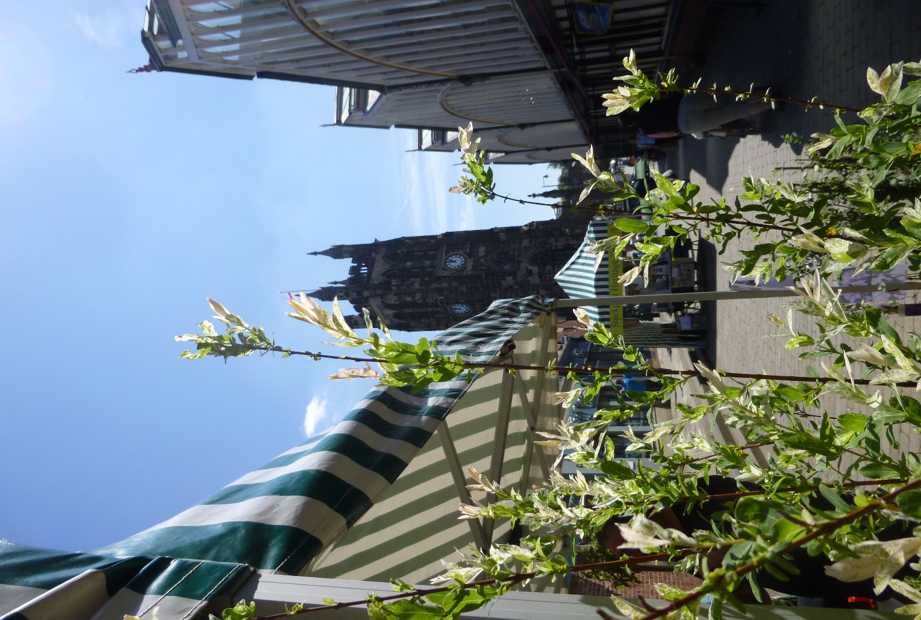

Parish Magazine

June 2014

**50p**

**From the Rector’s “ i-Pad”**

Dear Reader

On the first Saturday of next month I shall be away from Stockport conducting a wedding in a picturesque village in Derbyshire, Stanton- in-Peak, just outside Bakewell. It has a splendid view of Haddon Hall, which I learnt recently has an intimate connection with St.Mary's. It is that Richard de Vernon, whose effigy lies in the chancel, and who was Rector of this parish from 1306-1334, was closely related to the owners of the said Haddon Hall! Perhaps you knew that already! I didn't!  
  
This wedding is very special for me, because the groom is one of my godsons. He is in his 30 s and has left it a while to settle down, but he has at last chosen a lovely girl as his bride, much to the satisfaction, and relief I'm sure, of their parents!  
I attended his parents' wedding many years ago,and it has been a privilege to have known Tim and his younger brother,whose wedding in Biarritz I also took part in a few years ago, throughout their lives. I have followed his career with interest ,a fact of which Tim is aware and very grateful.  
  
Being a godparent is so much more than simply turning up at church on the day of the Christening. For me it has been a lifelong relationship of loving and caring and being concerned in prayerful and practical ways for one's godchild, without expecting anything in return. The gift of friendship and mutual respect in adult life is perhaps the gift that might be offered

**Where did the name come from ?**

That was a question raised not too long ago after Roger gave his talk about Jesus saying “I AM THE BREAD OF LIFE”

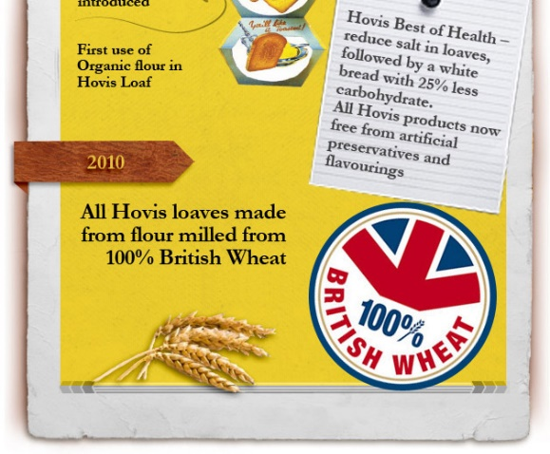“Hovis” began its life in 1886 following the discovery of Wheatgerm flour. The process was patented  on 6 October 1887 by Richard " Stoney" Smith ( 1836-1900) and S. Fitton and Sons Ltd developed the brand, milling the flour and selling it along with “Hovis” branded baking tins to other bakers.  
  
The brand name “Hovis” was registered in 1890 after Herbert  Grime won a national competition set by S.Fitton and Sons Ltd, to find a trading name for their patent flour. Grime won £25 when he coined the word from the Latin phrase hominis  vis - " the strength of man". The company became the Hovis Bread and Flour Company Limited in 1898; Hovis Ltd in 1918. Following a succession of mergers became Rank, Hovis, McDougell in 1962. When the abundance of certain  B vitamins in wheat germ was reported in 1924, Hovis increased in popularity.

Now they say “The best thing since sliced bread…”. Well Hovis became wrapped and sliced in 1931 but the television advert of the “Boy on Bike” didn’t appear until 1973. That hill (Gold Hill in Shaftsbury) is every bit as steep as it looks (says the Secretary Bird who walked up it **once** whilst living in Dorset many years ago). It soon became know by the local residents as “Hovis Hill”.

**Welcome Home**

**The Affinity Show Choir are back at St Andrews…….**

After a short break at Hazel Grove High School, the Affinity Show Choir have returned to St Andrews in their familiar Thursday evening slot.

The choir (of about seventy) is as strong as ever, busy rehearing for their programme of events, competitions and concerts.

Returning to St Mary’s in December, we look forward to hearing them once more and are delighted to have them back at St Andrews.

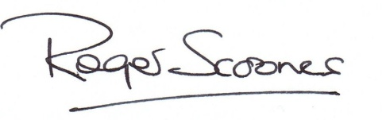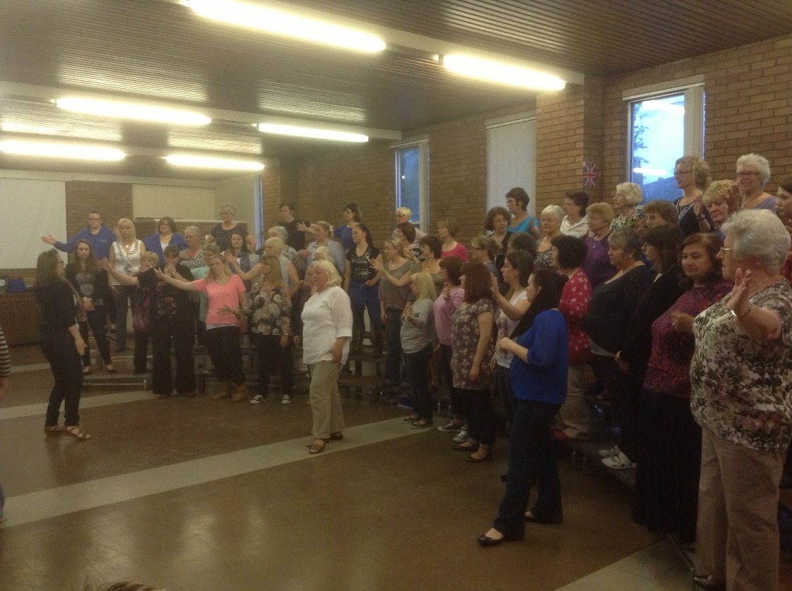

back to the godparent in due time, but not always so.

In the Order of Service I will be known as "Godfather Roger", which I think is rather touching, because that is how Tim has known me all his life.  
I will do my best for Clare and Tim on the day,  
as they make that lifelong commitment to one another, in Christian marriage. And hopefully,  
if they in turn have children , they will give to them godparents who can care for them ,as I have tried to care for my godson.  
  
So if you are thinking of being a godparent, or you are thinking of who might make a good godparent for your child, think hard about it, and don't just go for the easy option. It is a huge privilege and a big responsibility ,and can also be a blessing to all concerned throughout life.  
  
Yours very sincerely  
"Godfather Roger"

JIM CLARE .  
  
It was with great sadness that news of Jim Clare's death  came to us at St. Mary's on Thursday 22 May. Jim died peacefully in his sleep after a long and courageous battle with cancer. Our deepest sympathy is extended to his widow Margaret and her family, and to all in the Stockport Heritage Centre, which Jim founded. A full appreciation of Jim's life and contribution to the life of the Parish church and local community will follow in next month's Magazine.

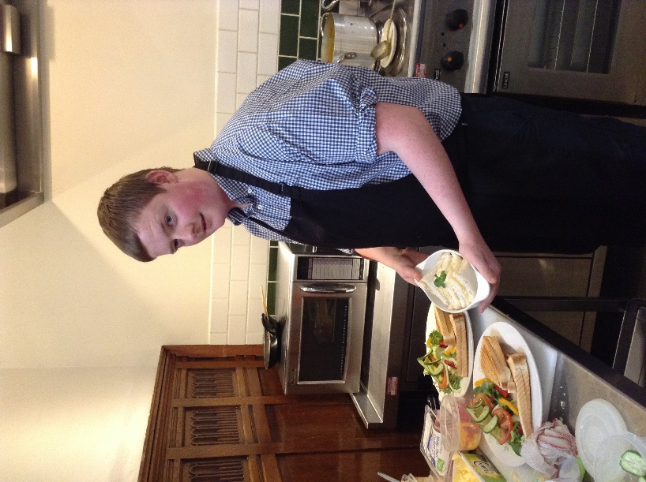**In the kitchen….**

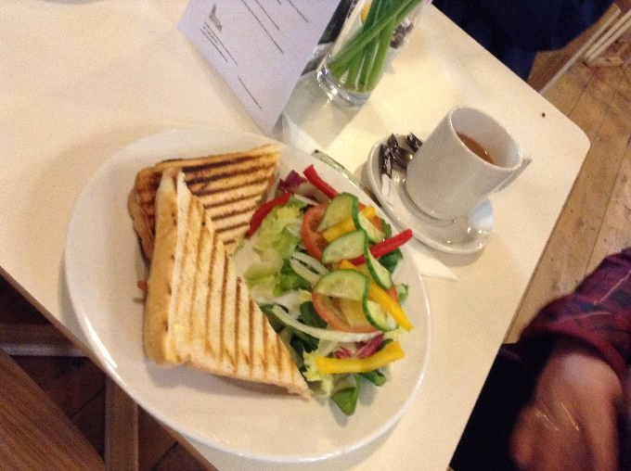

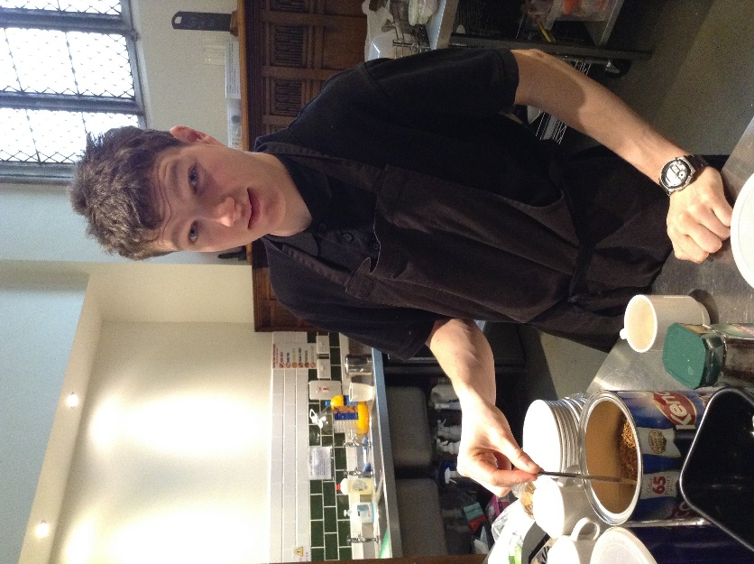Two very capable young gentlemen have joined the Nave Café team recently and we are delighted to welcome them both.

Alex McCartan (left) works alongside Pure Innovations on a Friday (when not at College) returning to work with us on Saturday.

Luke Chappell (above) is a “Loaves & Fishes” volunteer who has taken a shine to catering generally and the Nave Café, joining us in the kitchen most Saturdays.

Both are keen, capable, hard working and a delight to have with us at St Mary’s.

**The Civic Service in the presence of The Worshipful the Mayor & Mayoress of Stockport Cllr Kevin Hogg & Kathleen Hogg will take place on the 15th June 2014 10.30am**

The new Mayor of Stockport is Councillor Kevin Hogg. He is a Local Councillor for Hazel Grove Ward and his wife, the Mayoress, Kathy will stand alongside him and share his Mayoral year with Kevin with pride.   
To be the Mayor of Stockport is still a great honour and this couple will doubtless enjoy the privilege and the pleasure of being recognised as First Citizens for a year, through their many and various Mayoral activities. Not least of which will be to attend a Queen's Garden Party at Buckingham Palace in the summer, an occasion they will never forget, whatever the weather!  
  
The Civic  Service , which takes place each year in St. Mary's , is a public service to which all are welcome to attend. It marks the beginning of the Mayoral Year, and it gives us the opportunity to pray for the Mayor and Mayoress in their public office, and to celebrate the distinctive style of public service which is still held in high regard in this Metropolitan Borough and throughout the country. .  
  
This year, the new Mayor will have not one but two Chaplains, namely the Reverend Margaret Tait , recently retired from full time ministry with the United Reformed Church in Hazel Grove, together with the Rector, Roger Scoones, who has just enjoyed a year serving as chaplain to the Past Mayor, Councillor Chris Murphy. The duties are not onerous, it has to be said! But they are both looking forward to being Chaplain to the Mayor.   We wish the Mayor and Mayoress a very Happy Year in Office.

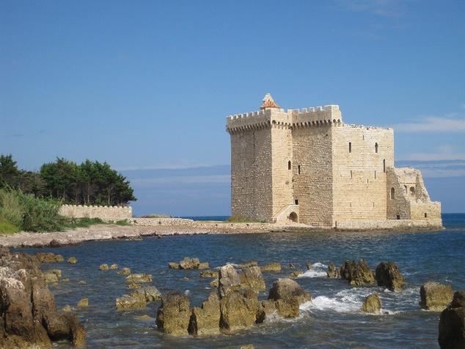**On Retreat- on the Riviera?**  
"How come you get to go on retreat to the South of France Roger, when normal people seem to go to places in the North Sea, like Lindisfarne?!"

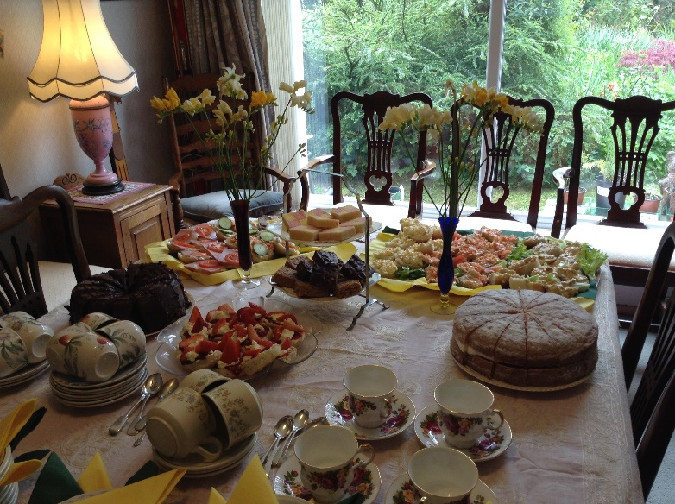That's what one of my more cynical Rotarian friends asked me a year or two ago. The answer is quite simple. "I'm invited!" What more can I say?  
  
It all began may years ago at my dear Godmother's funeral. I didn't know her family until that day, though we were related. Her son told me that he and his wife attended the English Church in Cannes, and knowing my interest in the mission work of the church in Europe, perhaps I would like to visit them one day.  The rest, as they say ,is history .  
  
On my first visit to Cannes, we went across to the island of St. Honorat for the day, with a group from church, with a picnic. It was a memorable day. As the years went by invitations came to me to join the Retreat, which is held in the monastery each June. And from time to time I have been invited to give the guiding talks to the group, who come not just from Holy Trinity Church, in Cannes ,but also from along the coast ( the Riviera as it is called) and from abroad.  I'm I am always  surprised to be invited back to speak, I have to admit. Indeed this year I had already planned to go with the group as a retreatant, but the Speaker dropped out, so I seem to have been their second

**Roger’s Daffodil Afternoon Tea   
OR Afternoon Tea at St Mary’s Rectory**

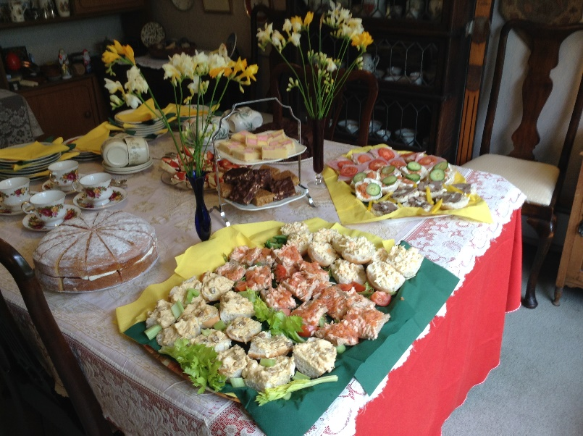It has to be said that we actually missed the flowering season – the normal host of golden Daffodils in the Rectory garden - – but there was no shortage of sandwiches and cake for those who attended on Sunday, 4th May. Thank you to everyone who supported us, the sum of £101.31 (after deduction of expenses) being collected towards “Project 2014” – Phase 6 Restoration of the Choir and Rectors Vestries.

It was lovely to see new as well as familiar faces round the table.

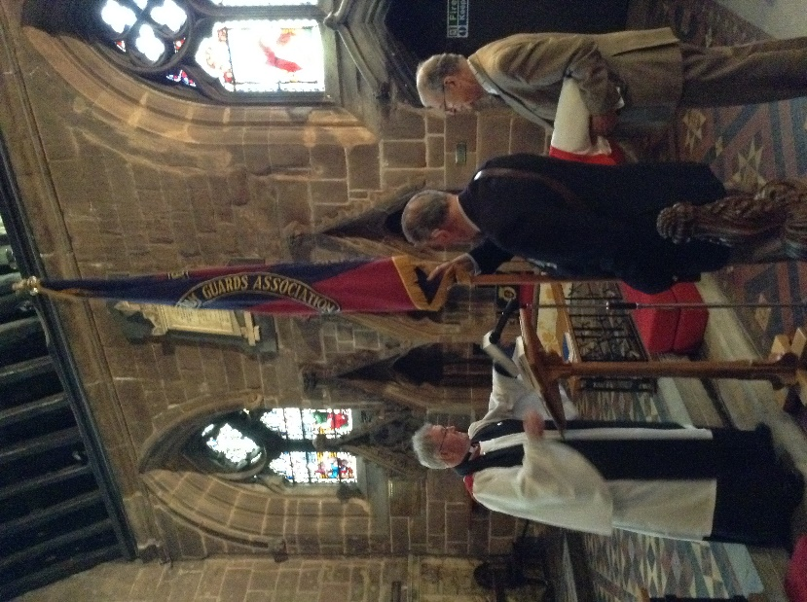**The gift of a new flag**

Presented to St Mary’s at our service of Morning Prayer attended by representatives of the Coldstream Guards Association (Manchester Branch) a new flag of St George.

It was windy to say the least on that particular Sunday lunchtime, but the flag was raised later in the day and is now to be seen bright and clean from miles around.

Thank You for this most welcome gift – our previous flag well worn and ready for replacement.

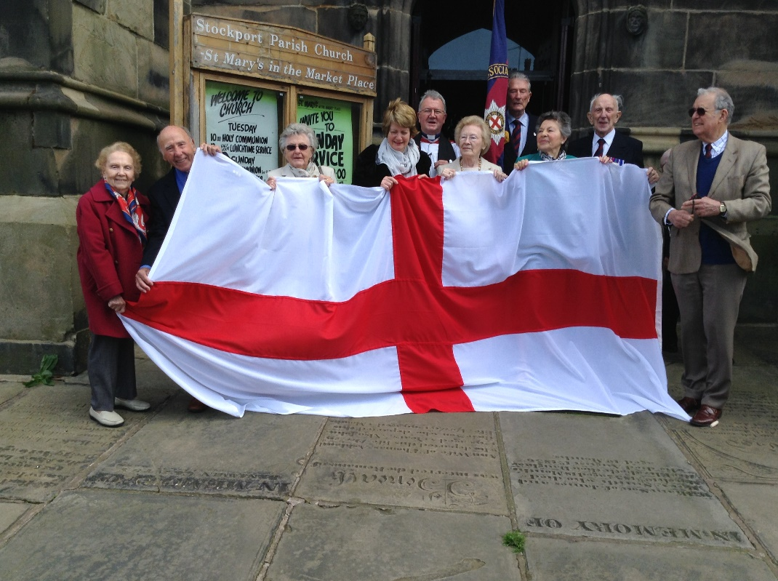

choice, which is humbling to say the least!  
  
As the Retreat leader I chose a subject, or theme, to which I speak each day. We enjoy animated conversation and I offer thoughts for the group to discuss and to go away to think about during the day. This year my theme is "Conversations with Jesus". I hope they will enjoy it.  
  
The island of St. Honorat, named after a saint who taught St. Patrick on the island before his return to Ireland in 432AD ,  
is  very small and very quiet, lying just five miles off the coast from Cannes. We arrive by ferry boat on Tuesday morning and leave on Friday morning. The group usually numbers about  20. We meet in the Monastery garden and we sleep in cells in the Cloister . We  eat our meals in silence, according to monastic tradition. it can be quite amusing at times! Individually we can chose to attend the monk's services throughout the day beginning with Matins at about 4.15 am and end with compline at 8.30 pm. All in French  naturally! As I am not fluent in French it is quite difficult to follow the chanting of the psalms and the readings. However one can worship in spirit, and join in where possible!  
  
For me the special aspects of the retreat are the warmth of  Christian fellowship and the peace of the island which is occupied solely by the monks. I also love to watch the sun rising out of the Mediterranean in the morning. And setting over the mountains to the west in the evening. It really is 'a retreat from the world' - on the Riviera!

Across

1 See 23 Across

3 Where the thief on the cross was told he would be, with Jesus (Luke 23:43) (8)

8 Invalid (4)

9 Blasphemed (Ezekiel 36:20) (8)

11 Adhering to the letter of the law rather than its spirit (Philippians 3:6) (10)

14 Shut (Ecclesiastes 12:4) (6)

15 ‘This is how it will be with anyone who — up things for himself but is not rich towards God’ (Luke 12:21) (6)

17 Mary on Isis (anag.) (10)

20 Agreement (Hebrews 9:15) (8)

21 Native of, say, Bangkok (4)

22 Deaf fort (anag.) (5-3)

23 and 1 Across ‘The Lord God took the man and put him in the Garden of — to work it and take — of it’ (Genesis 2:15) (4,4)

Down

1 Struggle between opposing forces (Habakkuk 1:3) (8)

2 James defined this as ‘looking after orphans and widows in their distress and keeping oneself from being polluted by the world’ (James 1:27) (8)

4 ‘The one I kiss is the man; — him’ (Matthew 26:48) (6)

5 ‘Be joyful in hope, patient in — , faithful in prayer’ (Romans 12:12) (10)

6 St Columba’s burial place (4)

7 Swirling current of water (4)

10 Loyalty (Isaiah 19:18) (10)

12 ‘God was pleased through the foolishness of what was — , to save those who believe’ (1 Corinthians 1:21) (8)

13 Camp where the angel of the Lord slew 185,000 men one night (2 Kings 19:35) (8)

16 ‘There is still — — — Jonathan; he is crippled in both feet’(2 Samuel 9:3) (1,3,2)

18 David Livingstone was one (4)

19 Driver and Vehicle Licensing Authority (1,1,1,1)

**Happy Birthday – Marion**

It isn’t often that we have the opportunity to report on very special Birthdays – but the 1st May was an important date on our calendar this year.

For “birthday girl” Marion Gordon celebrated her 90th Birthday and although the congregation sang “Happy Birthday” at the Tuesday lunchtime service, the actual day was celebrated with traditional “fish and chips” (and delicious they were too) with “birthday boy” Roger. Thanks Barbara for such a splendid idea, something totally different to mark the day.

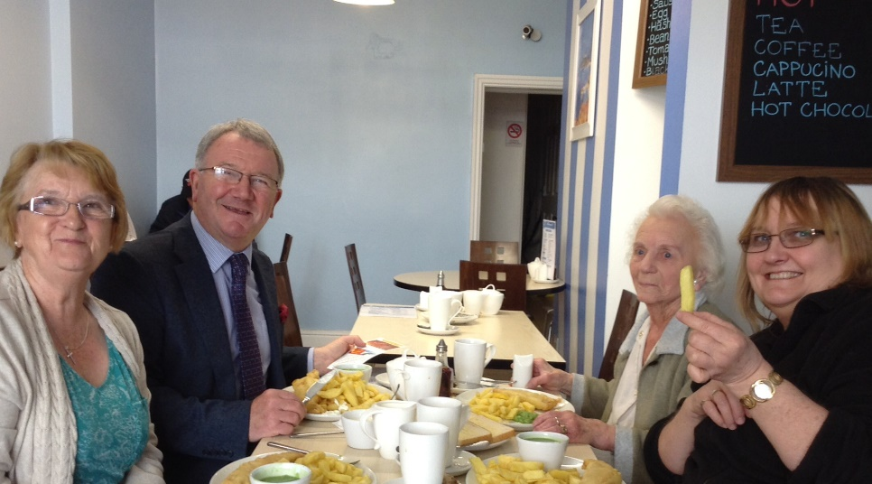

**A Day Off!**

**The Secretary Bird – takes flight!**

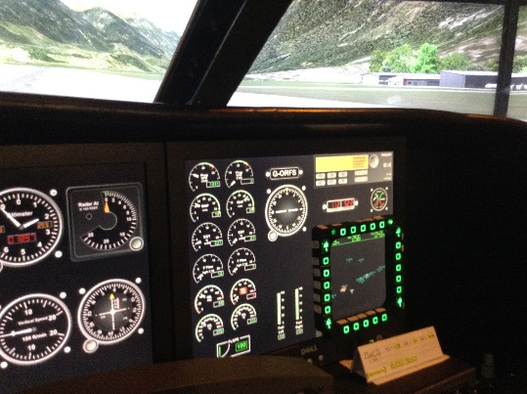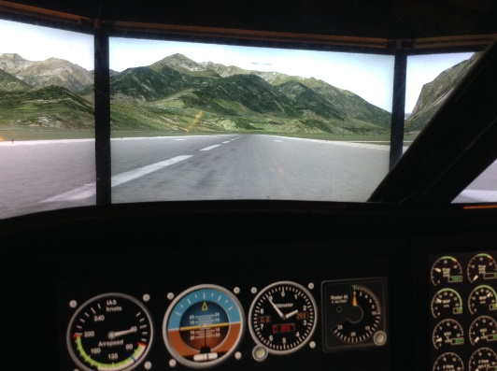It was to say the least a “squeeze” to get into the cockpit, but got there and the chance to experience flying with a very well qualified and experienced instructor. Correctly placed on the runway, take off the parking break, thrust the engine to full power and (after gaining the necessary speed) lift the nose of the plane upward into the blue sky. Wow…… so that’s what it feels like to be a real “Secretary Bird”. Bank the plane to the left, to the right and watch the world go by – but try not to “loop the loop” – well not on the first flight out! This was a light aircraft, easily buffeted by the wind and great fun but landing rather a challenge, bumping down a little too hard on the front wh eel, with a rescue from the professional on board as we ended up on the grass! Still it could have been worse.

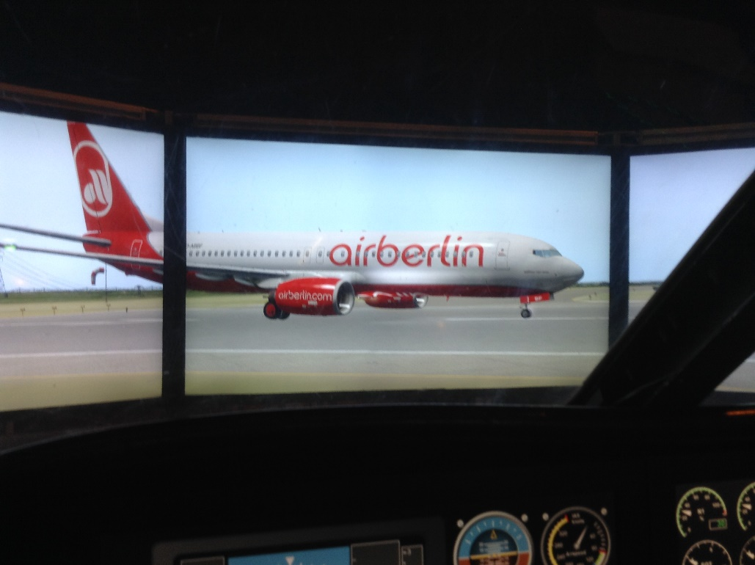Next trip, and a passenger plane, rather larger and more difficult to manoeuvre, with a time lapse between turning the controls and anything happening. Manchester to Liverpool, missed the approach to the runway alas and had to circle round for a second approach. Amazing how wide a loop that it takes to turn those heavy cumbersome jets, designed for passenger comfort rather than anything else. Wheels down, flaps down – oh dear! clearly I’m not ready for solo flying yet!

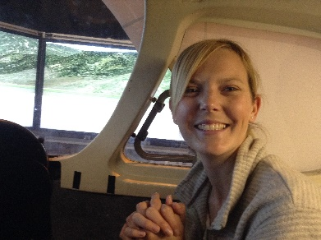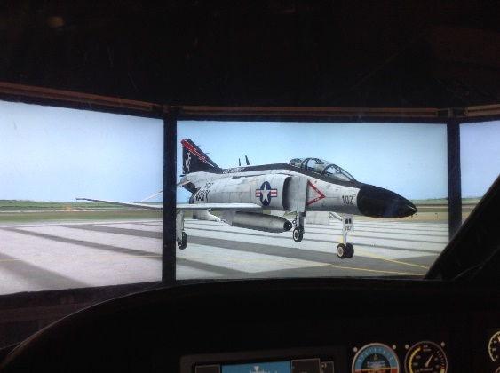Finally, a fighter jet – sleek and fast – very fast. Leaving from Valley, climbing to 3500 feet to whiz through the Snowdonia Mountain range, the idea being to land at Carnarvon, but missed that as well so we aimed at landing back at Liverpool. The approach was perfect – for awhile – you don’t appreciate how short run-ways are until you try and land on one! My instructor was of course a real pilot. I am more than impressed with her commitment to learn to fly – and the cost of such an undertaking is to say the least frightening. But what an achievement.

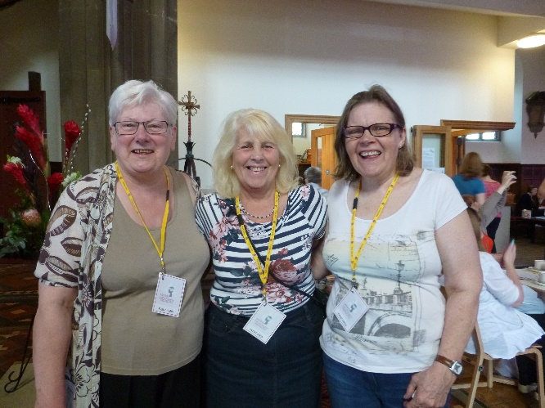Everyone had great fun, the event a big success, and it was nice to see so many members of St Mary’s involved and joining in.

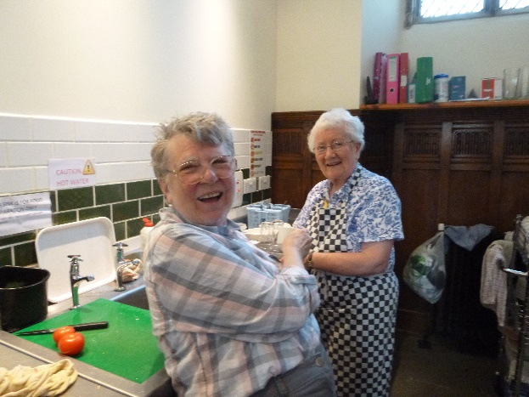

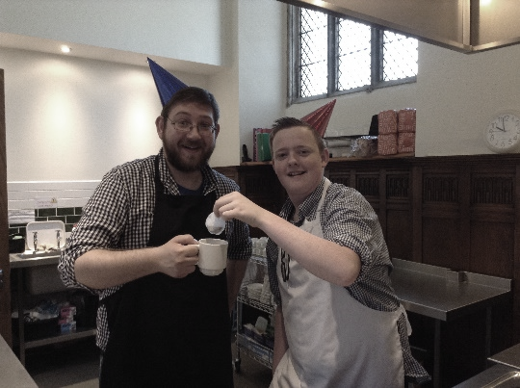

If not in the kitchen or recruited as ”Event Crew” (looking after our visitors) many others attending the show(s).

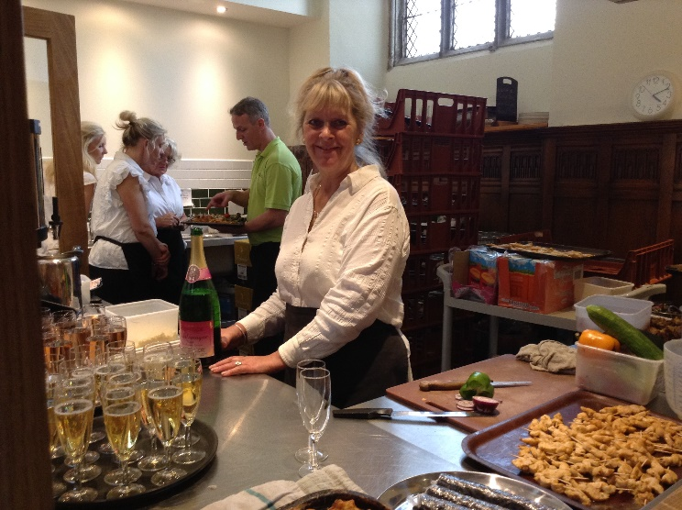It was also a first for us to share our kitchen facilities with outside caterers, and a partnership we hope to develop further in the future. To prepare a reception for 120 just a little bit too much for us to cope with, but just goes to show with a little help what can be achieved with the facilities we have available.

**Making Headway – Bringing Hatting Home and into St Mary’s**

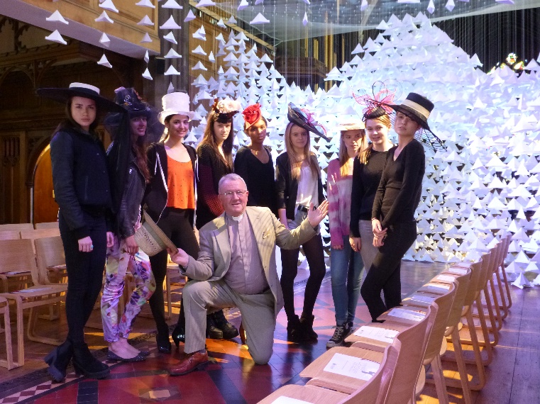

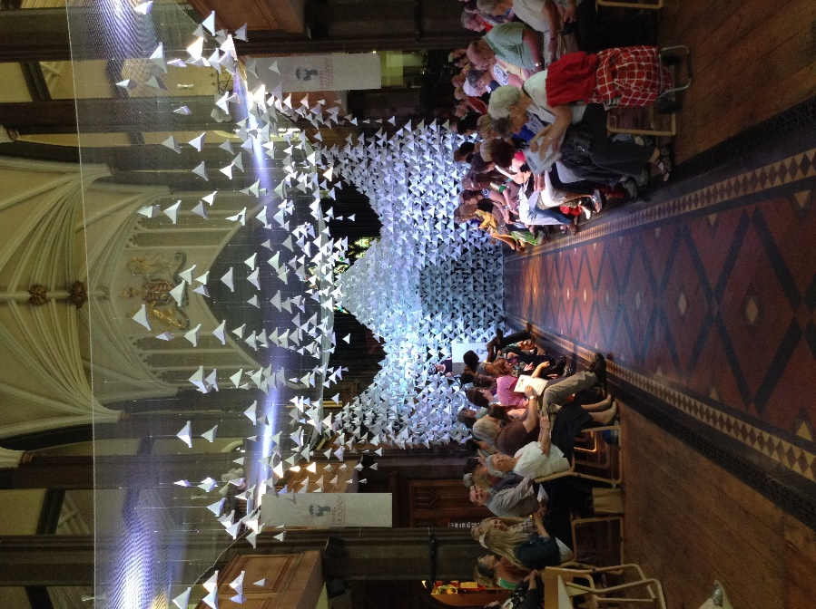

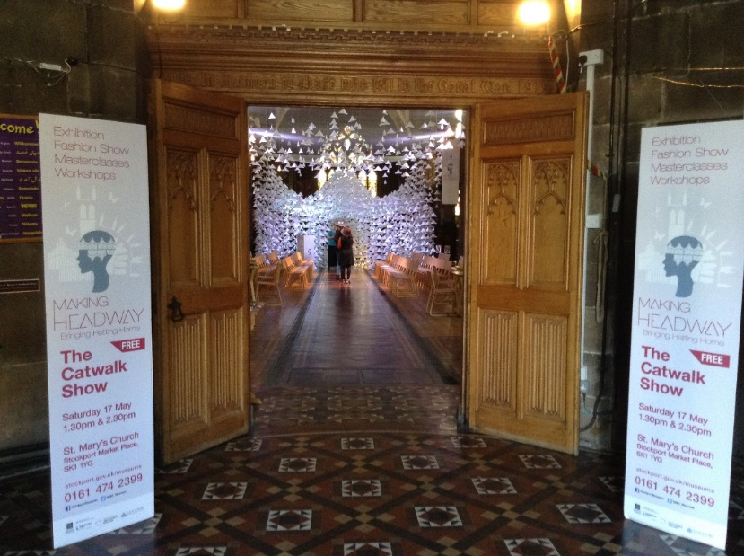It took three full days to install, and simply transformed St Mary’s into a stunning backdrop for the “Catwalk Show” on Saturday, 17th May. Two public performances, a private viewing and VIP Reception later and in just a couple of hours it was all gone! If you were unable to join us you really did miss a treat.

Well clearly my experience wasn’t strictly “up, up and away” rather in an industrial unit at Stanley Green Industrial Estate, Door Number 14.

However, after an hour “flying” I could hardly drive the car, my head still totally locked into flight controls. I had t o keep telling myself that driving home was real, and it wasn’t a simulator for pilot training. Try to keep on the road and not drift off into someone’s garden.

If anyone wants a go – Ringway Flight Sim welcomes members of the public, as well as those really learning to fly, to use their very realistic simulation. The computer graphics are really good.

I’m just wondering – should I go for real next time and actually take to the air!