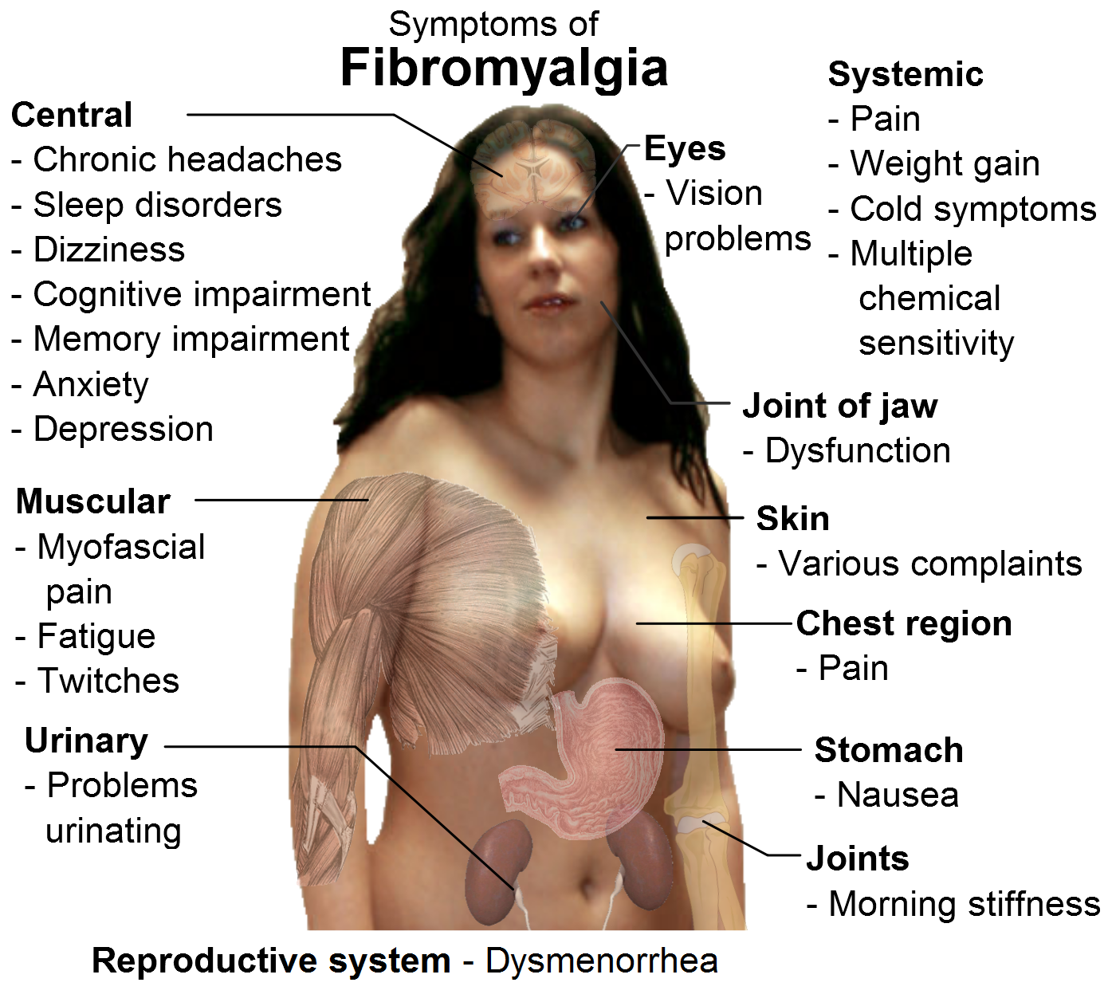
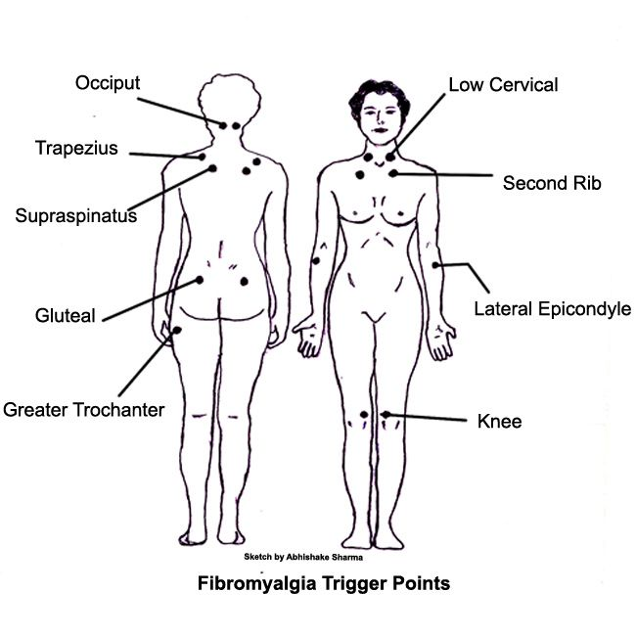

FIBROMYALGIA

What is Fibromyalgia? (FM)
FM means “fibrous-muscle-pain”. It is a mysteriously debilitating syndrome that causes pain in the muscles, joints, ligaments, tendons, and connective tissue.

Symptoms can also include: sleep disturbances, irritable bowel syndrome, digestive disorders, muscle spasms & twitches, fatigue, candida, depression, increasing allergies, etc.

1 in 10 people suffer with FM!
“Sixteen to twenty-five million people in North America suffer with diagnosed or undiagnosed FM.”

What causes Fibromyalgia?
FM is a chronic degenerative disease and is a symptom of a dysfunctional or compromised immune system.

People with FM have:
- reduced circulation to their muscle cells (lack of oxygen)
- damage to the cells’ energy production mechanism
- a breakdown of muscle protein at an unusually high rate, which causes the pain, aching and fatigue
- a reduced ability to heal and repair muscle after workout or exercise
- usually a compromised digestive system causing poor absorption of nutrients; therefore, compromised nutrition
- reduced microflora in the intestinal tract

Conventional Treatments Fall Short
Despite long years of research, there is still no ideal conventional medical treatment for fibromyalgia.
- An anti-depressant drug known as amitriptyline has been shown to provide some short-term relief, however, it is also known to have adverse side effects, including heart attack, stroke, irregular heartbeat, coma, seizure and hair loss.
- Ibuprofen, motrin, and advil are commonly prescribed, but with only temporary relief, (if any), but they all bring undesirable side effect that further complicate FM.

TEN NATURAL SUPPORT COMMANDMENTS FOR FIBROMYALGIA
- Follow the Healthy Body Diet at the end of this document – provide thorough nourishment to your muscles, tendons and bones

- Provide additional nutrients for repair & recovery with the nutritional supplementation …. see suggested protocol below. (Essential Fatty Acids are a MUST!)

- Detoxification is essential (Herb Lax & DTX + Optiflora) …sometimes heavy metals are a problem … if so, this must be addressed. Call 905-871-4281 to order a Hair Analysis Test Kit to determine if heavy metals are a problem.

- Provide aid to the compromised digestive system

- Provide optimal levels of microflora to the intestinal tract – Optiflora is ESSENTIAL for recovery

- Deep breathing is essential to increase the oxygen supply – also engage in a regular appropriate exercise programme

- Enjoy massage and/or heat treatments

- Get plenty of rest

- Reduce your internal toxin load – replace all household cleaners and personal care products with toxin-free products

- Address stress management

SUGGESTED SUPPLEMENT PROTOCOL
Step 1:
- Raw Soy Protein Powder (Soy Protein is not a vitamin, but a food.)
  - Two level tablespoons 3 times a day is equivalent to having 2 meal servings (28 gm of protein)… however, it is totally vegetarian and easily digested, and therefore, quickly available for muscle repair. (Shaklee 180 Smoothees are also an excellent choice)
  - Soy Protein is a wise choice any time of the day as a snack, especially when you are fatigued. Simply mix into juice, milk, water or cereal.

- Shaklee Vitalizer: A daily blister strip of nutrients

- Additional Essential Fatty Acids:
  - 3 tablespoons ground flaxseed per day OR OmegaGuard
  - Optional … Lecithin capsules

- Herb-Lax (as needed to maintain 2 or 3 good bowel movements per day)

- NutriFeron – 2 per day

- Shaklee 180 Energy Tea

- Vivix – 1 teaspoon per day

Step 2:
- CoQHeart

- Stress Relief Complex – 1 per day

- OsteoMatrix (U.S.) or Super Cal/Mag (Canada) … Many need more Magnesium & Potassium, in which case, VitalMag is also recommended

- Shaklee CorEnergy … PanaxGinseng /Green Tea/ Cordyceps Formula

- Alfalfa – use generously

- Ginkgo Biloba Complex (Shaklee Mental Acuity Complex)

Step 3:
- CarotoMax

- FlavoMax

- Liver DTX for liver detoxification

- Physique – take a serving when your muscles are tired for RECOVERY

- Increase Vitamin C

- Increase Vitamin E

HEALTH IS LIKE “LIFE INSURANCE” ……

Each person has to decide how much to invest in it

HEALTHY BODY DIET

CHOOSE FOODS FROM THIS LIST
Ocean Fish…at least three times a week
Low-fat dairy products
All veggies you want
Lots of fruit
Legumes – Beans, Lentils, Peas, etc.
Whole grain products – pasta, cereal, etc.
RAW nuts & seeds
Cold-processed vegetable oils ONLY
Always choose foods made with whole, natural ingredients whenever possible
Use stevia, honey, molasses, pure maple syrup, or fructose when a sweetener is needed
Drink a minimum of 8 glasses of water per day (purified water only)

REDUCE/ELIMINATE
Red meat….limit to once a week if eaten at all
All heat-pressed vegetable oils
Alcohol, coffee and black tea
White sugar
White flour
Processed meat of any kind
Organ meats….liver, kidney, brains and such
Skin of fowl
Fried foods
High-fat dairy products
ROASTED nuts and seeds
Heavily processed foods
Pre-salted prepared foods
Non-prescription, street drugs, or self medications
Soft drinks/phosphate seltzers/mineral waters
Limit salt intake

NOTES:
- 50% of your diet should be RAW
- Provide variety in your food choices
- Eat food as close to nature as possible (unprocessed and unrefined)
- Consume ADEQUATE protein on a daily basis
5. Avoid foods to which you are allergic

Fatigue
When people suffer from fatigue, the causes can be singular or multiple. The following is a checklist of the most common causes, and each area should be checked when someone has fibromyalgia:
- Anemia
- Adrenal Exhaustion (low DHEA) … this can be checked by blood or saliva testing
- Circulatory – High blood pressure or Cholesterol
  - Causes lower oxygen
  - Cholesterol meds reduce production of CoQ10
- Low thyroid (dry skin/hair falls out/cold feet & hands/weight problems)
- Toxic accumulation (bowels / lack of flora / heavy metals … a hair analysis would reveal heavy metals)
- Liver Congestion
- Depression
- Hypoglycemia
- Poor Sleep: caused by Hormones/Mineral deficiency/Low blood sugar/Stress
- Poor absorption
- Hormone imbalance
- Nutritional deficiencies

