JULY/AUGUST 2021
Dog Days of Summer?
Hmmm…..

A final month of summer ….. August ……………………….
usually the hottest, most humid days of summer, known by the ancient
Romans as “diës caniculärës”, or “dog days. The phrase is actually a reference to the fact that during this time, the sun occupies the same region
of the sky as Sirius, the brightest star visible from any part of Earth, and part of the
Constellation Canis Major, the Greater Dog.

We consider the Dog Days to be the 40 days beginning July 3 and ending
August 11. This is soo after the summer solstice in late June, which of course also
indicates that the worst summer heat will soon set in.

However you spend your “Dog Days of Summer”, we hope you continue
to have fun while the great weather lasts!

Sadly, this newsletter reports the passing of yet another member of the Class of ‘67:

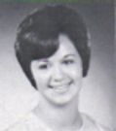
Sondra Joyce Dean Snow, 72, passed away on June 25, 2021, in her home in
West Unity, OH. While at GHHS, she participated in Block “G”, the Medical Careers Club, G.A.A., Intramurals, Spanish Club, Tri-Hi-Y, and was a Teacher’s Secretary. Sondra was the mother of two children, grandmother of six and the great-grandmother of one. She is also survived by a sister and brother, nieces & nephews.

Our sympathies are extended to Sondra’s family and friends. She will certainly be missed!

********************************



Alunni “On the Go”: We learned that Lora Finocchi Garrett takes her family on vacation every two years. This year they traveled to beautiful Destin Beach, Florida, and Linda Sindelar Steffen with hubby, Mark, enjoyed seeing their daughter, son-in-law, & grandchild during their July visit to England where they reside.

Kudos To: Sharon Travagliante Weitzman & family are proud to say that grandson, Dominic, is at football camp at
Harvard! Congratulations! Peggy Terry Berteau with hubby, Bob, won 2nd place with their original F85 1963 Cutlass” in the “Unrestored Class” at the Stan Hywet Father’s Day Car Show June 20th, and Doug Day who became a grandfather for the first time on July 20th when Weston Douglas Day at 6 lbs., 11 oz., was born. Congratulations all!

Alumni Anniversaries: Randy Stakes & wife, Kathy, celebrated 50 years together on June 19th, as did Julie Solar Ogella with husband, David! Another Golden Anniversary was celebrated June 21st by Marlette Zahler Tanzosh & husband, Jim. Gail Russler Meyer & hubby, Barry, celebrated 29 years on July 11th.

Thinking of: Christina “Tina” Sparacio Iceman who got a clean bill of health from breast cancer after having a lump-
ectomy. Marleen Krzywkowski Sooy who was unable to be included as a kidney transplant candidate with Hershey Medical Center in Pennsylvania. She is hoping that another hospital will add her to their transplant list. Mary Chadwick who began radiation treatments; Terry Blazey, husband of Valerie Schwonek Blazey, who is battling at the moment some autoimmune & kidney issues, Barry Meyer, husband of Gail Russler Meyer, who had emergency surgery August 8th for a perforated colon, and Karen Parhamovich Felon who had her 5th hernia surgery on August 20th. Also hope that knee replacement surgery for Mimi Zach, Ken Zach’s wife, scheduled for September 1st, goes well.
All of us wish you speedy recoveries!

Condolences to: Doug Day & his family upon the passing July 5, 2021, of his sister-in-law, Marcia T. Day, 72, of Valley City, OH. Marcia was the wife of Donald Day, Jr., who is also a graduate of GHHS. They shared 49 years of marriage and had two children, Donald T. Day and Jennifer Day Kunesh, and three grandchildren.
Marcia was involved in so many activities, including the Ohio University Women’s Club of Greater Cleveland and her church, All Saints Episcopal Church in Parma.

Our thoughts are with you.

Newsy Reflections & Tidbits: The“Lady Bulldogs” met for lunch at 1pm at Danny Boy’s in Broadview Heights because Michael Angelo’s Winery could not accommodate the group. The photo below shows those 8 gals who attended July 17th: Kathy Schneider Nowack, Amy Roman Kostka, Leslie Mroz Readinger, Helen Steblinski Cejer, Gayle Glowick Konet, and standing are Audrey Sopko, Peggy Terry Berteau, and Janice Wroblewski Hola.

Their next luncheon will be August 28, 2021. Ladies, to join us, just email Audrey Sopko at asopko@sbcglobal.net.

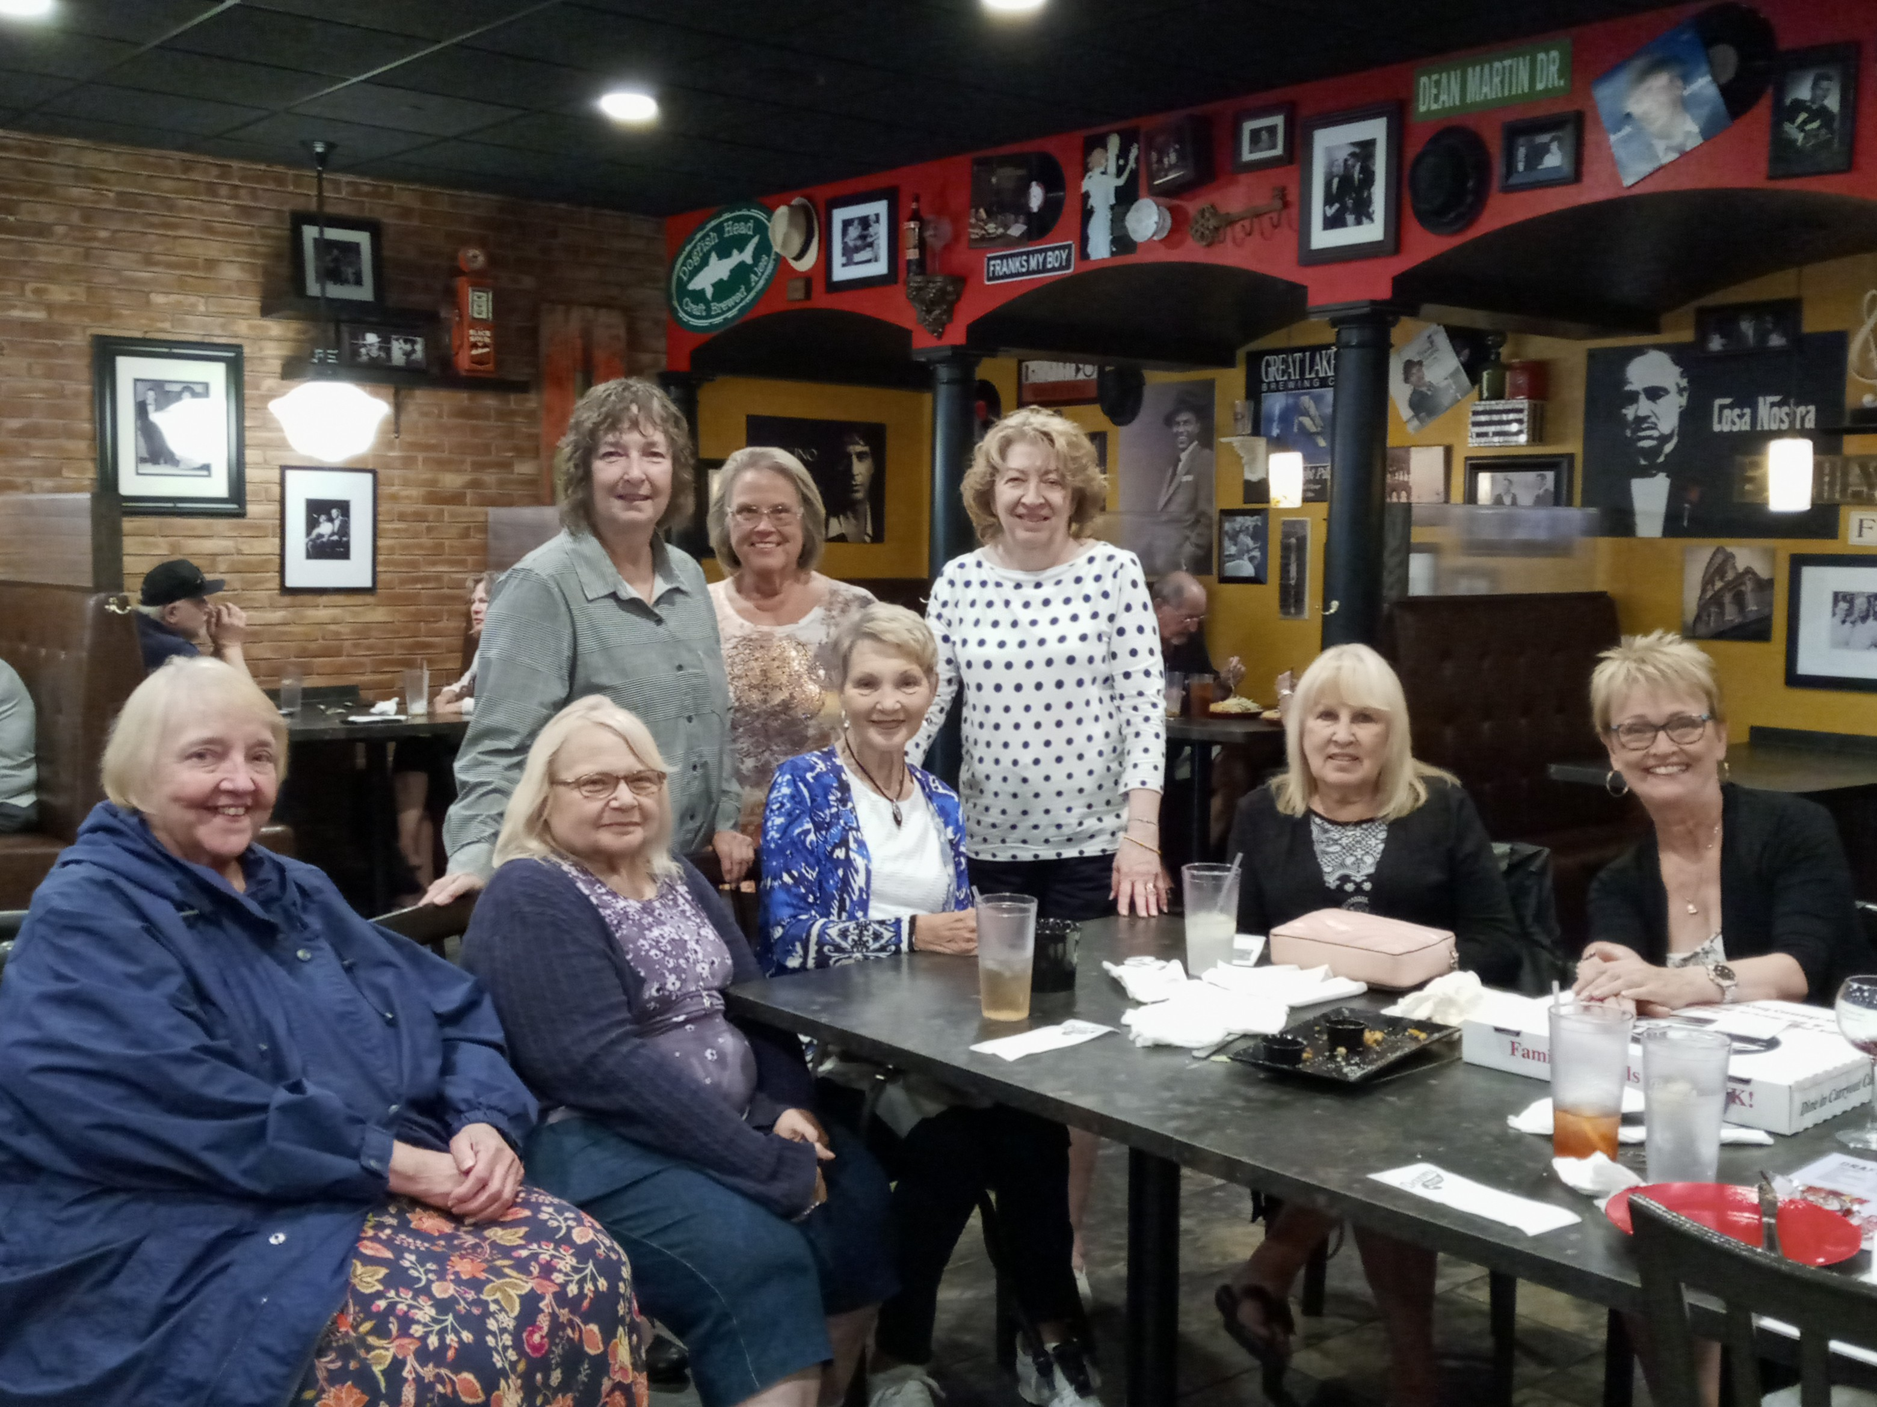

And, a little humor ……..

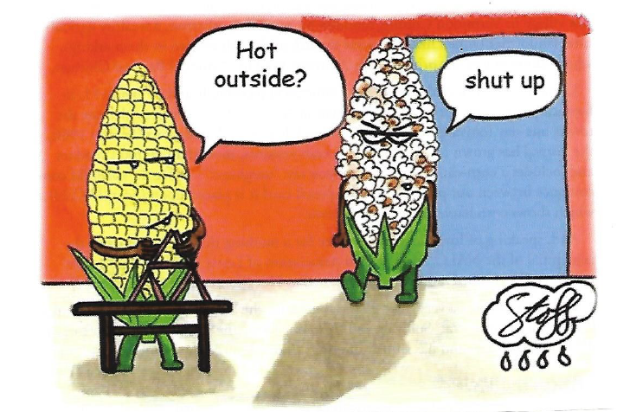

Till next time folks, go Bulldogs!

Your energetic editor,

Gail Russler Meyer

