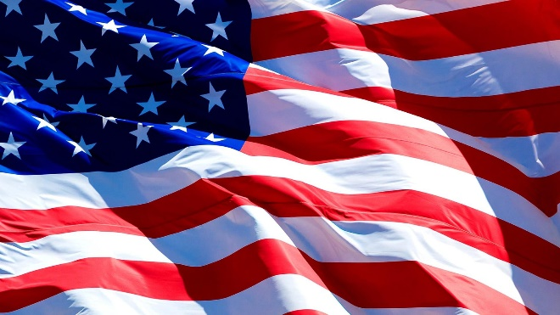
Freedom In Christ
Mark 5:21-34
July 1, 2018
Independence Day

Grace and Peace to you from God Our Father and from the one who can even raise the dead, Jesus Christ our Lord, amen.
A quote from Patrick Henry: Gentlemen may cry, Peace, Peace--but there is no peace. The war is actually begun! The next gale that sweeps from the north will bring to our ears the clash of resounding arms! Our brethren are already in the field! Why stand we here idle? What is it that gentlemen wish? What would they have? Is life so dear, or peace so sweet, as to be purchased at the price of chains and slavery? Forbid it, Almighty God! I know not what course others may take; but as for me, give me liberty or give me death.
From Abraham Lincoln: "Four score and seven years ago our fathers brought forth on this continent a new nation, conceived in liberty, and dedicated to the proposition that all men are created equal.
This week our nation celebrates Independence Day. For Americans, it should be a day that reminds us how fortunate we are. There have been people who have been enslaved by one form of government or another since man’s earliest history. Some right here in our congregation have fled the evils of Communism. Cornel and Elie Diceanu along with their son Danny and my own brother-in-law, Laszlo. If you talk to Elie, Danny or Laz you’ll very soon see a great love for these United States of America and the freedom we enjoy.
There have always been men ready to impose their will on others. Sometimes in the belief, right or wrong, they knew what was best for themselves and their fellow men. When they were right, their imposed will could be a blessing, lifting others out of lives of poverty, disease, and despair. When men desire to rule over others with right motives much good can be accomplished. Martin Luther called this the left-handed rule of God.
Our founding fathers came from a religiously repressive environment. I believe that’s why they insured life, liberty, and the pursuit of happiness were the first inalienable rights they included in the Declaration of Independence. These were men of different religious outlooks, but they had a burning desire to live where they were free to worship God as they saw fit. Many of our most important documents are framed around their love of God… One nation under God…indivisible, with liberty and justice for all. One nation, under God, not above, not even alongside, but under God.
Separation of church and state. Our founding fathers wanted that. What a can of worms that has become in the last 30 years. Every day in the courts around this nation there’s a case somewhere concerning the issue of separation of church and state.
When I attended elementary school we started the day with a prayer and we recited the pledge of allegiance. Church AND state. In school. Still today in some places prayer in school is still allowed. I go to the FM High School most Wednesdays during the school year. We meet in a classroom with kids who want to come and share their faith and to pray for their school, for their families and friends, and for our country and world. Despite our access to the FM High School, prayer is rarely allowed in most other places.
What separation of church and state means today in most places around the country is that belief in God, in the Bible, in prayer, in anything concerning love and worship of God, is being slowly being eroded and stifled by our increasingly secular society in the name of separation. The irony in all of this is that our founders weren’t concerned about God being in the State. They firmly implanted God there in the wording of our founding documents. What they did not want was the State sticking its nose into our religion. They left religious repression behind. They wanted one Nation, under God. Under God’s authority. Under God’s continued blessing, mercy, and love. It seems anytime humans are left to our own devices long enough, things begin to go sour. Our country is only a couple of hundred years old, yet, here we are, drifting slowly back toward the religiously repressive past our country was founded to escape. It’d be funny, if it weren’t such a sad statement concerning the sinful nature of the human condition.
I know no one likes pessimism. Neither do I. But I have some bad news. This will never end as long as broken and sinful people rule this earth. If the world as we know it ends tomorrow or five hundred years from now, people will still be struggling to keep from coming under the will of God.
So, what is the appropriate way to celebrate Independence Day? By getting drunk, firing off fireworks and guns, and gorging ourselves on barbecued meat? How about this? Why don’t we celebrate the independence of our “one nation” by staying “under God”. No one can be sure that our country is more or less loved or blessed by God than any other. I don’t know how you feel about our country, but I personally feel we, as a nation, have been especially blessed by God. When Israel stayed under God, He stayed over them. This nation was founded “under God” and I believe He has blessed us for it.
Every one of us wants freedom. From the time we are toddlers we want more and more freedoms. We want to be in charge of us. And we can, as long as our personal freedoms are “under God”. And even better than that, when we are free in Christ, no one can enslave us any longer. When you are under God, you can disregard all the cultural and social taboos that keep you from being the whole and complete person God intended you to be. For example in our Gospel this morning the woman with the 12 year flow of blood wasn’t free to be or do much of anything. She was outcast from the Church, from society, and even from her own family because she was considered ritually unclean. One thing changed all that for her. She trusted in the goodness of Jesus and that freed her to risk everything to make her way through the crowd and touch this new wonderful Rabbi who has been performing miracles all around the region. In the other story from the Gospel, the synagogue leader, Jairus was also freed from the chains that bound him. Trusting God freed the Jairus from the shackles of his pride and his worry about what the other Jewish leaders might think of him for prostrating himself at the feet of Jesus and begging Jesus to heal his daughter. When you’re living under God nothing can rule over you, except God’s love and mercy. You can lock me up and take away all my physical freedom, but I can be as happy as I choose wherever I am. You can’t jail my spirit. You can kill those I love, but in Christ, we will reunite. You can kill me, but in Christ I have already died and I now live for Christ. In the Gospel according to Saint John, Jesus promises us, “… if the Son makes you free, you shall be free indeed.” Never has there been a more true statement. Never has there been a more comforting statement. When Christ has freed you there is no force in this world that can take that away from you. When Christ has freed you, it is of little matter where you live, or how well or poorly you live. When Christ has freed you the things of this world become less and less important. Who cares if I am in jail when heaven awaits me? Why should I be depressed about a body that is slowly getting weaker and older when there is a new one that awaits me? Why should I fret about money when I know God provides me my daily bread and everything I need to live abundantly?
So, this week, may we all celebrate our freedom. Oh sure, we celebrate the freedom granted to us because of God’s left-handed rule through our government, but more importantly, our freedom we have that nobody can take away, the freedom we have to live under God, amen.

