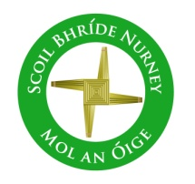
Scoil Bhríde
Nurney, Co. Kildare
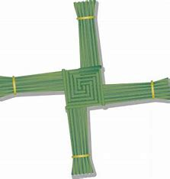
Telephone: (045) 526767
www.nurneyns.com
sbnurney@gmail.com

25th January 2023
Dear Parents/Guardians

Enrolment (September 2023) Closing Date is February 15th
For more details, please see the reverse side of this note. Thank you.

Swimming
A six-week course of swimming classes in K-Leisure Athy for 4th class starts on February 22nd. Payment of 50 Euro from each 4th class pupil is now due. Thank you.

A six-week course of swimming in K-Leisure Athy for all other senior classes will start as follows:
3rd class – April 26th 2023

Dance lessons for all pupils
A 6-week course of dance classes for all pupils with a specialist instructor starts on February 23rd. Payment of 5 Euro from each pupil is now due. Thank you.

Kildare Lilywhite Day
To celebrate the arrival of Spring, the feast of Saint Brigid and all things Kildare, all pupils are invited to wear anything ‘white’ on Thursday February 2nd. It’s also our way of giving a nod to all our heroic and amazing Club and County GAA football, hurling and camogie players, management teams, referees, officials, grassroot volunteers and workers (past and present) and the exciting season ahead, in particular all those with a close connection to our school. Thank you for sharing your skills and for showing all our young pupils the merits of dedication, practice, patience, hard work, planning, teamwork, volunteerism, dreaming big and how to take great joy in our national games. Up Nurney and up Kildare!

Home Learning page on our school website
If your child has to isolate or stay out of school due to COVID-19 or any other illness, please go to the following link on our school website to access the topics they would be doing at that time in class https://www.nurneyns.com/home-learning

Parent Teacher Conferences
Parent Teacher conferences will be held on a phased basis in February. You will receive notification from your child’s class teacher over the next few days via text and email. Thank you.

Dates for your diary
- School closes at 2pm for all pupils on Thursday January 26th 2023 to accommodate a staff meeting. Bus has been told.
- School will be closed on Monday February 6th for Saint Brigid’s Day.
- Ceremony of light 6th class – February 7th 2023 @ 7:30pm in Nurney Church.
- Mid-term break closure – School will be closed on February 16th and 17th
- Saint Brigid School Mass – Friday February 3rd @ 11:30am in School Hall. Parents welcome. Very limited space. Possibly standing only.
- School Book Fair – March 9th and 10th
- The Parish office wishes to inform you that Communion for families with children in 2nd class will be May 13th 2023 @ 11:30am in Nurney Church
- The Parish office wishes to inform you that Confirmation for families with children in 6th class will be March 25th @ 12 midday in Nurney Church

Wednesday Note and school information also available on
www.nurneyns.com
Thank you for your co-operation with the above.

__________________________
Dr. Vinny Thorpe – Principal
Ed.D (SL) M.Ed (SL), MA.Comp.Mus, H.Dip.Prim.Ed, H.Dip.Mus.Tech, P.Grad.Dip.Ed.St(SEN), B.Mus.Ed(H.Dip.Ed), Dip.Mus.Ed, T.Dip.ICT
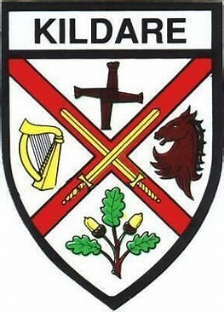

* Junior Infant Enrolment Process and Timeline

- “Expression of Interest in Enrolment Form” available from school website all year long. This Form puts applicants on a mailing list only.
- Enrolment forms posted to families on mailing list first Friday of February.
- Enrolment Forms to be returned to the school fully filled in by 3pm the last school day before February mid-term break.
- BOM meets the second Tuesday in March to (firstly) prioritize Enrolment Applications based on the Admissions Policy criteria (secondly) create a list of offered places and (thirdly) create a waiting list for places.
- Letters offering a place are sent out on the second Friday of March. Letters informing applicants they are on the waiting list are sent out on the second Friday of March also.
- Acceptance of offered place letters are to be returned to the school by 3pm the last school day of March along with a non-refundable deposit of the applicable book rental payment. This payment is not a condition of enrolment. It merely allows the school to purchase your child’s Book Rental Books so they are in place for your child in September.
- During the month of April, the BOM meets to (firstly) discuss, create and finalize an accepted places list (secondly) to review the waiting list and decide if places are available for those on the waiting list (thirdly) issue letters to those who have been successful/unsuccessful in gaining a place from the waiting list.
- The induction day for new junior infants and their parents is held on a date in June.
The school’s Annual Admissions Notice can be accessed here www.nurneyns.com/enrolment

