Child’s name_______is going to the Acacia room!

(Insert image of child)

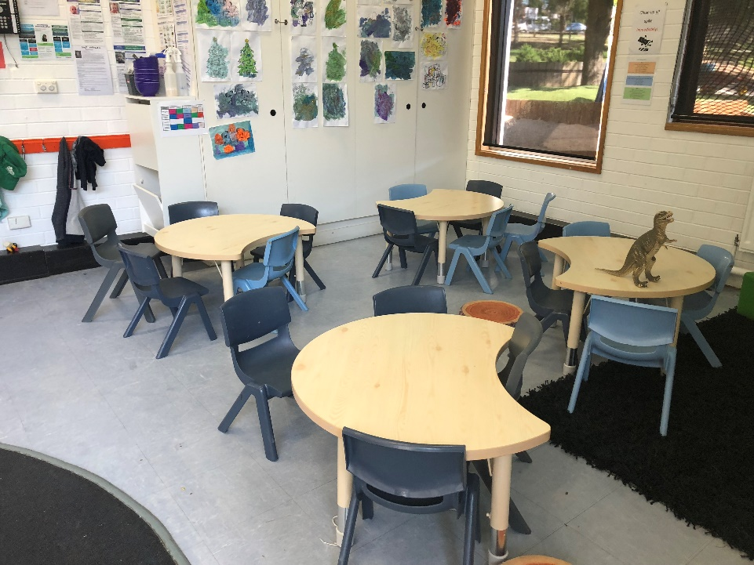
This is the Acacia room.

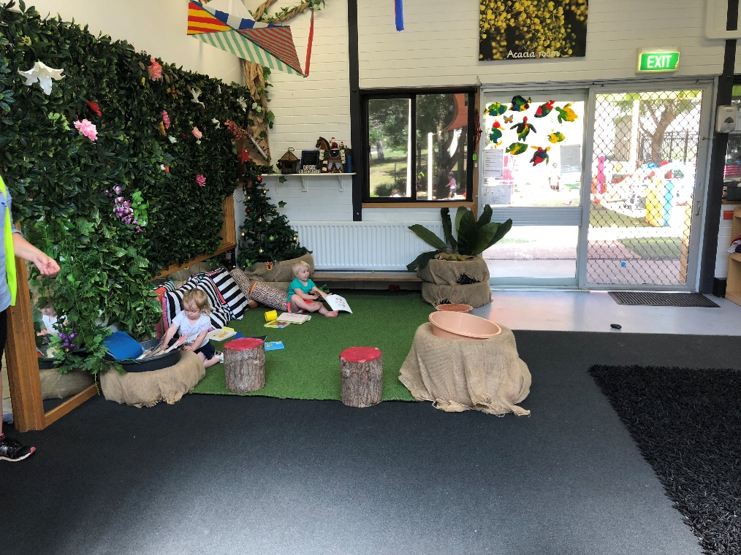

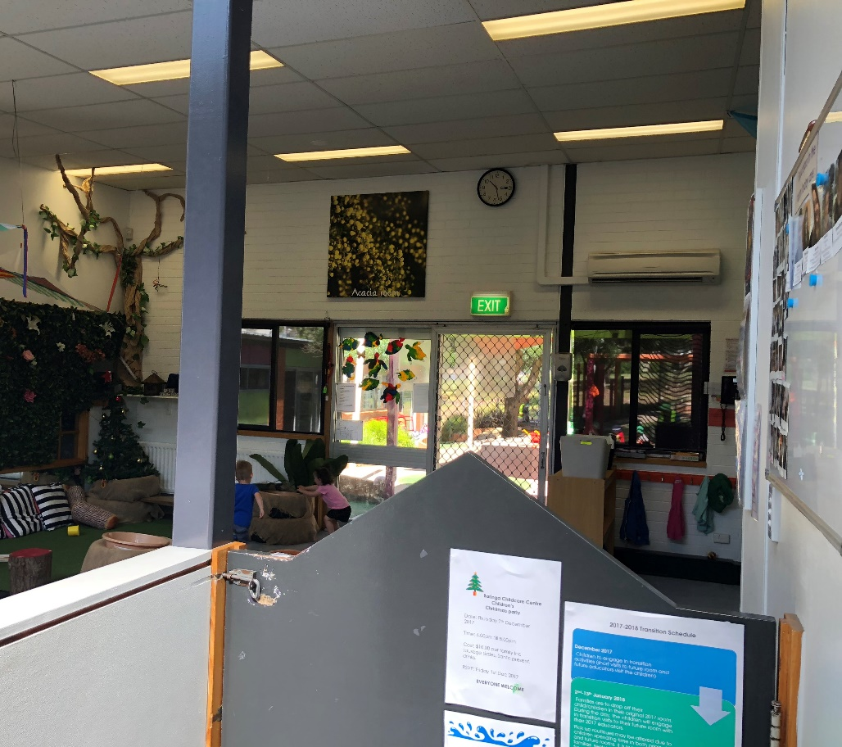

Child’s name will put his/her bag away in the Acacia room.

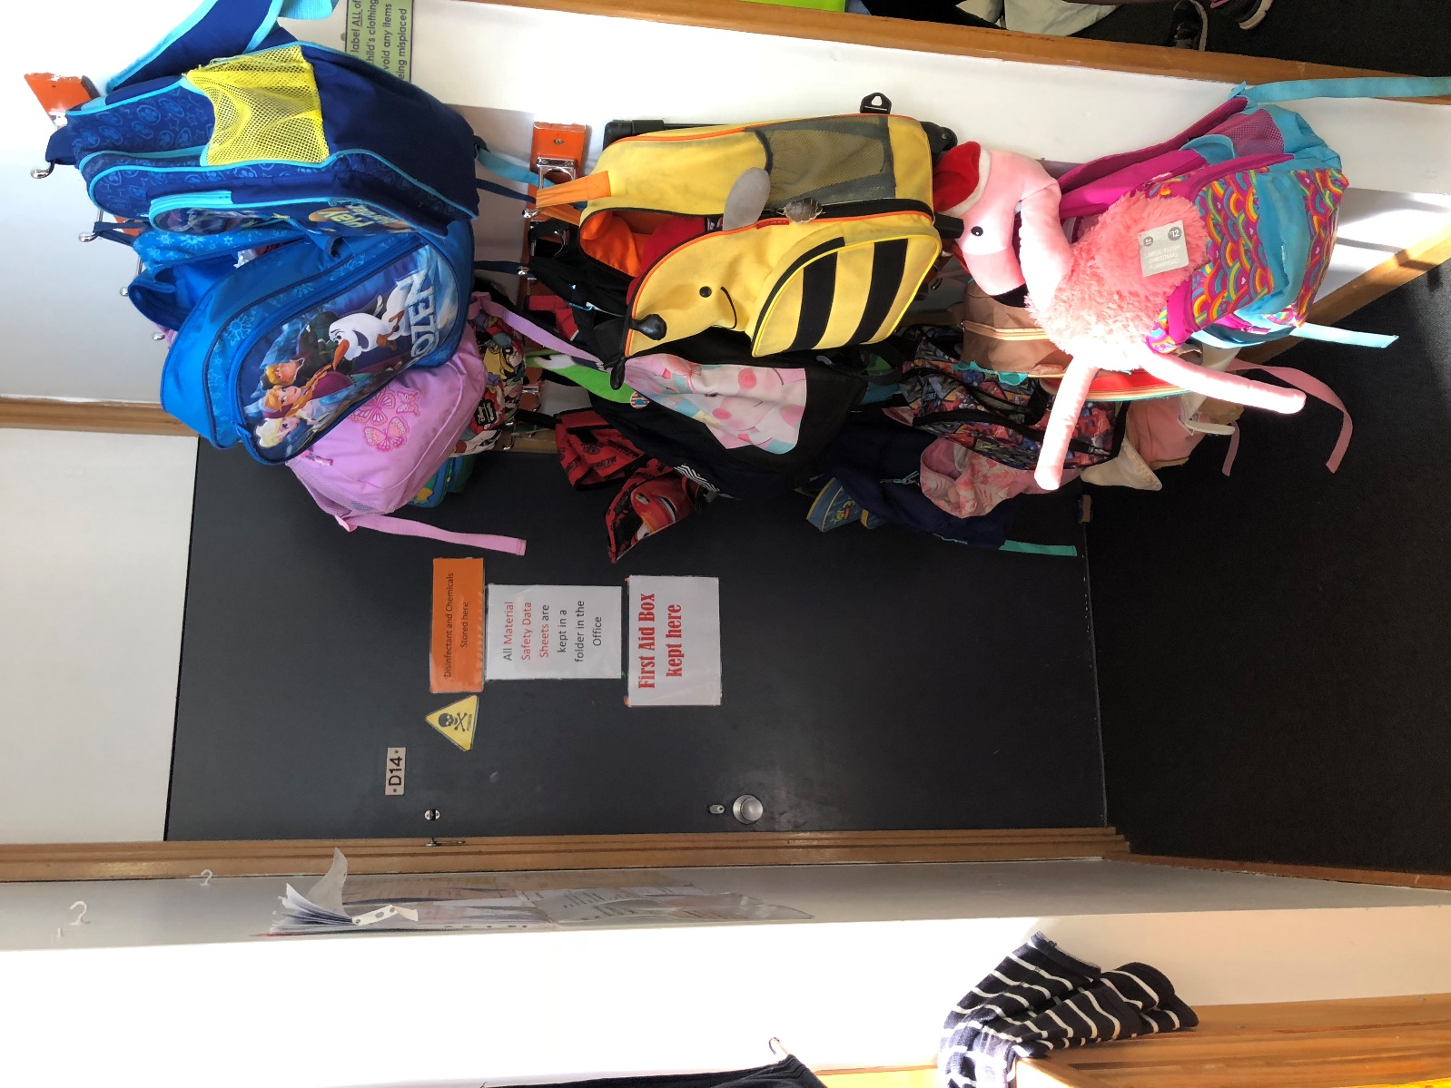

Child’s name will say hello to…
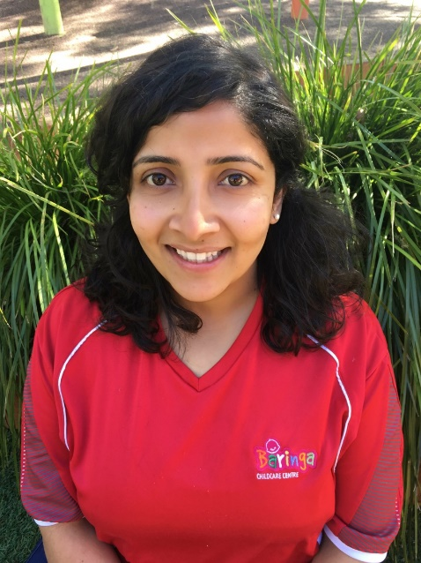
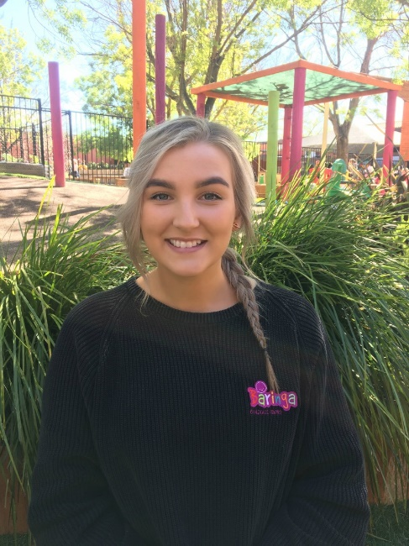

Lauren Bethel
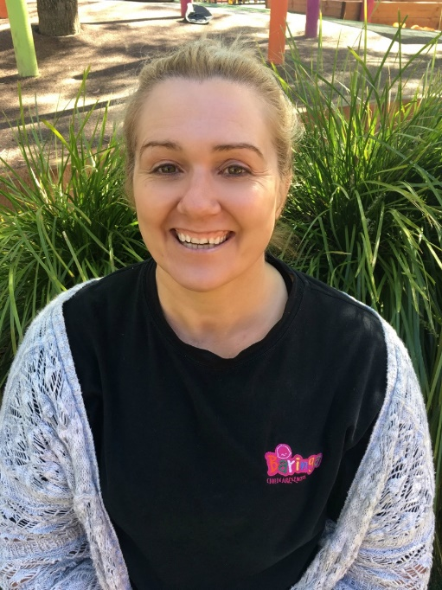
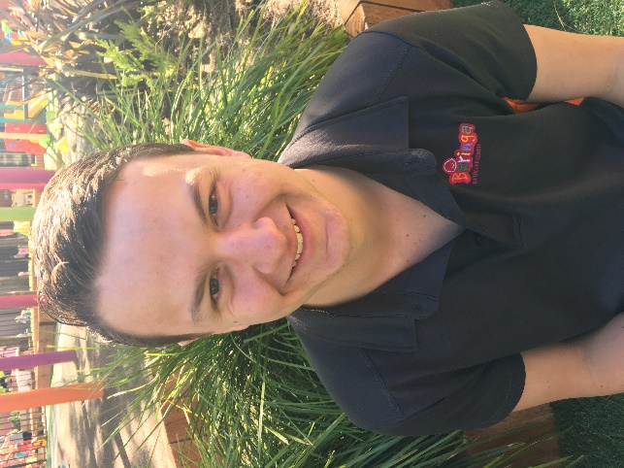

Liam Lisa
in the Acacia room.

Child’s Name is going to play with (Resource) in the Acacia room.

This is where Child’s Name is going get his/her nappy changed/go to the toilet room in the Acacia room.

Child’s name can wash his/her hands in the Acacia room.

Child’s name will have lunch in the Acacia room.

Child’s name will sleep/rest in the Acacia room.

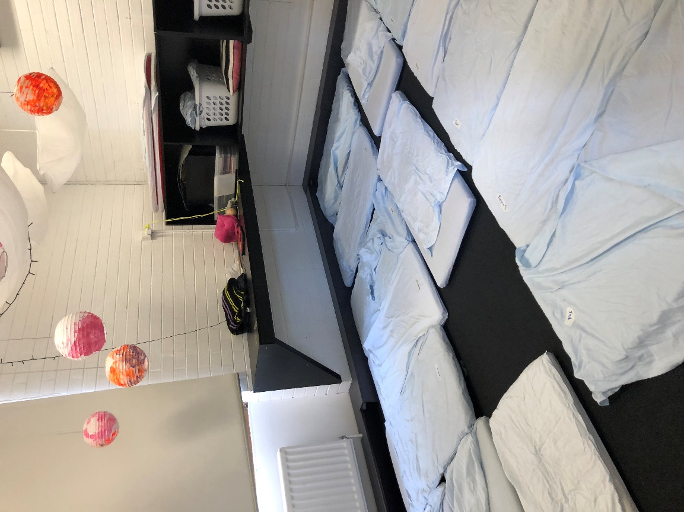

Child’s name will play outside in the Acacia room.

Child’s Name is going to play with (name a resource) in the Acacia Room.

Child’s name will have a happy time in the Acacia room.

