Ringworm
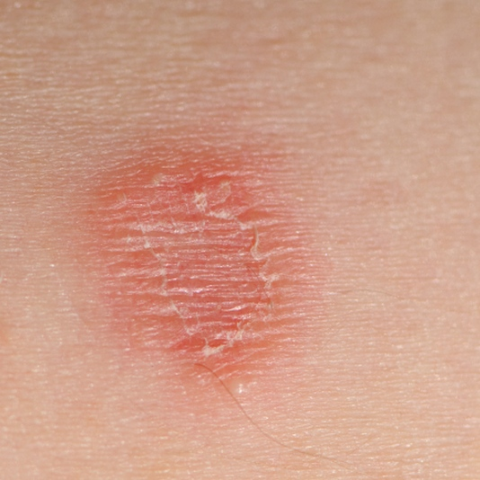
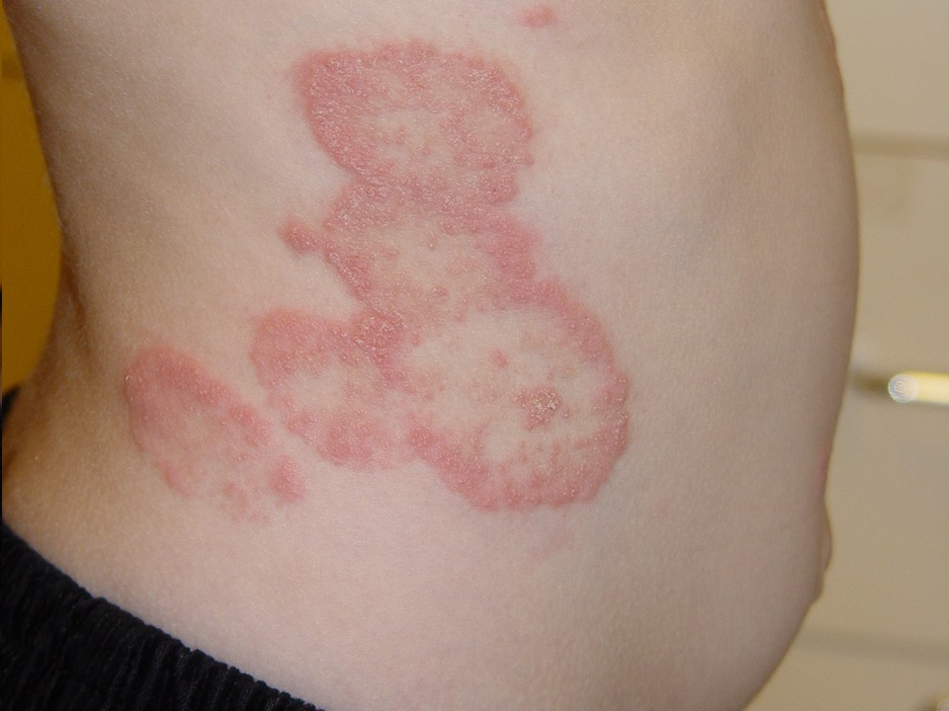
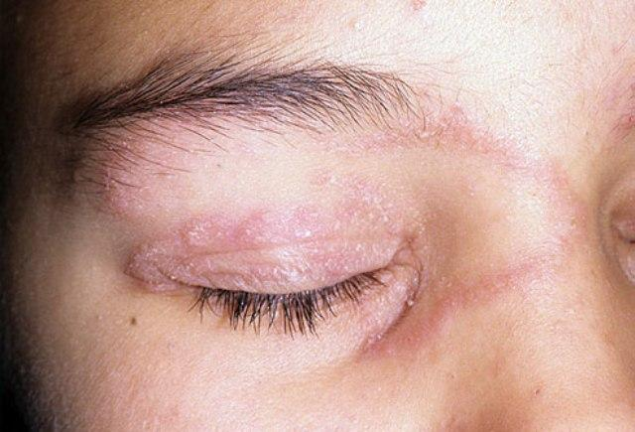

Ringworm is not a worm.
- Ringworm is a skin infection that’s caused by mould-like fungi that live on the dead tissues of your skin, hair, and nails. You can get it in any of these places -- and on your scalp.
- When you get it between your toes, it’s what people call athlete’s foot.
- If it spreads to your groin, it’s known as jock itch.
Symptoms:
- The telltale sign is a red, scaly patch or bump that itches.
- Over time, the bump turns into a ring- or circle-shaped patch. It may turn into several rings.
- The inside of the patch is usually clear or scaly.
- The outside might be slightly raised and bumpy.

How Do You Get Ringworm?
Ringworm is highly contagious. You can catch it in any of the following ways:
- From another person. Ringworm often spreads by skin-to-skin contact.
- From your pets. Rubbing or grooming Sparky? Wash your hands when you’re finished. It’s also very common in cows.
- By touching objects. The fungus that causes ringworm can linger on surfaces, clothes, towels, and in combs and brushes.
- From soil. If you’re working or standing barefoot in soil that’s infected with the fungus that causes ringworm, you can get it, too.
Natural ways to fight Fungal Skin Problems
Natural Health Support:
Step 1:
- Optiflora: Since optimal levels of Probiotics represent 70% of the power of the immune system, it is essential to optimize and maintain the level of “good bacteria” in the intestinal tract. Optiflora Pre-biotic is also recommended (1/8th teaspoon per day)
- Shaklee Life Shake: Also a great source of probiotics. Also provides a guaranteed supply of the 9 essential amino acids, which are critical in the production of antibodies, a very important part of immune health
- Garlic: is anti-fungal. Swallow it orally. Also slice a fresh garlic clove and tape on top of the ringworm externally.
- Shaklee Vita-Lea: The nutrients Vitamin B, C, A, E, D, and Zinc, are all important support for the immune system. Therefore, it is always wise to support the body with a quality multi-vitamin/mineral.
Step 2:
- Vitamin D3: Vitamin D3 is very important to support an optimal immune system. Make sure your personal levels are maintained at the optimal range based on the results of your own personal bloodwork

Step 3:
- Additional Antioxidants: are always beneficial for the immune system. That is why many people optimize their levels by taking additional Vitamin C, E, etc. along with their multiple vitamin.
Diet:
- Include the following foods in your diet choices: good quality yogurts, sauerkraut, garlic, onions, asparagus.

