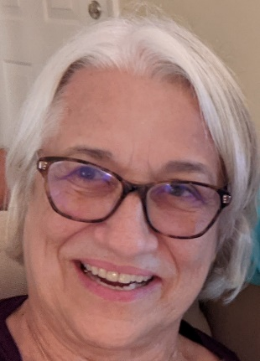
Marianne Schaefer
Marianne is a retired Labor and Delivery Nurse with Northern Arizona Healthcare in northern Arizona. She currently volunteers as a COVID Contact Investigator, a position she has held since the beginning of COVID-19 with the Yavapai County Medical Reserve Corps. She is an experienced, dedicated registered nurse with strong interpersonal, communication, and organizational skills and a proven ability to work effectively with people of various positions.

Her nursing career spans over 25 years in direct nursing care and management in Labor and Delivery/Women’s Health, policy formulation and review, planning and delivering education programs to clinical staff, developing quality management initiatives, as well as teamwork to collaborate/facilitate/deliver strategies and programs for healthcare IT implementations. She has completed various courses in peer support through the International Critical Incident Stress Foundation.
Education:
M.S. Nursing Informatics
Walden University
LNC Legal Nurse Consultant
Yavapai College
Prescott, AZ
B.S. Nursing
Old Dominion University
Norfolk, VA
A.D.N. Nursing
Yavapai College
Prescott, AZ
Her hobbies include nature walks, birdwatching, good wine and cooking with family and friends.
Marianne is a proud mother and grandmother.
Originally from Canton, Ohio, she currently shares her time between Arizona and Oregon

Contact Information: Marianne@PARFdn.com

