Signal for Help (or the Violence at Home Signal for Help)

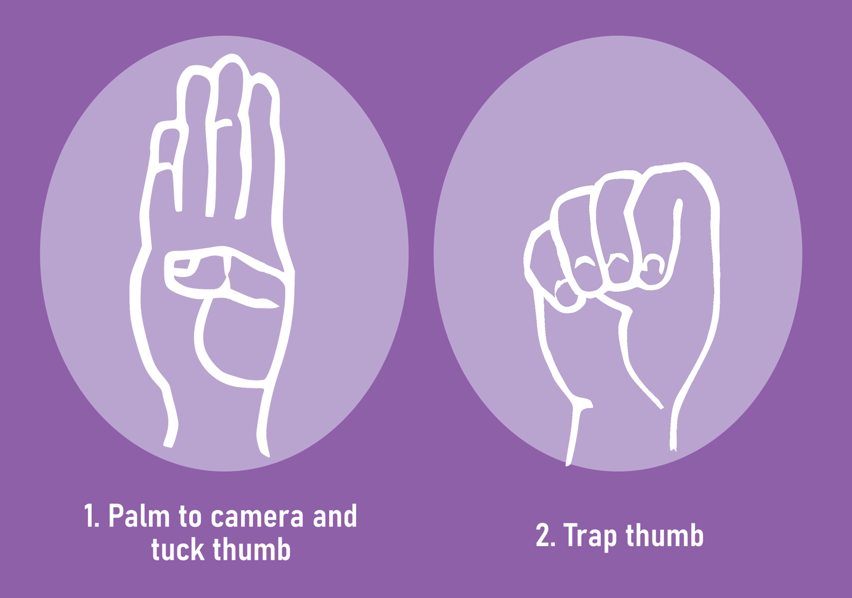

The Signal for Help (or the Violence at Home Signal for Help) is a single-handed
gesture to secretly indicate that someone is in distress, at risk of domestic violence and
needs assistance. It can be used over a video call or in person by an individual to alert others that they feel threatened and need help.

The signal was originally created by the Canadian Women’s Foundation (CWF) as a tool to combat the rise in domestic violence cases around the world linked to self-isolation measures that were related to the COVID-19 pandemic. It has become a
universal call for help, spreading through social media.

As reported on CNN, November 8, 2021, “A missing teenager from North Carolina was rescued by Kentucky police after she signaled for help by using a hand gesture known on TikTok to represent violence at home, according to police. A motorist in Kentucky called 911 to report seeing a girl in distress in a vehicle on the interstate.”

If you see someone using the above signal, call 911.

