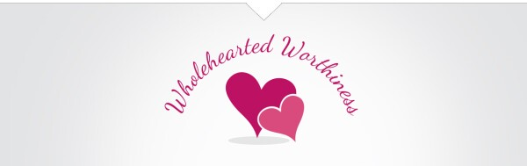
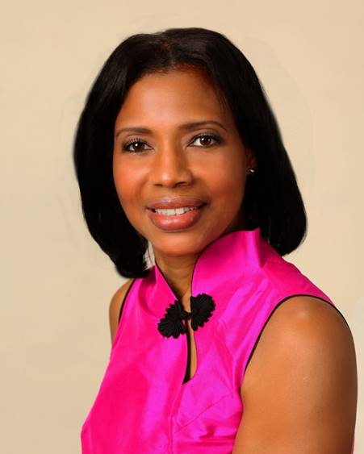
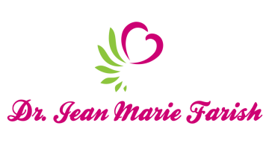

LOVE LIGHT NewsLetter

I am excited to host my VoiceAmerica Empowerment Show-LOVE LIGHT with amazing Guests to cultivate a lifestyle of love and wholehearted connections through worthiness. My show is aligned with my mission to live an altruistic and heart centered life.

MEET LOVE LIGHT GUEST

ANITA C. STEWART, R.N.
Energy Healer and Intuitive Counselor
Bridges of the Heart

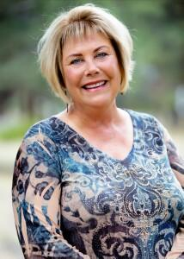

March 20, 2020

OVERCOMING LIFE CHALLENGES WITH LOVE

ABOUT ANITA C. STEWART

Anita C. Stewart, R.N. has been gifted to work in healing her whole life. Ernest tending to those injured was first experienced through her compassionate, gentle care of animals as a child. She went on to earn her nursing degree, with high level hospital nursing as her career for 40 years. Her own debilitating injury initiated a series of events that naturally led her to expand her abilities to help others, physically, emotionally and spiritually- not through her own knowledge and power, but through surrender to a power greater than her own. Energy healing, at times and for some, is unexplainable in words, but seen in the transformed lives of those through whom Anita provides her specialized care. A holistic approach expertise utilizes hands-on energy alignment. Naturally intuitive, she identifies areas in need of work and guides patients through a journey of deep self-discovery.

Her goals are to bridge Energy Medicine into mainstream medicine as a complimentary approach to holism. One patient said, “You were the only person caring for my husband that did not cause him pain when you touched him.” She was referring to Healing Touch.

Anita says, “The longest Bridge a man will cross is from his head to his heart.”

As we become purer channels for God’s light, we develop an appetite for the sweetness that is possible in this world. A miracle worker is not geared toward fighting the world that is, but toward creating the world that could be. –Marianne Williamson

Contact Anita
http://www.bridgesoftheheart.com
Intuitive Counseling
Energy Medicine

“An empowered self is a loving self, and keep your love light shining.”

