Beach Week  Week 1 | Monday, June 21  Summer Camp Begins  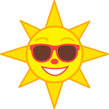 |  | Tuesday, June 22  Sand Dollar Craft | Wednesday, June 23  Water Play  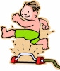 | Thursday, June 24  Jellyfish Craft  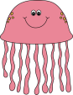 | Friday, June 25  Beach Party  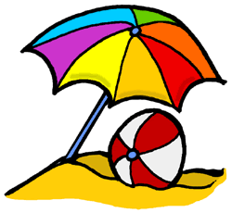
Party in the USA  Week 2 | Monday, June 28  Popsicle Day |  | Tuesday, June 29  Fourth of July Craft | Wednesday, June 30  Water Play | Thursday, July 1  Fireworks! | Friday, July 2  Fourth of July Party
Bug Week  Week 3 | Monday, July 5  FOURTH OF JULY  HOLIDAY  CAMP CLOSED |  | Tuesday, July 6  Butterfly Craft | Wednesday, July 7  Water Play | Thursday, July 8  Bug Catchers  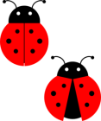 | Friday, July 9  “Bug”noculars  Bug Hunt
Everyday  Heroes  Week 4 | Monday, July 12  Policeman Day |  | Tuesday, July 13  Fireman Day | Wednesday, July 14  Water Play | Thursday, July 15  Ambulance Craft | Friday, July 16  Ice Cream Party
Book Week  Week 5 | Monday, July 19  Flat “Camper” Day |  | Tuesday, July 20  Splat the Cat  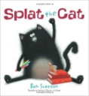 | Wednesday, July 21  Water Play | Thursday, July 22  Dr. Seuss Day  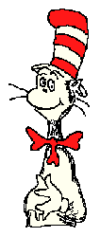 | Friday, July 23  Pete the Cat  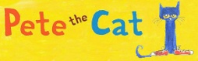
Pirate Week  Week 6 | Monday, July 26  Pirate Hats |  | Tuesday, July 27  Pirate Telescope | Wednesday, July 28  Water Play | Thursday, July 29  Treasure Chests  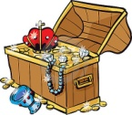 | Frida, July 30  Treasure Hunt  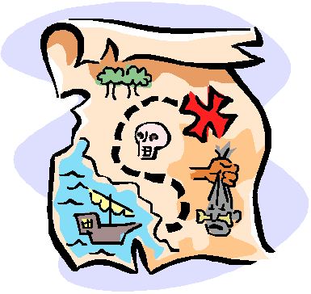
Winter in August  Week 7 |  | Monday, August 2  Snowflake Craft | Tuesday, August 3  Snowman Craft  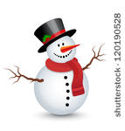 | Wednesday, August 4  Water Play | Thursday, August 5  Snowball Games  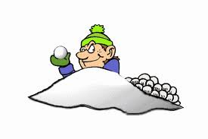 | Friday, August 6  Popsicle Day
Out of Space  Week 8 |  | Monday, August 9  Rocket Craft | Tuesday, August 10  Earth Craft | Wednesday, August 11  Water Play | Thursday, August 12  Oh My Stars | Friday, August 13  End of Camp Celebration

