ACROSS:

8, Cross-examined. 9, Ash. 10, Apocrypha. 11, Sci-fi. 13, Typical. 16, Visited. 19, Offer. 22, No account. 24, RAC. 25, Sovereign Lord.

DOWN:

1, Oceans. 2, Hophni. 3, Islamist. 4, Exhort. 5, Omar. 6, On spec. 7, Add all. 12, CBI. 14, Plotting. 15, Awe. 16, Vanish. 17, Starve. 18, Daub it. 20, Furrow. 21, Recede. 23, Cure.

**Service times at St Mary’s**

**Sunday: 10:30am Holy Communion**

**or Morning Prayer**

Normally the first and third Sunday is Holy Communion with Morning on the second and fourth.  Baptisms by  arrangement with the Rector.

**Tuesday: 10.00am Holy Communion**

**12.15pm Lunch-time Service**

Readers contributions to the magazine are always welcome. Hard copy (hand written if easier) to the Rectory address or by email: to : [**st.marysstockport@gmail.com**](mailto:st.marysstockport@gmail.com)

Editorial discretion with regard to content and space available will apply.

**St Mary’s in the Marketplace**  
St Mary’s Rectory, 24 Gorsey Mount Street,  
Stockport, SK1 4DU.   
0161 429 6564 [www.stmarysinthemarketplace.com](http://www.stmarysinthemarketplace.com).



St Mary’s in the Marketplace   
50p

Parish Magazine  
February 2014

**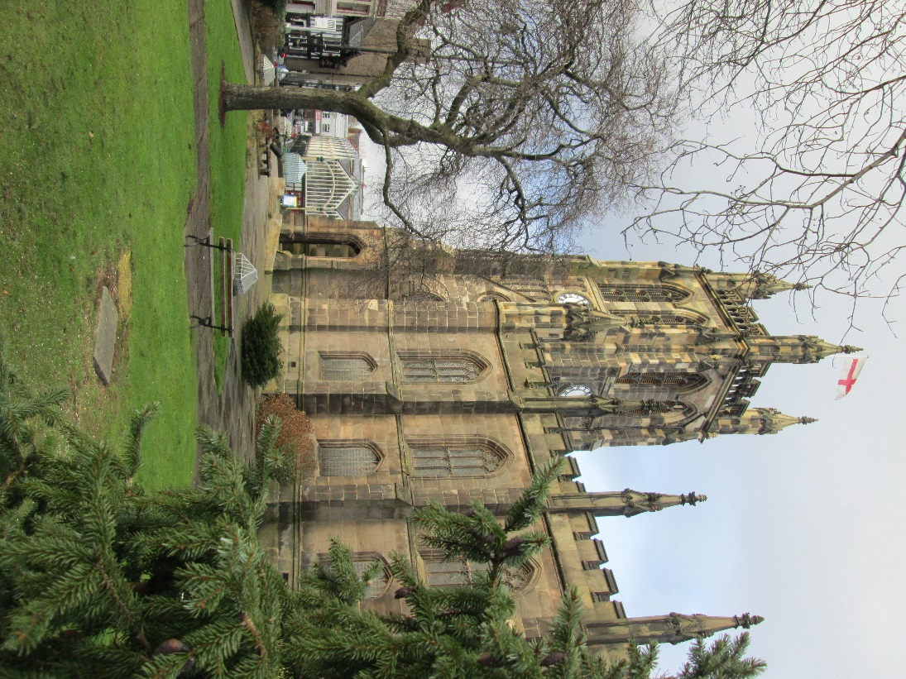**

**From the Rector’s “ i-pad”**

**Dear Reader**

As I write to you I am looking out of my study window and ,for a change, the sun is shining. The sun always makes a difference, and certainly after a few grey days it cheers everything up. My attention is drawn to the outer edges of the garden, where I see a clump of snowdrops which have just appeared, without any fuss or bother. So pure and white are they, that I wonder what the meaning of them is in the garden . Coming so soon after Christmas, and still in the season of Epiphany , they remind me of the Virgin Birth and the sweetness of the Christ Child in infancy and those early weeks of life of his life .  
  
I was trying to explain the ins and outs of infant baptism to a family and the godparents of the child the other evening. Its not easy by any means, and mindful of the current debate about the proposed new wording of the Baptism Service I was eager to see what people made of the concept of sin and the devil as presently included in the service. Perhaps I should have picked a snowdrop from the garden to demonstrate purity from sin!  
Further along, under the hedge, I am delighted to see the daffodils, pushing their way up through the dead leaves which I had carelessly raked to the back in the Autumn. Especially delighted, because this year there seem to be more buds on them than in previous years. These particular daffodils have been a considerable disappointment to me since I first planted them a few years ago, and I would be so happy to have a good show, outside my kitchen window this Spring! The daffodil is a cheerful edition to the garden a herald of Spring isn't it? By May the Rectory garden will be full of red, yellow, orange and white daffodils a marvellous sight. But not before the crocuses have splashed their vivid array of colours across the otherwise rather plain front lawn. And so life in the Rectory garden unfolds, as it has done, before my very eyes every year for the past 16 years, when I first began to plant bulbs in it.  
  
All this horticultural activity speaks to me of the life of the church, from year to year.

**PRAYER 24**  
" God's people worshipping with praise and prayer , lifting up the Name of Jesus across Stockport"  
  
For the 30 hours leading up to New Year's Eve a great event took  place in St. Mary's which brought together Christians of different churches, denominations and traditions for PRAYER 24' , organised by REV320 a local Christian charity. Anne Rodger of Heaton Moor Christian Fellowship described it like this.  
" It has been a great blessing for us- not just the event itself, but to see so many diverse parts of the Church coming together, each playing their part...so many styles of worship and different traditions blending together, and proving that we really ARE One Body, with One Lord, One Spirit, One Saviour".  
  
It was an undoubtedly an extraordinary experience, to witness the church at one moment being swamped with loud Christian music and singing, and at another time fille with an atmosphere of stillness, quietness and prayer. During the event there was Anglican worship,of a type; and there was Spirit -led  worship of another type; together with a short time of Taize prayer too. Alongside this there was constant prayer and fellowship and teaching.  
  
The event was so well received by all those who took part that it is hoped there will be a similar event at St. Mary's on Good Friday ( daytime ) and Easter Eve leading into Easter Morning (night time), to which Christians across the town will be invited to take part. There is already a well established pattern of worship and witness in the Town Centre on Good Friday and it is to be hoped that this can be incorporated into the PRAYER 24 event, just as the St. Mary's regular worship was part of the PRAYER 24 on New Year's Eve.  
  
Watch out for further details about  
PRAYER 24 this Easter ( 18-20 April 2014) or visit [www.rev320.org](http://www.rev320.org/)

**The Tuesday Service - the Bible and its meaning for us today.**  
  
The Tuesday service began with four people attending ,sitting in the front row of the stalls. Did they sing a hymn? Did they listen to a sermon? Did they say the Lord's Prayer together? What was it like in those days? Somehow the memory fades. The reality is that somehow, no one knows   exactly how, the  service began to grow and people began to come to the Tuesday Service . They came not only from other churches, but also from no other churches; they began making St. Mary's on a Tuesday their regular place and act of worship , rather than on the traditional choice of a Sunday. Many have been blessed through the Tuesday Service ,not only through the teaching of God's Word, but also through the fellowship and friendship of meeting with others week by week, before and after the service. Deep and lasting have been made, and a number of people have found their way to Heaven prepared for them , simply through attending the Tuesday Service .  
The number of those attending this simple act of worship, with the teaching of God's Word at its heart , has grown steadily and assuredly over the years, and today it is not unusual to  see forty or more at the Tuesday Service, or listening to it in the Nave Cafe, which is a gentle way in for some, into the Christian community.  
  
This month we bring to mind the teaching of St. James through 5 studies in his epistle , which have received the title Practical Christian Living. On two of the Tuesdays there will be a special focus on other aspects of the Spiritual life, namely Christian Aid and MASHAV. The teaching of God's Word will then  be taken up with a series of addresses in Lent in which it is hoped visiting clergy will bring a fresh approach to the message of Lent and Easter ( details to be announced later).  
  
The Tuesday Service begins at 12.15 ,is a non liturgical service , and lasts about half an hour. There are two hymns , a Bible Reading, an Address and prayers. The Nave Cafe remains open, and all are welcome to come and find out more about the Bible and its meaning  for us today.   
For those who appreciate a midweek service of Holy Communion, a said Service of Holy Communion is held in the Memorial Chapel at 10am every Tuesday, and lasts about 40 minutes. All are welcome.  
  
  
Rev. Roger Scoones  
Rector, St. Mary's Stockport

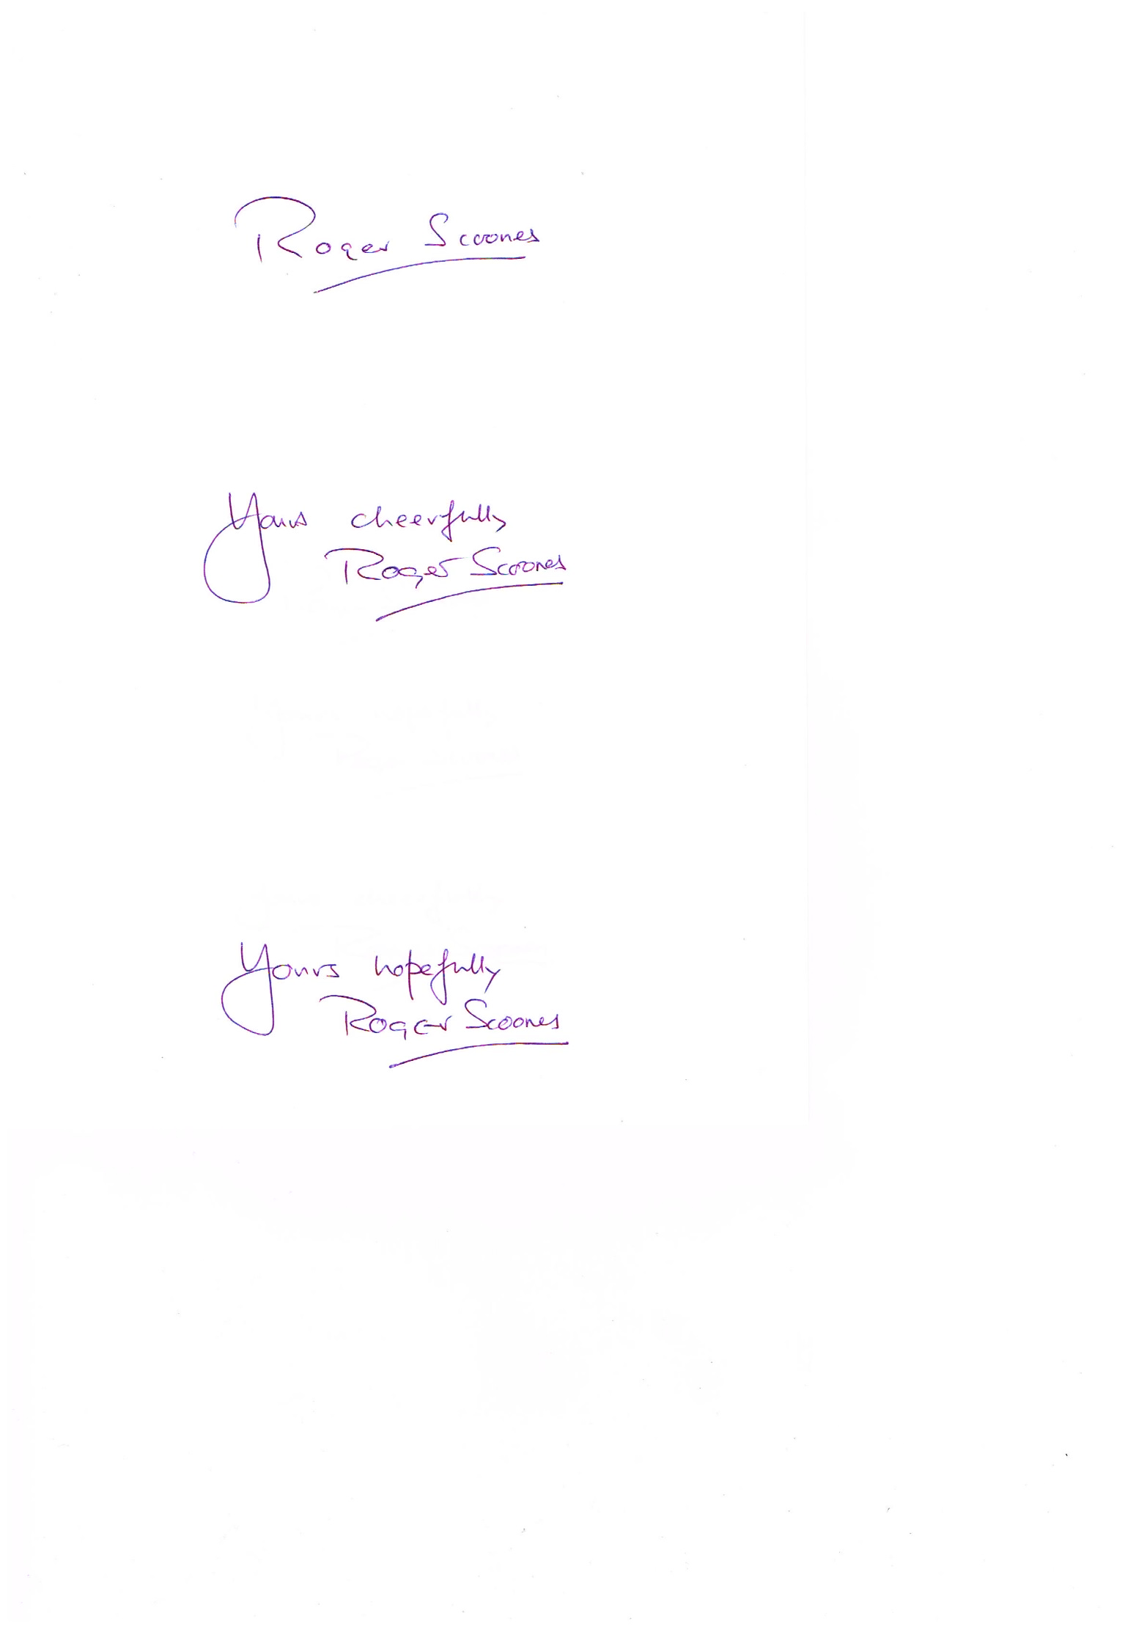At the beginning of this month little baby Ava  Platt- Chance will be Christened in St. Mary's . Having known her father since he was a teenager himself, the scene of such a young man bringing his child for baptism is like those snowdrops , a sign of purity and new life. And a cause for rejoicing in our local community.  
Later in the month a guest speaker will be coming to St.  Mary's to speak about Christian Aid, reminding us of the ongoing life of that great organisation, which has received so much support in the community over the years. Christian Aid Week appears every year at this time, just like the daffodils!  
  
At the end of the month MASHAV will bring new insight into the church's life with a short, powerful exhibition and stimulating information, which will undoubtedly make people sit up and think. A splash of colour like the crocuses in the lawn, short flowering, but very colourful.  
  
However, Winter and Spring can bring surprises, chilly winds and hard frosts, with sometimes heavy snow. The early optimism of the New Year may yet bring with it some nasty surprises, some difficult moments in the garden and in the church's life There is still much work to be done in the garden, if summer is going to be a pleasant one in the Rectory garden. And that is true for the church too. St. Mary's does not yet have everything in place ,as I write ,to go ahead with the restoration of the two  vestries, and this is in itself a major project , quite as large and expensive as the five previous phases of work, which have been successfully completed in recent years. I am very grateful to the  small Project Team for their diligence and hard work. It will pay dividends in the end, with an undoubted successful conclusion to the work in hand in the foreseeable future.  
  
As I look out of the study window and see the sun streaming ever so optimistically across the garden, bringing hope for longer days and warmer days in the weeks ahead I pray in the words of St. Julien of Norwich  " that all will be well, and all will be very well".  
  
And dear Reader, what I pray for the church I pray for you in this month of February. I do hope you enjoy reading this Magazine.

**The Na** **ve Café**

Italian Evening

Saturday 22nd February 7pm

**Menu details to be announced   
when the Chief for the evening (Adam)  
has decided what to cook!**

**Tickets: £12.00**

**Our Café theme for February is “Italy” and all things “Italian” – we hope you will be able to join us for another of our social evenings at St Mary’s.**

**===================================================**

**Level 1 Food Safety                       Saturday 10thMay 1- 4.30pm**

**Venue**:  
St. Matthew’s Church, Grenville Street, Edgeley, SK3 9EE.

St Matthews are inviting people from across the Stockport Deanery of churches to join them on the above Basic Food Hygiene course. Please let us know if you are interested in attending. The only criteria to attending is the willingness to work in Church.

**The Bells of St Mary’s**

'"FANTASTIC!" " I was cycling through Stockport and I heard the peel of bells. It was so beautiful, I just had to stop and listen. Fantastic!"

This comment from a regular visitor to St. Mary's is a welcome and timely reminder that the bells of St. Mary's are being heard across the town once again, after a silence of 7 years, while work was being done on the Tower. Thanks to the Steeple Keeper, Clive Calton, the bells are in good order and will be rung at regular intervals on Sunday afternoons, by a team of ringers from the region. On special occasions there will be quarter peels, which last longer than a normal peel.

The Bells of St. Mary's are ringing again - fantastic!



We are already planning for later in the year.

Events, research projects and commemorative ceremonies will be taking place during the four years of 2014 to 2018, marking the 100th anniversary of the First World War.

St Mary’s will be joining in with various activities in and around Church, starting in August (when we hope to have a special ringing of the bells). However, it’s not too late to get involved **– if you have any ideas to share as to events we can do in recognition of this very important anniversary, just let us know.**

C:\Users\Staples-Display\Downloads\pp_2014_2_feb_cross-word_grid.tif

Across

8 Interrogated (Acts 12:19) (5-8)

9 ‘Burn it in a wood fire on the — heap’ (Leviticus 4:12) (3)

10 Tobit, Judith, Baruch and the books of Esdras and the Maccabees are part of it (9)

11 Science fiction (abbrev.) (3-2)

13 Clay pit (anag.) (7)

16 Went to (John 4:46) (7)

19 ‘Therefore, I urge you, brothers, in view of God’s mercy, to — your bodies as living sacrifices’ (Romans 12:1) (5)

22 David’s plea to God concerning those referred to in 14 Down: ‘On — — let them escape’ (Psalm 56:7) (2,7)

24 Royal Automobile Club (1,1,1) 25 How the book of Ezekiel refers to God more than 200 times (Ezekiel 2:4) (9,4)

Down

1 Seas (Proverbs 8:24) (6)

2 One of the sons of Eli the priest, killed in battle by the Philistines (1 Samuel 4:11) (6)

3 Specialist in the study of the Muslim religion (8)

4 ‘Do not rebuke an older man harshly, but — him as if he were your father’ (1 Timothy 5:1) (6)

5 One of Esau’s grandsons (Genesis 36:11) (4)

6 Taking a chance (colloq.) (2,4)

7 God’s instructions to the Israelites concerning grain offerings: ‘ — salt to — your offerings’ (Leviticus 2:13) (3,3)

12 Confederation of British Industry (1,1,1)

14 ‘All day long they twist my words; they are always — to harm me’ (Psalm 56:5) (8)

15 The crowd’s reaction to Jesus bringing back to life a widow’s son in Nain (Luke 7:16) (3)

16 Disappear (Psalm 104:35) (6)

17 How Jeremiah was likely to die if he wasn’t rescued from the cistern where he was imprisoned (Jeremiah 38:9) (6)

18 What the prophets do to a wall, with whitewash (Ezekiel 13:10, RSV) (4,2)

20 Made by a plough (Job 39:10) (6)

21 Noah was relieved when the flood waters continued to — (Genesis 8:5) (6)

23 Jesus gave the Twelve the power and authority to do this to diseases (Luke 9:1) (4)

**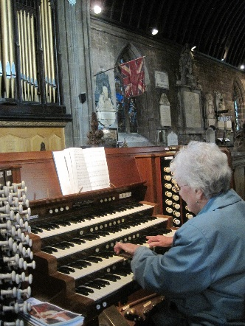A tribute to Isobel Clarkson**  
  
On his retirement my Grandfather Prebendary George Ruck of Bath said of his organist " that many things had been said over the years about the relationship between Rectors and Organists, but I can honestly say that I have enjoyed the best of relationships with mine!" That organist "B.J.M" ( Mr. Ben Maslem, I believe his name was) gave my Grandfather a pen and ink drawing of their church, St. Mary's Bathwich, painted by his own hand, in 1938; and I have that same painting hanging in my study , as a testimony to their relationship ,as Rector and Organist, 70 years later.  
  
Isobel Clarkson offered her services to me as organist shortly after the sudden death of her dear husband nine years ago. Her offer of help was greatly appreciated at that time.  Since then Isobel has not only played the organ regularly on Sundays , but also for weddings and funerals and countless carol services; and most recently for the Tuesday lunchtime service ,following the long and faithful ministry of the late Frank Walton who had played at that service for many years, until ill health overtook him.  
  
Isobel has not only played the organ, but has also been responsible for choosing  the hymns for each Sunday service. This monumental task came naturally to her, having a keen interest in hymnology and a vast  knowledge of traditional hymns.  
Being able to read music meant that Isobel could not only chose both the right hymns to compliment the Readings for the day, but also the appropriate and best known tunes to suit the congregation .  
  
Isobel has worked tirelessly for these past years , giving her time and musical talent freely to the church, as any Christian should. She has coped with all the changes which have overtaken the church in recent times, leaving the Organist more isolated from the congregation than ever before, and without the company of a choir to sing along with her. Congregations large and small have appreciated her playing ,and children's school parties have often been treated to a close up

**St Mary’s Spring Fayre**

**Saturday, 29th March 2014**

A date for your diary – to come and join us at our Spring Fayre.

Items for our stalls are most welcome – jams, cakes, plants, crafts etc. NO BOOKS OR BRIC-A-BRAC PLEASE. Help on the stalls, front of house or in the café area will be most welcome at various times throughout the day. Please let us know if you can spare an hour or so.

The weekend will continue with   
**A Special Mothers Day Service  
at 10.30am  
on Sunday, 30th March 2014**[Remember the clocks will have changed as British Summer time begins]



**Slow down – it is February!**

How are your energy levels?

February is famous for being the time of year when people most want to hibernate – to sleep, to be left alone, and to do as little as possible.

So instead of fighting the winter blues this year, why not go with the natural rhythms of nature? Set aside as much time as you can – to do nothing but rest. It is no coincidence that February is when retreat bookings soar: people want to escape the crowds and renew themselves.

“I think the human spirit is like a daffodil bulb, preparing for the Spring by refreshing its roots, so it can bloom again when the times comes.” So says Stafford Whiteaker, former monk, ex-hermit and editor of The Good Retreat Guide. The Bible makes clear that God blesses our times of rest: ‘In peace I will both lie down and sleep; for you alone, O Lord, make me dwell in safety.’ (Ps 4:8)

**Craft Sessions**

**Not too energetic however is the opportunity to sit in Church and make craft items for the Spring Fayre. Come and join us on a Thursday– from 11am onwards – all welcome. We suggest that you bring with you your chosen craft work, although help with the making of general items will be appreciated. Our “theme” will be connected to Mothers Day and Easter.**

Volunteers Events

Many thanks to those of you who have already offered help and assistance – it has taken a little time to sort ourselves out (apologies for this) but we are now in a position to organise “volunteer” events which we hope as many of you as possible will wish to attend.

The sessions will be open to anyone, those already part of the “St Mary’s Team”, those interested in helping out, whether you have put your name forward already, are just thinking about it, or have not yet even given a thought to offering us a little of your “time”.

There are lots of opportunities – from playing the organ at Sunday and Tuesday services, to taking a turn “front of house”, working in the Nave Café/Kitchen or undertaking support tasks including cleaning and general maintenance.

If you can spare a few hours on a regular basis, that would be most helpful to us. We need to have as many of us as possible on the various rosters we need to maintain to keep St Mary’s fully functional and in “tip-top” shape at all times. There is nothing worse than popping to the loo to find that the loo paper has all gone or the mirror doesn’t look as if it has seen glass cleaner in months! That there is dust on everything , finger marks on the glass doors or that dirty pots are still lurking on the café tables waiting to be collected. Someone needs to be there, someone needs to do all these little tasks – could that be you?

We pride ourselves on being a “welcoming” church, but sometimes there aren’t enough of us to just be there to say “hello”. Especially on a Saturday, we find it hard to manage the Nave Café and cover the “Welcome Desk” function – could you assist us? We all have our own strengths – can you help out at St Mary’s?

**The Nave Café**

[NAVE CAFE](http://ratings.food.gov.uk/business/en-GB/624592/NAVE-CAFE-Cheshire)

St Mary's in the Marketplace Churchgate Stockport Cheshire

SK1 1YG

Food hygiene rating is '5': Very good

It is now official - we have been inspected by SMBC Environmental Health & Trading Standards and awarded a Food Hygiene Rating of 5. We are naturally absolutely delighted.

It was full marks all round:  
Compliance with food hygiene and safety procedures 5  
Compliance with structural requirements 5  
Confidence in management/control procedures 5  
Total score .. .. .. .. .. .. .. 15

The rating was given after an inspection by a Food Safety Officer (from the local authority) on the 10th January 2014. Although the Nave Café was registered when we opened last year this was the first official inspection.

The rating given depends on three main areas: (a) how hygienically food is handled (how it is prepared, cooled, stored and what measures are taken to prevent food being contaminated with bacteria);(b) the condition of the structure of the premises (including cleanliness, layout, lighting, ventilation, equipment and other facilities); and (c) how the business is managed (also ensuring that appropriate records are maintained).

16th February – Education Sunday

Ninth Sunday before Easter

Education Sunday began more than 100 years ago (1878 to be precise) and is a national day of prayer and celebration when churches join to offer to universities and in the church. A time to celebrate the achievements of education, to recognise the challenges, and support and pray for all who are involved in education. Today, our prayers are needed every bit as much as ever, as teachers and students alike face ever increasing demands upon them.

Education Sunday this year will look at the theme of ‘Going Above and Beyond’, and will be based on Matthew 5.21-37.



2014 marks the centenary of the start of the First World War. There will be many events around the country, celebrations of heroism in the face of danger and national soul-searching about the justification for war. Some young people will be given the opportunity to visit First World War battlefields and cemeteries, and others will learn about some of the people, perhaps even their ancestors, who played a part in the war. At the heart of many discussions will be the question of obedience. Those who fought in the First World War, and any combat situation before or since were required to obey orders, no matter what their personal feelings might be. Others who objected to war in obedience to their faith or conscience were stigmatised, branded as cowards and even imprisoned.

**Advance Notice of the   
Women’s World Day of Prayer**

**Friday, 7th March 2014**

**2.00pm**

Special Service to be held at St Mary’s in the Marketplace



Egypt – Streams in the Desert

*STOCKPORT YOUTH ORCHESTRA*

**the next concert of the Stockport Youth Orchestra  
will be held at   
St. Mary's in the Marketplace**

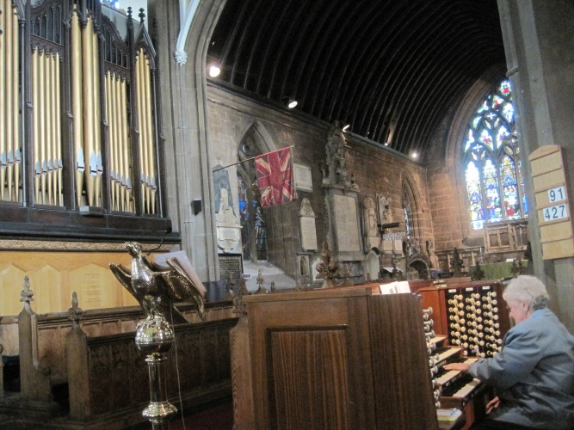**on**

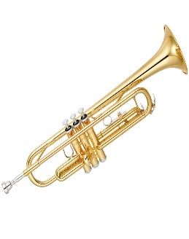**Sunday 23rd March 2014**

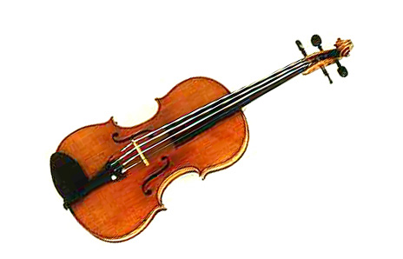**7.00pm**

demonstration of her playing on the organ console, a sight which they will long remember.  
  
Without Isobel Clarkson as Organist over the last few years, St. Mary's would have been a poorer place, and her decision to give up playing the organ at this special time of her life robs the church of a talented and committed musician,

who will be hard to replace. The familiar sight of Isobel, hidden away behind the vast organ console is now a thing of the past, but she will be remembered with affection by all those who knew her and heard her playing the organ at St. Mary's .

No Rector or Vicar could have wished for a more dedicated and thoughtful, and hard working Organist than Isobel Clarkson. It is only sad to record that circumstances have prevailed upon her to relinquish this voluntary post just at this time, as the church is beginning to grow and develop in its ministry into the community, and is seeking the support and help of volunteers in its ministry , indeed people just like Isobel.  
  
Future generations will hear of the name, Isobel Clarkson, which will always be associated with the great Makin Organ at St. Mary's, and will remember her with warm gratitude for the enormous contribution she made, single-handedly and most generously, to the life of the church, which she chose to make her spiritual home all those years ago.  
  
As my Grandfather said of his esteemed Organist of many years, so say I of Isobel Clarkson. "As Rector and Organist we have enjoyed the best of times together". And now it is the time to say simply, "thank you Isobel."  
  
  
  
Rev. Roger Scoones  
Rector, St.Mary's Stockport

## Loaves and Fishes

It’s a cold winter evening, damp and wet. One young man (we’ll call him Jo) has called into St Mary’s for a hot meal (it’s Hotpot) and the chance for some time in the warmth and to get some additional odds and ends to take with him. Jo is on the streets tonight “literally” – someone has nicked his tent. He left us to sleep under a bridge near a well known supermarket in Stockport. He prefers to be a little further out of town really, where he is less likely to be bullied. Chelwood will provide him with a new tent as soon as they can.

Now Christmas is over the numbers attending the Sunday evening “food kitchen” in the Tower of St Mary’s was expected to increase and a record number of 27 appeared at the main door (and one dog – a lovely little chap who calls in with his owner every week). Another regular visitor was a lady (we’ll call her June) who had been sleeping outdoors as well (she has actually spent a few nights outside the south door in the porch area you may have seen her blankets inside church). She wasn’t there – you wonder if she is alright and where she is. A guy (we’ll call him Walter) has a flat, but says that it is cold with no heating. Another (we’ll call him Jason) looks for a new hat, one that will cover his ears.

“Loaves and Fishes” have been with us a few weeks now, and growing from strength to strength. It makes you think ….. returning to a centrally heated house, food in the fridge.

It’s a privilege really just to pop down for an hour or so to support the team from Chelwood Baptist and to see our café tables full of people enjoying a good meal and some companionship. This surely must be taking St Mary’s into the community and the community into St Mary’s!

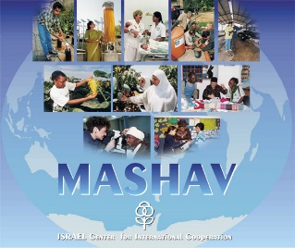

amended dates

**MASHAV EXHIBITION**

**Israel’s Centre for International Co-operation**

**25th February – 17h March 2014**church open for viewing Tuesday, Thursday, Friday & Saturday

9:00am – 3.30pm

**This exhibition shows the various initiatives undertaken by Mashav throughout its 65 years of existence.**

**Mashav is a division of the Israeli Ministry of Foreign Affairs and since it’s inception in 1958 the Centre has trained over 250,000 people from 140 countries.**

**Israel has the distinction of being a donor country, leading in such fields as agriculture, water issues, public health and education**.

**Exhibition arranged by The Israel Information Centre  
 in association with Stockport Metropolitan Borough Council  
for further information:** [**www.mashav.mfa.gov.il**](http://www.mashav.mfa.gov.il)