Mitral Valve Prolapse

Mitral Valve Prolapse occurs in approximately 10% of the North American population. It is also called “floppy valve” and “Barlow’s syndrome”. It may be inherited, or may occur as a result of nutrient deficiencies during the gestation period. It affects more women than men and often peaks after the age of 40.

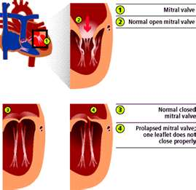
It occurs when the mitral valve, which is located between the upper and lower chambers on the left side of the heart, does not function correctly. The mitral valve has two leaflets that swing open and shut as blood travels from the upper chamber (left atrium) to the lower chamber (left ventricle) on the left side of the heart. The valve has supporting structures that attach to the heart muscle to help it open and close properly. When these structures weaken or lengthen abnormally, the valve leaks blood backward. During mitral valve prolapse, these leaflets buckle back into the left atrium.

This can cause:
- Mitro valve regurgitation (when blood flows the wrong way)
- Sharp, left-sided chest pain
- Fatigue, or a pounding feeling in the chest
- An infection of the heart valves (because it is a weakened area)
- Heart rhythm abnormalities
- Breathing difficulties
- Ankle swelling
- Fluid in the lungs.
- Anxiety
- Headaches
- Morning tiredness
- Constantly cold hands and feet

An echocardiogram is diagnostic test that can detect it. Diuretics, caffeine, and donating blood may aggravate the symptoms.

Traditional Treatment:
- Beta blockers
- Repair or replacement of the mitral valve with an artificial heart valve

Since valves are muscular tissue, complementary treatment would include nutrients that are essential for healthy muscle tissue and a healthy heart:
- Alfalfa (lots of tablets) – an abundant mineral source essential to build muscle tissue
- Vitamin C – strengthens muscle tissue
- Calcium-Magnesium – essential for muscle tissue strength
- CoQHeart – to enhance the strength of the heart
- Soy Protein – Protein Amino Acids are the components used by the body to build strong muscle (Shaklee Physique is excellent for muscle repair … Shaklee 180 Smoothees – the leucine is very beneficial)
- Vita-Lea – for chemistry balance
- Drink lots of water, especially during strenuous activity & hot weather

