**Marine Collagen 1000mg Tablets + Vitamin C (2 Month Supply / 60 High Strength Capsules) Type 1 Hydrolysed Collagen for Skin, Hair, Nails and Joints**

Some of the benefits of Marine Collagen that are backed by science include:

* **Improved skin health**
* **Relieved joint pain**
* **Bone loss prevention**
* **Boost muscle mass**
* **Promotes heart health**

Collagen supplements may have other health benefits which may include:

* **Hair and nail strength**
* **Gut health**
* **Brain health**
* **Weight loss**

## Important information

#### Ingredients:

Each maximum strength capsule is made from pharmaceutical grade Marine Collagen (1000mg), Vitamin C (10mg) and L-ornithine HCL (15mg).

## Product Description

### Marine Collagen Tablets (x60) 1000mg Tablets (1 Per Day / 60 Day Supply)

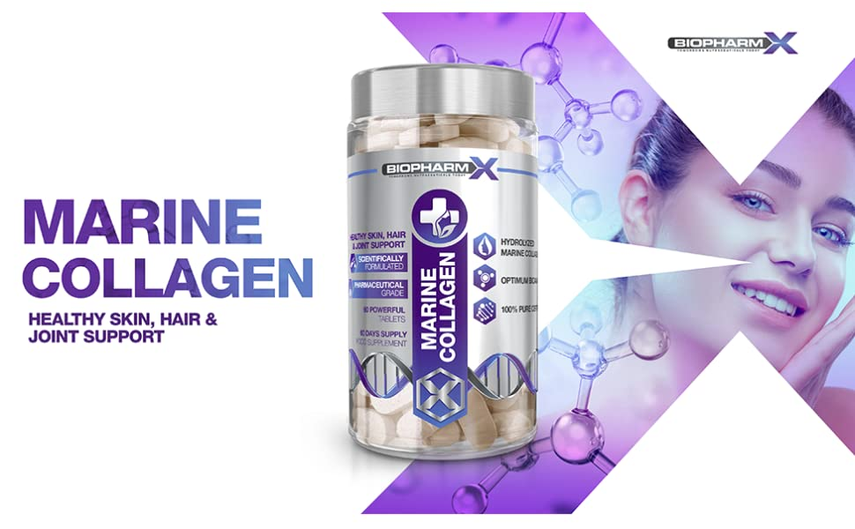

Collagen is the most abundant protein within the body, making up one third of the body’s total. It fulfills numerous critical functions as the major structural component of all connective tissue within the body. It is not only vital for both the structure and strength of the skin, hair and nail but is also a major component of tendons, blood vessels, ligaments, bones and organs.

* Type 1 Hydrolysed Marine Collagen
* Maximum Strength Formulation
* Pharmaceutical Grade Ingredients
* Suitable For Men & Women
* Manufactured in the UK

|  |  |  |
| --- | --- | --- |
| **collagen** | **marine collagen** | **collagen** |
| Skin Health & Firmness A reduction is collagen is the main characteristic of aging skin (wrinkles); this is because collagen determines the skin physiology by maintaining the skins strength, elasticity and hydration - all of which gives youthful skin its vibrancy, smoothness and plumpness   * Increase skin hydration * Increase skin density * Increase skin firmness * Increase skin vibrancy | Joints, Tendons & Bones Collagen is central to the structural integrity of cartilage and contributes significantly to the health, maintenance and formation due to its role as an essential amino acid. Collagen makes up 95% of the cartilage within the joints and also binds muscle to ligaments and bones. Cartilage that is not cared for is significantly more susceptible to over 200 different musculoskeletal conditions that can severely damage the joints and cause daily pain, stiffness and swelling.  Supplementing with Collagen supports the long term health of joints. | Hair & Nail Health Collagen consists of 19 different amino acids, but is primarily made up of proline, hydroxyproline and glycine. Proline is crucial for the synthesis of keratin – a naturally occurring fibrous structural protein and a vital component of both hair and nails.  Its primary function is to activate protein and amino acid metabolism in fingernail cells and hair roots to promote growth, maintain strength and texture. |



### Each BioPharmX Marine Collagen tablet is enhanced with premium grade Ascorbic Acid, providing an equivalent of 10mg of Vitamin C per tablet.

The regulation of collagen synthesis is controlled by several factors, including Vitamin C intake. It is a critical cofactor for collagen synthesis and acts as the building blocks that trigger natural collagen production. If you have a vitamin C deficiency, collagen production will suffer. Vitamin C is also an essential nutrient responsible for the growth, development and repair of all tissue within the body, with higher levels correlating directly with peak overall health.

* Vital for the synthesis of collagen
* Ensures glowing healthy skin
* Supports a health immune system
* Powerful antioxidant properties

### BioPharmX: Superior Standards in Nutritional Supplements

|  |  |  |
| --- | --- | --- |
| **marine collagen** | **collagen** | **marine collagen** |
| Leaders in Nutritional Supplements BioPharmX has the goal of enhancing the well-being of their customers around the world by delivering premium quality, best value nutritional supplements.  Each tablet has been formulated to safely provide significantly more then other Marine Collagen supplements on the market. | Premium Quality Every bottle is manufactured in the UK in a fully licensed facility, using only premium graded ingredients.  Rest assured that we would never consider manufacturing an item that did not fully meet these requirements. | Directions for Use Adults: As a supplement begin by taking 1 tablet in the morning on an empty stomach with at least 8fl oz of water.  Do not exceed stated dose in a 24-hour period.  Use only as directed. |