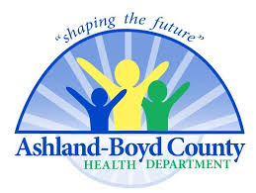
Ashland – Boyd Co. Health Department
Syringe Services Program Weekly Update
May 16th – 20th

- Return Client Visits – 44
- New Client Visits - 5
- Syringes Returned – 1470
- Syringes Dispensed (repeat clients) – 1390
- Return Rate – 94.5%
- Narcan Kits Dispensed – 46
- HIV tests performed – 8
- HEP C tests performed - 1

