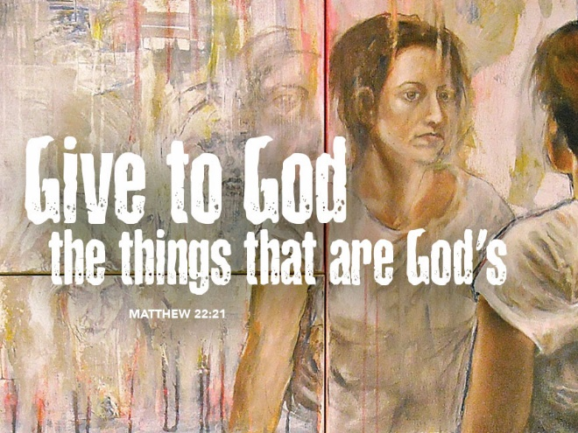
Give to Caesar, But Give to God
October 22, 2017
Matthew 22:15-22
Grace and peace to you from God Our Father and from our Lord and Savior, Jesus Christ, amen.
A Little Boy desperately wanted $100.00 to buy some toys and prayed to God for a whole week, but nothing happened. So, he decided to write a letter to God requesting the $100.00. When the Post Office got the letter addressed to God they forwarded it on to the White-house. The President surprisingly received it was very impressed, touched and amused so he instructed his aid to send the boy $5.00. He thought $5.00 would be a lot to the little boy. And the boy was, indeed, delighted by the money. He sat down and immediately wrote a thank you note, which read: Dear God, Thank you very much for sending the money. However, I noticed that for some reason you had to send it through Washington DC and, as usual, they kept most of it… Taxes have been in the news a lot lately, with the President and republicans pushing for tax reform. If anyone thinks there’s even a small chance your taxes will be lowered, come and talk to me after the service today, you clearly need some counselling…
Now, we’ve left the parables section of Matthew and entered into what Bible Scholars call the “Conflict Stories” between Jesus and the religious leaders. Of course, the foremost things that create conflict between people are either religion or politics and once you start talking politics, taxes are usually high on the list of things people disagree about. Considering the points Jesus was making in some of his parables it’s really no wonder they led directly into these confrontations. First, Jesus compares them to the bad son who says he’ll do the father’s will, but fails. Then he says they’re like the dishonest renters who refuse to pay their rent and kill the owner’s son. Last week they were invited guests who dishonor the king and kill his messengers. In today’s text, Jesus comes right out and calls them hypocrites. Jesus is nothing is he isn’t honest and straight forward. He certainly doesn’t mince his words.
Jesus speaks the truth, even when it seems harsh, out of love and in the spirit of invitation. Does anyone here think that for one minute, if the religious leaders had realized Jesus was 100 percent right in his evaluation of their behavior, and then repented, that he wouldn’t have accepted them with love and open arms? If he accepted prostitutes, tax collectors, and other sinners, he all the more would have accepted these self-appointed “men of God.” Ah, but alas, all these holy men could think to do was plot against Jesus. They came up with this quite brilliant way to trap Jesus by posing him a question that seems to have no good answer. If Jesus sides with the Pharisees and says no you can’t pay taxes to Caesar because Orthodox Jewish Law prohibits possessing and using any graven images, he would be praised by the people, but arrested by the Romans for speaking against the state. The Jewish people took this having no graven images thing so much to heart they actually had their own monetary system where the coins didn’t have icons of anyone or anything engraved in them. You see the coin of the realm in the Roman world had the head of Caesar Augustus along with the words, ‘Tiberius Caesar, majestic son of the majestic God, and High Priest’ on each coin. Do you see how this kind of goes against having no other gods?
On the other hand, the Herodians were a group of people who aligned themselves with the secular ruler, King Herod and his family. These people were in total allegiance with the Roman government and would expect all citizens to pay their fair share of the tax bill no matter whose face is on the coin. Normally, these two groups, the Pharisees and the Herodians were on opposite sides of every issue, yet their hatred of Jesus has brought them together for this verbal trap. If Jesus sides with the Pharisees he risks being charged with sedition against the government. If he sides with the Herodians, then the Pharisees can make the case that he is no man of God by advocating the use of a coin that clearly breaks the Jewish law and would turn the people against him because they also hated paying the Roman tax.
Jesus isn’t so easily fooled. First off, he sees through their flattery and calls them out for who they are as hypocrites. Then he asks for a Denarius, the very coin of the realm in question. I noticed, Jesus wasn’t carrying one himself and apparently neither were his disciples. The coin is given to Jesus by none other than one of these “holy men” claiming to be the expert keepers of the law. Oops, what are they doing with one of the offensive coins with the image of Caesar and the inscription that Caesar is divine? Looks like Jesus didn’t have to do too much to prove his point about their hypocrisy. Then, as if to rub their noses in their hypocrisy he asks whose face is on the coin. I would have been more than a little embarrassed…
I’ll bet the Herodians were ecstatic when Jesus said we should give to Caesar what belongs to Caesar. Can’t you see them chest bumping and high fiving? Meanwhile, the Pharisees are huddled together rubbing their hands saying, “Aha, we’ve got him now!” That’s when Jesus drops the other foot, like a bombshell. “Give to God the things that are God’s…”
This text is most often used to show our relationship to the state and how we’re indebted by all the things government does so that we are obligated to pay our taxes. In Lutheran terms we call this the Two Kingdoms Theory. We Christians acknowledge the existence of two separate realms. There’s the Kingdom of God or sometimes called the Kingdom of Heaven and then there’s the Kingdom of Man. We’re citizens of God’s Kingdom and sojourners or travelers in the Kingdom of Man. In the Bible we see God isn’t limited to operating only in His Kingdom, but clearly moves and has His Being in both worlds. All you have to do is look at the First Lesson and see how God used Cyrus, the Assyrian Emperor, to reverse the exile and allow the Israelites who had been deported after being conquered by the Babylonians over 60 years previously. Since God can and does use people and governments who don’t even know his name, we should live under these people and governments in peace as much as we are able. That’s the first half of Jesus’ answer to this complicated and trick question.
But Jesus doesn't stop with “Give to Caesar the things that are Caesar's.” He then says, “and give to God the things that are God's.” What does this mean: to “give to God the things that are God's?” Jesus might use any one of us as an example. Take a look at this person. Whose image does he or she bear? For the answer to this question we have to look all the way back to the beginning, back to the 1st chapter of Genesis, ²⁶ Then God said, “Let us make humankind in our image, according to our likeness. That’s right every living person, every person who ever lived, and every person who will live on the face of the earth is, was, and will be created in the image and likeness of God. So, when Jesus says, “give to God the things that belong to God”, he’s not talking about a couple of bucks you throw into the offering plate when you come to church. He’s not referring to your tithe for those who do that either. Jesus is making the claim that everything you have and everything you are belongs to God. Yes, we can and should pay our fair share of the tax burden. After all God is working through just governments to provide for the general welfare of the people. So, give a pittance to Caesar, but realize everything and I mean every… single… thing… belongs to God.
It’s no accident this Gospel Lesson comes up right smack dab in the middle of the traditional North American harvest time. It’s a not so subtle call to remember where all the abundance of the earth comes from and yes, it’s a clear call to give back to God out of all the blessings we’ve received. More than that, this Gospel reminds us to give thanks to God for all the rest because it all belongs to God. We’re stewards or caretakers of everything we have, including our own bodies. We’re just like the coin Jesus examined in our story. For better or worse we each reflect the likeness of the one who created us.
It actually goes even deeper that just your creation. You’ve been bought back from the devil by the death and resurrection of God’s only Son. When humankind fell into sin God said this will not stand and paid the ultimate price for our redemption. There’s been a lot of talk on the news this past week about gold star families. Those families who have experienced the loss of a loved one in combat for our freedom. God is the ultimate Gold Star family. He sacrificed his only son in battle against sin, death, and the devil for you. We’re in double debt—to the God who created us and the same God who redeemed us.
May we keep the two Kingdoms straight in our mind and hearts always remembering where our true citizenship lays. May we cheerfully give to Caesar what belongs to Caesar, but may we joyfully remember and give thanks to the God who created, redeemed, and sustains our very lives. Amen.

