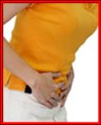
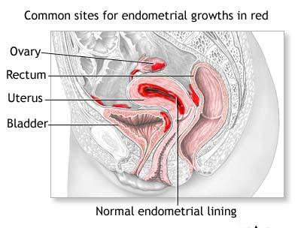

Endometriosis
Endometriosis is a condition in which the cells from the endometrium (the lining of the uterus) also grow elsewhere in the abdominal cavity.

SYMPTOMS:
- It can produce a host of different symptoms, including incapacitating pain in the uterus, lower back, and organs in the pelvic cavity prior to and during the menses
- Intermittent pain throughout the menstrual cycle
- Painful intercourse
- Excessive bleeding, including the passing of large clots and shreds of tissue during the menses
- Nausea, vomiting and constipation during the menses
- Infertility

CAUSES:
- Systemic Candida which punctures the uterus from the exterior wall and allows endometrial cells to leak out into the pelvic cavity
- Diet
- Stress & emotional unrest which blocks pelvic energy
- Many scientists believe that environmental toxins that are estrogen mimicers (like dioxin, chlorine, etc.) can convert pelvic tissue to endometrial tissue which responds to hormonal fluctuations.
- It can be a developmental abnormality or birth defect, probably caused by:
  - irritation by environmental toxins that the mother was exposed to during her pregnancy, ……. embryonic female genital tissue that never made it to the inside of the uterus during development, and when puberty causes the onset of periods, there can be immediate problems.
  - Nutritional deficiencies that cause abnormal development

DIAGNOSIS
Laparoscopy can give a definite diagnosis.

UNDERSTANDING ENDOMETRIOSIS
Growths of endometrial tissue outside of the uterine cavity occur most often in or on the ovaries, the fallopian tubes, the urinary bladder, the bowel, and the pelvic floor. The following explanation tells what causes the pain and why the endometriosis tissue can proliferate in the abdominal cavity:
- During the normal menstrual cycle, a continually changing hormonal environment stimulates the endometrium to grow in preparation for a possible pregnancy. Though not inside the uterus, the abnormal implants of endometriosis also respond to the hormonal changes during menstruation.
- Like the uterine lining, these fragments build tissue each month, then break down and bleed. Unlike blood from the uterine lining, however, blood from the implants has no way to leave the body. Instead, it must be absorbed by surrounding tissue, which is a comparatively slow process.
- In the meantime, the blood accumulates in body cavities. The entire sequence, from bleeding through absorption, can be painful.
- As the menstrual cycle recurs month after month, the implants may get bigger. They may seed new implants and form localized scar tissue and adhesions … scar tissue that attaches to pelvic organs and binds them together. This contributes to the pain of endometriosis.
- Sometimes a collection of blood called a sac or cyst forms. Endometrial or “chocolate” cysts are common on the ovaries. These are usually found to contain moderate amounts of oxidized blood, which looks something like chocolate syrup. If a cyst ruptures, it can cause excruciating pain.

WHAT TO DO:
- Use high amounts of natural progesterone cream from day 5 to 28 of the menstrual cycle (or whenever your normal cycle ends)

- Avoid birth control pills

- Use only toxin-free cleaners and personal care products (most commercial cleaners/personal care products contain toxins that interfere with hormonal balance)

- Diet:
- Avoid anything that creates estrogen dominance – female meat & eggs
- Avoid coffee – it is a stimulant and will increase the problem
- Include generous amounts of Shaklee Soy Protein in your food choices (soy helps balance hormones)

- Supplements:
- Lots of Vitamin E + selenium to help dissolve the excessive tissue
- Essential Fatty Acids (such as OmegaGuard /flaxseed / lecithin / GLA) help to balance hormones
- Adequate B Complex and Stress Relief Complex to help reduce estrogen dominance.
- Always take a multiple vitamin/mineral (Vita-Lea)

- Other Helpful Suggestions:
- Follow recommendations for candida – (Optiflora & Garlic)
- Ginger tea and red raspberry tea are beneficial
- Detoxification is a must (Shaklee DTX, Alfalfa, Herb Lax) – detoxification supports a healthier liver, and the liver is very involved in balancing hormones.

