Sunday Services
Following discussion with many of our neighbouring churches the hand of welcome and friendship has been offered to us to join them for Sunday services whilst St Mary’s is closed on the 3rd, 10th & 17th February.
To help you decide where you would like to attend – here are a few of the alternatives:-
Tiviot Dale Methodist Church [10.45am]
St George’s, Heaviley [8.00am Holy Communion; 10.15am Sung Eucharist]
St Matthew’s, Edgeley [3rd Feb: 10.30am Holy Communion 10th&17^{t h} 9.30am & 11.15am ]
St Luke’s, Brinnington [10.00am Holy Communion]
St Alban’s, Offerton [8.00am Holy Communion; 10.00 Sung Eucharist]
St Mary’s, Cheadle [8.00am Holy Communion; 9.30am/11.15am Morning Worship]
St Andrew’s, Cheadle Hulme [Services at 10.45am – 3rd Feb Holy Communion 9.30am]
St Saviour’s, Great Moor [8.30am Holy Communion; 10.45am Sung Eucharist]
Stockport Evangelical Church
(Independent, Bible-believing church – services at St Andrews, Hall Street) [10.30am]

Tuesday Services
Not too far to travel from St Mary’s – our 10.00am Holy Communion & 12.15pm Lunch-time services will move to St Peter’s. This covers the 29th January, 5th & 12th February. We look forward to your return to St Mary’s on Tuesday, 19th February when we open our doors for the first time after the present works to the interior are completed.
DIARY NOTE: Please join us if you can for a special service to mark the “Week of Prayer for Christian Unity 2013” to be held at St Mary’s in the Marketplace on Tuesday 22nd January 2013 at 12.15pm

St Mary’s in the Marketplace.
Issue No 27 (20th January 2013)

“Securing the future for the next 100 years”

St Mary’s will be closed
from Monday, 28th January
re-opening on Tuesday, 19th February 2013.

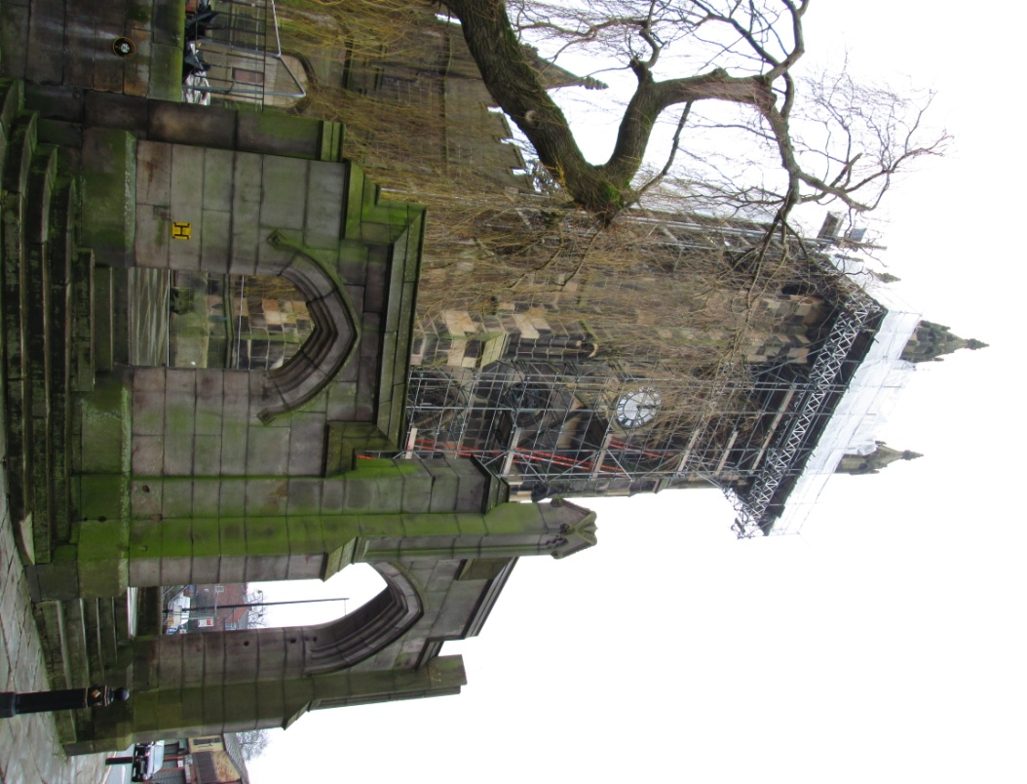
In order to allow Lambert Walker
(and other sub-contractors) to complete
the interior works presently scheduled
we have agreed to close between the
above dates. Alternative arrangements
have been made for our Tuesday
services and we have been warmly
invited to neighbouring churches for our
Sunday worship – see back page for
further details.
The faculty application has been submitted, an
interim licence issued and scaffolding erected -
so work can now commence on the archway to
the churchyard. Another couple of months and St Mary’s will look completely different – how lucky we are to be part of this exciting time in the life of our wonderful church.
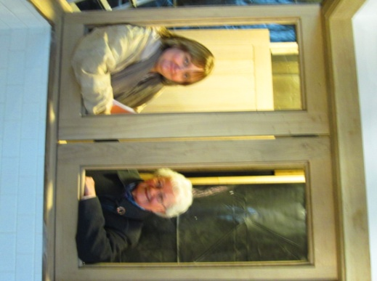
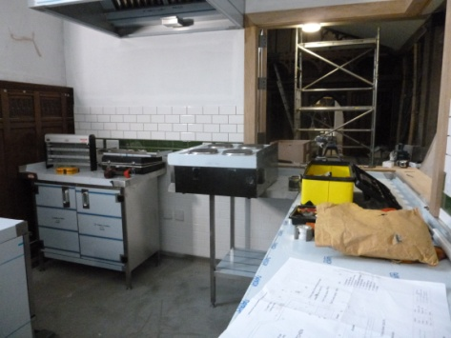
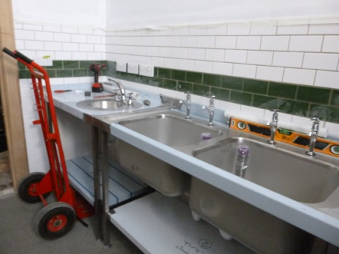
It won’t be long now before we are
serving our first cups of tea and coffee
from the new Nave Café….. The units
have been delivered and fitting well
underway. Our turn now to keep up the
pace to prepare for re-opening the snack
bar in the north aisle, to revise staffing
arrangements and make plans to
expand the refreshments we offer . We
will be going shopping very soon now
for our non-fitted kitchen essentials!

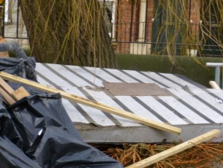
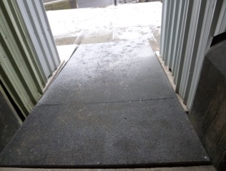
Has anyone noticed that we have a lovely new non-slip ramp – look down when you next walk into Church through the great west doors – for the old ramp is ready for the skip!

Come and join us for our Pancake Party
Tuesday, 12th February 2013 6pm – 8pm
St Mary’s Rectory

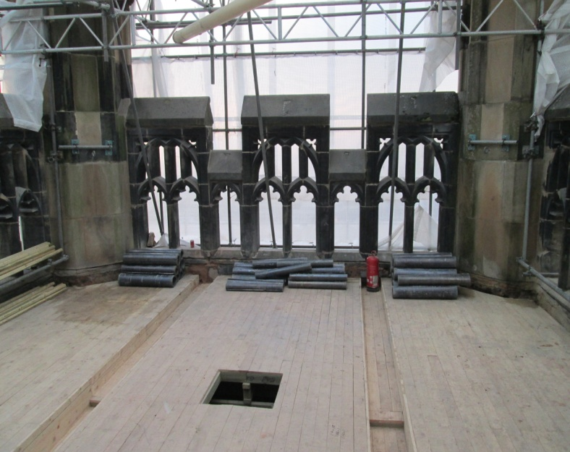
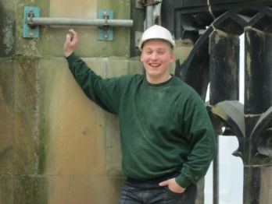
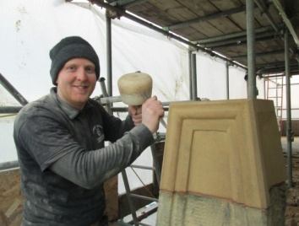

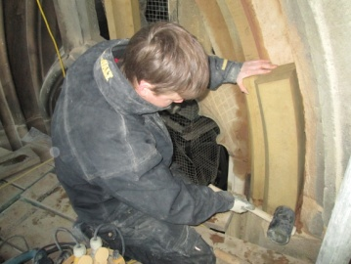
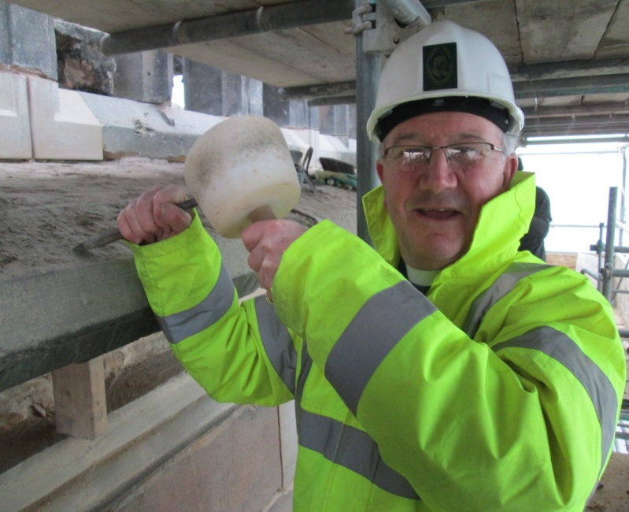

Still plenty going on roof-
wise as the covering goes
down before the new flag
pole can be fitted. Still
plenty of stonework to be
completed although there
would appear to be a new
apprentice trying his hand!
