Elite Mixed Martial Arts Center

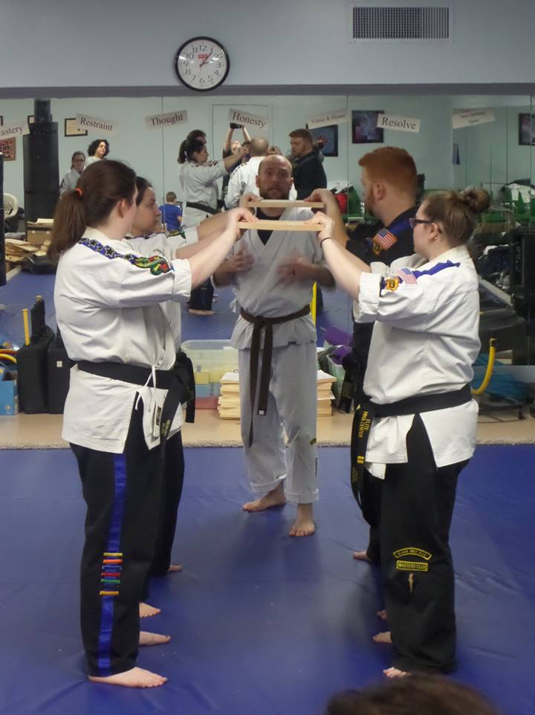

Board Breaking Exhibition

March 2021 – Date TBA

Come join the fun! Your child will have 15 minutes of instruction on board breaking techniques! Then 1 hour of doing advanced breaks, Elite will supply the boards and your child will experience the thrill & confidence builder of breaking like an instructor! We will also be doing Hollywood Kicks...

Cost: $40.00

10:15am-11:30am Youth Class
11:45am-1:00pm Youth Class
1:15pm-2:30pm Adult Class

This class is too advanced for Little Dragons - their regular class 9:30am - 10:00am will be held!
No Regular classes for Youth & Adult

